Coastal Public Access and Risk grants 2017/18
2015/16
Successful projects by region
Total funded projects: 17 | Total funding awarded: $932,000

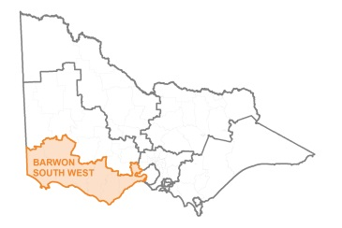
Barwon South West

Recipient | Project | Grant amount
Moyne Shire Council | Port Fairy Surf Club Boat Ramp Reconfiguration | $ 45,000
Surf Coast Shire Council | Bells Beach replacement of Winki lookout pathways | $ 128,000
Glenelg Shire Council | Portland Coastal Stability Assessment | $ 20,000
Otway Coast Committee | Marengo Beach Access & Beach Re Nourishment Mitigation | $ 27,000
Otway Coast Committee | Wye River Beach Access | $ 35,000
Bellarine Bayside Foreshore Committee of Management | Public safety and access: Jade Tiger Beach, Indented Head | $ 88,000
Bellarine Bayside Foreshore Committee of Management | St Leonards Coastal Trail Realignment | $ 24,000
Warrnambool City Council | Moyjil-Point Ritchie Access Upgrade | $ 121,000
Great Ocean Road Coast Committee Incorporated | Steps Beach Stairway Replacement Jan Juc | $ 60,000
TOTAL |  | $548,000

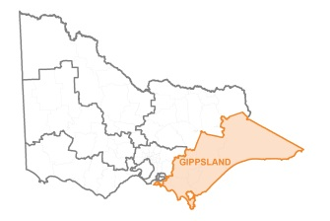
Gippsland

Recipient | Project | Grant amount
Phillip Island Nature Parks | Colonnades Boardwalk | $ 18,000
Seaspray Reserve Committee of Management Inc | Caravan Park Beach Access | $ 40,000
Sandy Point Foreshore Committee of Management Inc | Safety upgrade of Sandy Point Foreshore Main Beach Access | $ 15,000
Gippsland Ports Committee of Management Inc | Lakes Entrance Risk Mitigation Works | $ 34,000
Bass Coast Shire Council | First Surf Beach Foreshore Stair Access Replacement | $ 56,000
TOTAL |  | $163,000

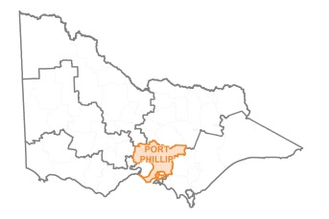
Port Phillip

Recipient | Project | Grant amount
Mornington Peninsula Shire | Mornington/Mt Martha cliffside fence upgrade | $ 35,000
Hobsons Bay City Council | Altona Foreshore Access Ramp Upgrade | $ 150,000
Merricks Beach Foreshore Reserve Committee of Management Inc. | Merricks Beach Access Improvement | $ 36,000
TOTAL |  | $221,000

