| Balnarring Beach Foreshore and Parks Reserve  Coastal Management Plan |
| --- |

|  |  |
| --- | --- |
| |  | | --- | | Cover photo of foreshore looking out from foreshore area. | |

|  |
| --- |
| Creative Commons licence logo.© The State of Victoria Department of Environment, Land, Water and Planning 2015    This work is licensed under a Creative Commons Attribution 3.0 Australia licence. You are free to re-use the work under that licence, on the condition that you credit the State of Victoria as author. The licence does not apply to any images, photographs or branding, including the Victorian Coat of Arms, the Victorian Government logo and the Department of Environment, Land, Water and Planning logo. To view a copy of this licence, visit <http://creativecommons.org/licenses/by/3.0/au/deed.en>  ISBN 978-1-74146-383-5 (pdf)  **Accessibility**  If you would like to receive this publication in an alternative format, please telephone the DELWP Customer Service Centre on 136186, email [customer.service@delwp.vic.gov.au](mailto:customer.service@delwp.vic.gov.au) or via the National Relay Service on 133 677 [www.relayservice.com.au](http://www.relayservice.com.au). This document is also available on the internet at [www.delwp.vic.gov.au](http://www.delwp.vic.gov.au)  **Disclaimer**  This publication may be of assistance to you but the State of Victoria and its employees do not guarantee that the publication is without flaw of any kind or is wholly appropriate for your particular purposes and therefore disclaims all liability for any error, loss or other consequence which may arise from you relying on any information in this publication. |

Executive Summary

The Balnarring Beach Foreshore Reserve Committee of Management (the Committee) is a voluntary Committee appointed by the Minister for Environment and Climate Change. The Committee is responsible for the management of 76 hectares of publicly owned foreshore, camping grounds and bushland at Balnarring Beach on the Mornington Peninsula in Victoria.

This Management Plan has been prepared to gauge the community’s views on its contents which will guide and direct the future management of Balnarring Beach Foreshore Reserve (Reserve). The plan describes the Reserve’s current conditions, identifies a vision for the Reserve, and establishes management strategies and actions for the Committee to use and implement over the next three years to help achieve that vision.

This plan aims to ensure that management strategies will enhance the natural beauty, biodiversity, cultural heritage and community enjoyment of the Reserve. These values will be maintained in accordance with the vision for the Reserve and existing strategies and guidelines established by State Government, Local Government, and other relevant governing bodies.

The Committee will continue to manage the Reserve as a natural bushland with camping allowed at strategic locations throughout. This focus will ensure that the Reserve continues to be enjoyed by campers who enjoy the bushland feel and continue to return year after year. The Committee will investigate options to improve facilities and services within the campgrounds during the life of the plan, including the replacement of amenities blocks.

The Committee will endeavour to make the area along Merricks Creek east of the Yacht club an example of local indigenous vegetation by building on the remnant vegetation cover. This will be achieved with the help of funding through grants as they can be accessed. Weed management and erosion control are the main issues in this area.

Throughout the whole Reserve, efforts to replace the larger trees like Manna Gums and Coastal Banksias will need to be effected so the local population of Koalas and other indigenous wildlife will have a chance of continued survival. Much of this vegetation is grown from locally collected seed in the Committee’s nursery.

On the sand dunes along the beach an active Hooded Plover conservation programme will be developed. This will be achieved through an ongoing public awareness campaign and signage in combination with restricted access to breeding spots.

Other issues as and if they are brought to the attention of the Committee could be incorporated in an ongoing and ever changing environment of managing the natural and physical assets of the Reserve. All this is of course dependant on the resources of the Committee.

**Belinda Williams**

Chairperson

Balnarring Beach Foreshore and Parks Reserve

Committee of Management

|  |  |
| --- | --- |
| **Contents** | **Page No.** |
| 1. **Introduction** |  |
| * 1. ***The Reserve*** | **1** |
| * 1. ***History of the Reserve*** | **1** |
| * 1. ***Land status*** | **2** |
| * 1. ***Management responsibility*** | **2** |
| * 1. ***Management context*** | **3** |
| * 1. ***Adjoining land use*** | **3** |
| * 1. ***Stakeholders*** | **3** |
|  |  |
| 1. **Existing Conditions** |  |
| * 1. ***Aerial photography*** | **5** |
| * 1. ***Climate*** | **5** |
| * 1. ***Geology and soil types*** | **5** |
| * 1. ***Vegetation*** | **6** |
| * 1. ***Local fauna*** | **9** |
| * 1. ***Cultural heritage*** | **10** |
| * 1. ***Current use of the Reserve*** | **11** |
|  |  |
| 1. **Future Directions** |  |
| * 1. ***Vision for the Reserve*** | **12** |
| * 1. ***Community consultation*** | **12** |
| * 1. ***Regional connectivity*** | **13** |
| * 1. ***Camping*** | **13** |
| * 1. ***Recreation*** | **14** |
| * 1. ***Access*** | **15** |
| * 1. ***Vegetation management*** | **15** |
| * 1. ***Local fauna management*** | **17** |
| * 1. ***Fire management*** | **18** |
| ***3.10 Education and Interpretation*** | **19** |
| ***3.11 Balnarring Foreshore Pathways Strategy*** | **19** |
|  |  |
| 1. **Management Zones** |  |
| * 1. ***Zone 1: Restoration area*** | **21** |
| * 1. ***Zone 2: Beached areas*** | **22** |
| * 1. ***Zone 3: Bird sanctuary*** | **23** |
| * 1. ***Zone 4: Car park and rotunda*** | **25** |
| * 1. ***Zone 5: Habitat zone*** | **26** |
| * 1. ***Zone 6: Yacht club and adjoining car park*** | **27** |
| * 1. ***Zone 7: The Spit*** | **29** |
| * 1. ***Zone 8: Fethers road*** | **30** |
| * 1. ***Zone 9: Camping Reserve A*** | **31** |
| * 1. ***Zone 10: Camping Reserve B*** | **33** |
| * 1. ***Zone 11: Camping Reserve C*** | **35** |
| * 1. ***Zone 12: Ranger’s compound*** | **37** |
|  |  |
| 1. **Business Plan** |  |
| * 1. ***Camping fees*** | **38** |
| * 1. ***Income*** | **38** |
| * 1. ***Expenditure*** | **38** |
| * 1. ***Grants*** | **40** |

|  |  |
| --- | --- |
| **Figures** |  |
| **Figure 1: Location of Balnarring Beach** | **1** |
| **Figure 2: Aerial photo of Balnarring Beach** | **5** |
| **Figure 3: Pre 1750s EVCs within the Reserve** | **6** |
| **Figure 4: Existing EVCs within the Reserve** | **7** |
| **Figure 5: The identified biolink** | **13** |
| **Figure 6: Zone 1 – Restoration area** | **21** |
| **Figure 7: Beach & jetty, looking east** | **22** |
| **Figure 8: Zone 3 – Bird sanctuary** | **23** |
| **Figure 9: Zone 4 – Car park and rotunda** | **25** |
| **Figure 10: Zone 5 – Habitat zone** | **26** |
| **Figure 11: Zone 6 – Yacht club and adjoining car park** | **27** |
| **Figure 12: Zone 7 – The Spit** | **29** |
| **Figure 13: Zone 8 – Fethers road** | **30** |
| **Figure 14: Zone 9 – Camping Reserve A** | **31** |
| **Figure 15: Zone 10 – Camping Reserve B** | **33** |
| **Figure 16: Zone 11 – Camping Reserve C** | **35** |
| **Figure 17: Zone 12 – Ranger’s compound** | **37** |
|  |  |
| **Appendices** |  |
| **Appendix 1: History of the Reserve** |  |
| **Appendix 2: Management context** |  |
| **Appendix 3: Reserve regulations** |  |
| **Appendix 4: List of indigenous plant species found within the Reserve** |  |
| **Appendix 5: List of high priority invasive plant species found within the Reserve** |  |
| **Appendix 6: List of fauna likely to be found within the Reserve** |  |
| **Appendix 7: Balnarring Foreshore Pathways Strategy** |  |
| **Appendix 8. Map of Camping Reserve A** |  |
| **Appendix 9: Map of Camping Reserve B** |  |
| **Appendix 10: Map of Camping Reserve C** |  |

1. Introduction
   1. The Reserve

The Balnarring Beach Foreshore Reserve (Reserve) is located 2 kilometres south of the township of Balnarring on the south-east coast of the Mornington Peninsula, overlooking Western Port towards Phillip Island.

|  |
| --- |
| Map of local area with Balnarring Beach markeddse1305654 |

Figure 1: Location of Balnarring Beach

### History of the Reserve

The historical landscape of the Reserve was dominated by coastal banksia (*Banksia integrifolia*) species with an understorey of coast tea-tree (*Leptospermum laevigatum*). The foreshore would have been dominated by vast dune systems protecting the inland landscape and coastal vegetation.

Balnarring Beach was first gazetted as a town in 1886 with subdivision of the town into individual lots. Initially these lots were used as holiday locations with some shacks constructed, but the majority of owners used tents when staying in the area. By 1910, Balnarring was beginning to attract holiday makers and by 1920 there was a surge of sales leading to the construction of simple holiday homes.

The Reserve evolved into a popular camping spot and by 1919 it was estimated that about 200 people had travelled from all around Victoria to stay in the Reserve. This has led to the creation of the Reserve that is seen today, including the three camping grounds. Soon after the Reserve’s creation, a foreshore committee was established to manage the land on behalf of the Crown.

Since the creation of the Reserve, there have been many changes to the Reserve’s use and the use of the surrounding areas. The Reserve is still a popular destination for many campers who continue to return to Balnarring Beach for its natural values and country feel. The popularity of the Reserve lead to the creation of infrastructure such as the amenities blocks within the camping grounds, a rotunda and barbeque near the store, various tracks and car parks and the Westernport Yacht Club.

The natural environment has also seen a number of changes over the years, including the erosion of sections of the beach which led to the construction of seawalls and other protective structures. The erosion of areas of the beach exposed sensitive foreshore vegetation to salt-laden winds which resulted in the loss of foreshore vegetation. Other negative impacts to the vegetation of the Reserve include the introduction of pest animals and exotic plant species entering the Reserve from adjoining properties and gardens.

The Reserve will continue to change over the coming years with the increased popularity of beachfront property and increased housing prices transforming former beach shacks to large-scale holiday homes. The Reserve will continue to be managed to protect its natural values to ensure a resilient environment into the future.

A detailed history of the Reserve is in Appendix 1.

* 1. Land status

The Reserve is 76 hectares of coastal Crown land reserved under the *Crown Land (Reserves) Act 1978*. It consists of the foreshore land between the mouth of Merricks Creek to the east and south of Cliff Road to the west.

* 1. Management responsibility

***Balnarring Beach Foreshore and Parks Reserve Committee of Management***

The Reserve is managed by the Balnarring Beach Foreshore and Parks Reserve Committee of Management Inc. (the Committee). The Committee is appointed under the *Crown Land (Reserves) Act 1978* to manage, improve, maintain and control the land for the purposes for which it is reserved. The Committee was appointed by the Minister for Conservation, Forests and Lands in 1990 (now the Minister for Environment and Climate Change), and is incorporated. Committee members are selected through an expression of interest process. Each Committee member is appointed for a term of three years.

***Department of Environment, Land, Water and Planning***

The Department of Environment, Land, Water and Planning (DELWP) acts as the landowner of Crown land and delegates the management responsibility to the Committee. DELWP provides advice and guidance to the Committee and assists to resolve issues and build relationships with key stakeholders. Committees are eligible to apply for various grants via DELWP. Committees are required to provide financial or audited statements to DELWP and can request assistance or advice as required.

***Westernport Yacht Club***

The Westernport Yacht Club leases 3835m2 of the Reserve from the Committee for the purpose of a yacht club and boat storage yard. The current lease was issued on the 1st January 2013 for a period of 10 years, and therefore expires on the 31st December 2022. The lessee is responsible for managing the land within the lease area to the satisfaction of the Committee.

* 1. Management context

A detailed description of the legislation, policy and plans applicable to the Reserve can be found at Appendix 2.

***Reserve Regulations***

The Reserve’s regulations were declared in 1989 (Government Gazette 28 June 1989, page 1561 - 1565) and relate to the types of activities, uses, and behaviours permitted within the Reserve. The Committee has the authority to enforce these regulations, and may grant permits for specific uses, with the consent of DELWP. A copy of the regulations is attached as Appendix 3.

* 1. Adjoining land use

In most places, the Reserve is adjacent to private freehold properties or roads of the Balnarring Beach Township. Beyond the housing to the north lies cleared farmland. On the north side of the Merricks Creek is the Coolart Wetlands and Homestead Reserve, managed by Parks Victoria. The Reserve adjoins the Somers Foreshore Reserve to the east which is also managed by Parks Victoria and the Merricks Foreshore Reserve (managed by the Merricks Foreshore Reserve Committee of Management) to the west.

* 1. Stakeholders

The Reserve has many stakeholders. The following stakeholders have a direct interest in the management of the Reserve:

**Local residents**

The local residents use the Reserve throughout the year for various recreational pursuits including walking, dog walking, sunbathing, swimming and wildlife watching. The Reserve is valued for its natural bush setting and peaceful atmosphere. The local residents have an interest in safely maintaining the Reserve for these purposes.

**Campers**

The Reserve contains 141 camp sites, both powered and unpowered, which are used by people from around Victoria for their camping holidays. Campers come to the Reserve to enjoy its natural bush setting, proximity to the beach and local atmosphere. The campers are provided with a camping site, and shared amenities blocks within each of the camping grounds. Campers expect that the amenities blocks will be functional and well maintained, that the campgrounds will be managed for public safety and that there is a Ranger on site to assist them.

**Adjoining residents**

The Reserve adjoins a number of private residences. The Reserve side of the boundary varies, and includes sandy beach, access roads and natural bushland. The land adjoining the residences is managed as a buffer to prevent weeds entering the Reserve, fire protection and safe access.

**Westernport Yacht Club**

The Westernport Yacht Club is located within an area of the Reserve with both natural bushland and sandy beaches, and is occupied via a lease agreement with the Committee.

**Victorian public**

All Crown land reserves within the state of Victoria are managed for the benefit of the Victorian public. The Reserve not only caters for the needs of those who directly use it, but for all Victorians. The Reserve provides an area for a range of recreational pursuits that is accessible to all. The Reserve also harbours many native flora and fauna species.

**Coolart**

The Coolart homestead is also Crown land and is managed by Parks Victoria. Coolart is managed as a natural bushland reserve with a wetland that is important for migratory bird species. As the two reserves

share a common boundary, each must consider the impact of land management techniques on the other. The Reserve is managed to reduce the threat of weeds entering Coolart via the common boundary. The Committee also consults with Parks Victoria for larger grant projects such as pest animal control and to maintain a functional relationship, which ensures that the reserves work together for a common goal.

**Lord Somers Camp & Somers School Camp**

Lord Somers Camp and Somers School Camp also share a common boundary with the Reserve. The Committee and both Camps work together on land management issues common to both areas. The Committee and the two Camps have previously submitted grant applications together.

**Local schools**

The Committee maintains a close working relationship with many local schools in the area. The local schools provide much-needed assistance with on-ground works such as planting days with students. The planting days allow students to learn firsthand about the management of the landscape and allow them to feel a close connection with the land. Local schools have also partnered with the Committee in applying for grants for larger projects.

**Adjoining Crown land reserves**

The adjoining Crown land reserves are the Somers Foreshore Reserve at the eastern end and the Merricks Foreshore Reserve at the western end. The Committee works closely with adjoining Crown land managers to ensure continuity in the landscape. The Crown land managers also share information such as land management techniques, grant opportunities and local contractors. They have also submitted joint grant applications to various organisations.

**Mornington Peninsula Shire Council**

The Mornington Peninsula Shire Council is the governing body for planning permit applications for works within the municipality. The Committee maintains a close working relationship with Council officers. Council supports the Committee by providing gravel to maintain the tracks and car parks and maintaining the public toilet block near the rotunda. Council also provides grant opportunities to the Committee.

1. Existing conditions
   1. Aerial photography

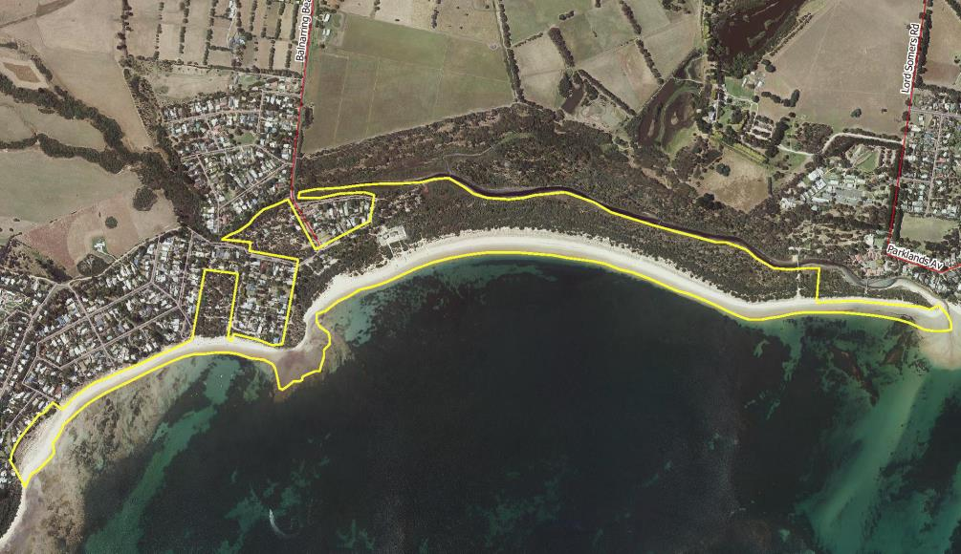

Figure 2: Aerial photography of Balnarring Beach Foreshore and Parks Reserve

* 1. Climate

The area has a coastal, temperate climate with warm, moist summers and cool, wet winters. Average yearly rainfall is 800mm; the wettest months are May to October, with the driest months occurring in January and February.

* 1. Geology and soil types

The geology of the Reserve area includes siliceous sands with sandy beaches. The coastal dune systems here extend from Sandy Point to Flinders. Inter-tidal reefs occur just offshore and consist of ferruginous sandstone, which are exposed at low tide.

It is believed that Western Port formed only 10 000 years ago. Recent evidence suggests that the Merricks Creek entered the bay in front of the Somers General Store only 65 years ago. This formed an extended spit of consolidated dunes parallel with the current shoreline. Currently, this spit extends from the western end of Somers through to Balnarring Beach providing considerable protection to the coast. This enables substantial vegetation communities to develop.

* 1. Vegetation

There is little information available on the original vegetation communities present at Balnarring Beach. The Ecological Vegetation Classes (EVC) prior to 1750 (as identified by DELWP) includes a strip of Coastal Banksia Woodland alongside Western Port, Swampy Riparian Woodland along Merricks Creek, and Grassy Woodland behind the Coastal Banksia Woodland on the south side of the creek. Swamp Scrub/Wet Heathland Mosaic occurs on the north side of the creek behind the Coastal Banksia Woodland, but is not within the boundaries of the Reserve.

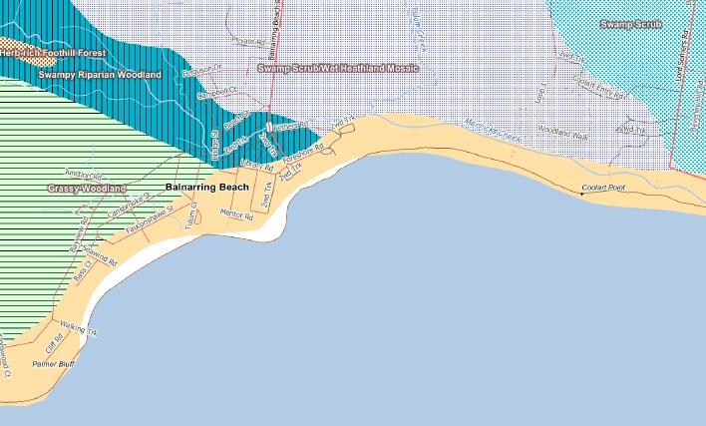

Figure 3: Pre-1750s EVCs within the Reserve.

Although much of the pre-1750 vegetation has been removed, the remnant indigenous vegetation of the Reserve is an essential part of the landscape image of Balnarring Beach.

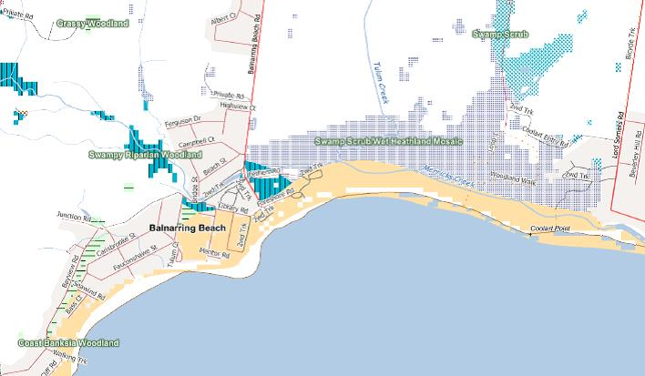

Figure 4: Existing EVCs within the Reserve.

Remnant vegetation from all three Ecological Vegetation Classes exists within the Reserve. Below is a summary of each of the communities present, as per DELWP vegetation mapping:

Coastal Banksia Woodland (EVC 2)

Noted as being high significance as this community is vulnerable within the Gippsland Plains Bioregion. This community is present along the supra-littoral zone above the beach along the entire shoreline. It is dominated by an overstorey of coastal banksia and a middle storey of the tall shrub coast tea-tree*.* Scramblers such as bower spinach (*Tetragonia implexicoma*)are common in the understorey with a groundcover of grasses, herbs and sedges.

Grassy Woodland (EVC 175)

Noted as being very high significance as this community is endangered in the Gippsland Plains Bioregion. A very small patch of this community exists within the Reserve adjacent to Fauconshawe Street. This EVC is described as being a variable open eucalypt woodland to 15 m tall over a diverse ground layer of grasses and herbs. The shrub component is usually sparse.

Swampy Riparian Woodland (EVC 83)

This community is endangered in the Gippsland Plains Bioregion and is therefore of very high significance. Small patches of this EVC exist within the Reserve adjacent to Merricks Creek. Swampy riparian woodland generally occupies low energy streams of the foothills and plains and at Balnarring Foreshore there is an overstorey of swamp paperbark (*Malaleuca ericifolia*)to 5 m tall. The lower strata are dominated by a range of large and medium shrub species including many *Acacia*s on the stream levees in combination with large tussock grasses and sedges in the ground layer. While the Reserve contains many species from this EVC, noticeably absent species are swamp gum (*Eucalyptus ovata*)and narrow-leaved peppermint (*Eucalyptus radiata*).

In addition to DELWP’s vegetation mapping, the following EVCs have been identified by a flora and fauna assessment of lower Merricks Creek, commissioned by Melbourne Water and carried out in 2010 by Jeff Yugovic for Biosis Research.

Coastal Dune Scrub (EVC 160)

Closed scrub to 5 metres tall occurring on secondary dunes along the ocean and bay beaches and lake shores. Occupies siliceous and calcareous sands that are subject to high levels of saltspray and continuous disturbance from onshore winds.

Coastal Saltmarsh (EVC 009)

Occurs on and immediately above marine and estuarine tidal flats and contains distinct floristic communities as bands or zones in the same location, depending on the positioning of the various floristic communities in relation to the saline environment. Consists of a large range of life forms including succulent herbs, low succulent shrubs, rushes and sedges.

Estuarine Wetland (EVC 010)

Grows on anaerobic peat-rich muds on the edges of estuarine water bodies such as creeks, rivers and lagoons with intermediate salinity conditions. Vegetation is determined by fluctuating salinity, which varies in time from occasionally fresh to brackish or occasionally saline according to river flood and marine tidal events. Dominated by graminoids and halophytic herbs and often fringed by a tall scrub layer of swamp paperbark at the landward edge.

Estuarine Reedbed (EVC 952)

Reedbed with a sparse herbaceous ground-layer of salt-tolerant herbs. Occurs in sub-saline situations of coastal estuaries that are sometimes periodically blocked by sand bars. The habitat is subject to surface salinity as well as flushing by freshwater, including via ground-water, but is beyond direct inundation from normal tidal inputs. Distinguished from estuarine wetland by the vigour and total dominance of the reeds, as well as the absence of samphires in the ground layer.

Estuarine Flats Grassland (EVC 914)

Closed to open grassland to 1.5 metres tall with occasional shrubs occurring on estuarine flats often associated with current or old beach berms or sand sheets that are occasionally inundated by high tides. Occupies areas on marginally higher ground inland from coastal saltmarsh.

Swamp Scrub (EVC 053) & Estuarine Scrub (EVC 953)

Closed scrub to 6 metres tall growing on the edge of estuarine water bodies such as creeks, rivers and lagoons with intermediate salinity and poor drainage conditions. Dominated by swamp paperbark with a halophytic ground layer dominated by graminoids and herbs. Often occurs in close association with estuarine wetland.

Tall Marsh (EVC 821)

Occurs on quaternary sedimentary geology of mainly estuarine sands, soils are peaty, silty clays, and average annual rainfall is approximately 600mm. It requires shallow water (to 1m deep) and low current-scour, and can only tolerate very low levels of salinity. Close to open grassland/sedgeland to 2-3 metres tall, dominated by common reed (*Phragmites australis*) and Cumbungi (*Typha domingensis*). Small aquatic and semi-aquatic species occur amongst the reeds.

Along with the above mentioned EVCs, in 2011 white mangrove (*Avicennia marina var. australasica*) seedlings began appearing along the banks of Merricks Creek. This is a natural occurrence and most likely due to the creek mouth remaining open for a considerable time, allowing the tide to push mangrove seeds up the creek. Since then, several hundred plants have begun to establish. The existing presence of coastal saltmarsh suggests that the conditions are suitable for mangroves. This has added another EVC to the Reserve.

Mangrove Shrubland (EVC 140)

Shrubland to two metres tall. Confined to protected low energy coastal environments where there is sufficient shelter from strong wave action and currents to allow the accumulation of fine sediments, generally on mud flats within the tidal zone.

A table showing indigenous plant species found within the Reserve is provided in Appendix 4.

Invasive plant species

Invasive plants and animals threaten native biodiversity because of their ability to change and destroy habitats and ecosystems. They are the number one cause of native animal extinctions in Australia, the second biggest threat to river and stream areas and nationally important wetlands and the third biggest threat to threatened ecosystems.

Past projects undertaken by the Committee have resulted in a reduction in pest plant species such as blackberry (*Rubus fruticosus*) and blue periwinkle (*Vinca major*). These projects have provided opportunities for the natural regeneration of indigenous species, with infill plantings happening where natural regeneration did not occur.

A table showing the invasive plant species within the Reserve is provided in Appendix 5

* 1. Local fauna

The Reserve contains a number of native fauna which rely on the surrounding indigenous vegetation for shelter and food. The most well-known of these species is the koala (*Phascolarctos cinereus*) which feeds on the coastal manna gum (*Eucalyptus pryoriana*) trees scattered throughout the Reserve. Swamp wallabies (*Wallabia bicolor*), short-beaked echidna (*Tachyglossus aculeatus*) and agile antechinus (*Antechinus agilis*) also inhabit the Reserve, specifically in the area known as the Spit. The Reserve is home to a number of ground-dwelling species including swamp rats (*Rattus lutreolus*), snakes and lizards. The Reserve also hosts resting Australian fur seals (*Arctocephalus pusillus*). Little penguins (*Eudyptula minor*) and pods of dolphins are often seen in Western Port. The Reserve’s status as part of the Ramsar site, known as Western Port Ramsar site, also means the Reserve attracts a number of migratory bird species.

There is no recent comprehensive fauna survey for the Reserve. A flora and fauna survey conducted at the adjoining Somers Foreshore Reserve in 2000 has been used to provide an indication of the types of fauna likely to be present within the Reserve. A list of indigenous fauna likely to be found within the Reserve can be found in Appendix 6.

**Pest animal species**

Invasive animals can pose a serious threat to biodiversity and primary production. They contribute to the loss of native animals and can significantly disturb native vegetation, encouraging the spread of weeds.   
  
The *Catchment and Land Protection Act 1994* declares certain species to be established pest animals in Victoria. These include foxes (*Vulpes vulpes*), European rabbits (*Oryctolagus cuniculus*), feral pigs (*Sus scrofa*), feral goats (*Capra hircus*) and wild dogs (*Canis familiaris*). The Reserve contains known populations of rabbits and foxes and, due to their large range, eradication of these species is difficult. Effective control must be undertaken at the landscape scale in collaboration with surrounding landowners, including privately owned farmland.

* 1. Cultural heritage

**Indigenous cultural heritage values**

Throughout Victoria, the landscape holds the imprint of thousands of generations of Aboriginal people. Each part of Victoria, from the coast to the high country and from the semi-arid Mallee to the rain forests of the east, has places where Aboriginal people lived; obtaining sustenance, expressing themselves artistically, passing on creation stories and cultural values, engaging in conflict, establishing alliances and social networks, trading goods, celebrating rites of passage and committing the departed to their final resting places.

Prior to European settlement, the Mornington Peninsula was occupied by the people of the Bun wurrung (also Bunurong, Boon wurrung and various other spellings) language group. Their traditional land extended from Werribee River in the northwest down to Wilson’s Promontory in the southeast, including the catchments of Carrum Swamp, Western Port Bay and Tarwin River. Indications of their presence are reflected in place names – in particular Tulum (a former name given to the beach area) and to the location of middens (recorded by Europeans in earlier days).

The endurance of Aboriginal society across the continent is of global significance and the cultural heritage places and objects associated with that society are a significant part of the heritage of all Australians. More importantly, they are a fundamental part of Victorian Aboriginal community life and cultural identity.

Sites of Aboriginal significance include water bodies, coastal locations and mountains. Balnarring Beach may contain areas of cultural significance to Aboriginal people as it contains Merricks Creek and the beach fronting Western Port. These areas may have been used as campsites or hunting grounds by Aboriginal people.

Underpinning these material aspects of Aboriginal cultural heritage are intangible places where there may be no physical evidence of past cultural activities. These include places of spiritual or ceremonial significance, places where traditional plant or mineral resources occur, or trade and travel routes. Information about such places may be passed down from one generation to the next or may survive in nineteenth century documents and records.

**European cultural heritage.**

From 1840, Balnarring Beach was part of the Colourt (Coolart) run. Much of this run was released for selection about 1860 with certain areas being retained by the Crown for specific purposes. Early maps show a planned township on the coast. The beach area was public reserve and a “Water Reserve” is marked at a point where there is a spring in the creek. It is said that settlers brought barrels to the spring to fill them with fresh water. Balnarring Beach first appears as a gazetted town in 1886 but few lots were initially taken up. A few shacks were put up but tents were commonly used on these blocks.

The sale of lots was again promoted during the early 1920s with the ‘Tulum Township subdivision offering 72 blocks for £3 deposit, £1 per month’. The houses that were erected were simple holiday homes. Some of these buildings were leased out as holiday places. Very few were solid constructions of brick or cement block. One exception was Yamba in Foreshore Road which was built in 1924 and was let out. Another was the home built by Dr O. S. Woods in 1926. A veterinarian, he had bought the grazing property that covered the area behind Balnarring Beach back to Balnarring. He built his homestead plus an adjoining cottage on the hill overlooking the bay close to Palmers Bluff.

Since the earliest days when the beach was made accessible to the public, Balnarring’s beach had been a popular recreation spot. Many local families enjoyed a break by the sea and many groups from the growing Balnarring community held an annual beach picnic. Others came greater distances. Towards the end of World War I the Balnarring Progress Association organised, with the Red Cross, a picnic for repatriated soldiers. The foreshore area was also a popular place for camping. The Balnarring Progress Association had been increasingly alarmed at the destruction of trees along the foreshore and the lack of sanitary arrangements for some years and in 1914, formed a committee which would evolve into the Balnarring Beach Foreshore Committee. By 1919 it was reported that over 200 campers had come from ‘all over the metropolis”. A permanent reserve and separate camping grounds were defined over the following years.

* 1. Current use of the Reserve

Local residents, day-trippers, and overnight campers visit the Reserve. Balnarring Beach is a well-known family friendly beach, with its shallow, sheltered waters.

The Reserve has three campgrounds with a total of 141 campsites. These campgrounds are heavily used, especially during the warmer summer months.

Community feedback undertaken in the preparation of this plan identified that the areas of the Reserve most heavily used are the areas east and west of the yacht club, with the area west of the yacht club being slightly more popular. The following activities have been identified as being undertaken on the Reserve.

**Land-based recreation:** Walking, dog walking, camping, passive recreational activities, bird watching, enjoying the views.

Balnarring Beach is also used for horse exercising (via a permit for each horse issued by the Committee). Horse owners with a permit are entitled to exercise their horse/s to the east of the yacht club below the high water mark between 5am and 9am.

**Water-based recreation:** Swimming, fishing, boating, kayaking/canoeing, kite-surfing.

1. Future directions
   1. Vision for the Reserve

*A self-sustaining Reserve in near-natural condition which meets the growing recreational and environmental needs of the community in a cost-effective manner.*

To achieve the vision, the Committee aims to:

* Protect, improve, identify and interpret the flora and fauna values of the Reserve.
* Identify, protect and where appropriate, interpret Aboriginal and European cultural heritage sites.
* Improve the quality of recreational experiences and passive enjoyment of the Reserve.
* Promote the enjoyment and sustainable use of the Reserve.
* Improve the conditions and overall landscape character and amenity of the Reserve to promote care and respect for its environmental and cultural values. This includes the protection and improvement of key landscapes and public vistas, including towards Western Port.
* Encourage a sense of shared ownership and custodianship for the Reserve among the local and wider community by pursuing greater community participation in planning and management activities.
* Increase awareness, understanding and appreciation of the Reserve’s natural and cultural values among the local and wider community.
  1. Community consultation

As part of the preparation of the management plan, the community were given an opportunity to provide input towards this plan and to raise any issues with the current management of the Reserve. A number of issues were raised. These include:

* A dog off-lead area – there was equal community support for providing a dog off-lead area and continuing the current regulations of allowing dogs on-lead on the foreshore at certain times of day, and no dogs on the beach outside these times.
* Horses on the beach – there was generally support for the horse owners to be able to use the beach, however, there were some concerns regarding the impact of the horses, and getting horses off the beach earlier in summer.
* Natural environment – there were many comments regarding the amount of weeds in the Reserve and ensuring that revegetation was undertaken with indigenous species.
* Water sports – there were a number of comments received regarding the use of Western Port, however, these are beyond the scope of this management plan and cannot be addressed.
* Development – a number of respondents were concerned with the amount of private development in Balnarring Beach, however, the scope of this management plan is for the Reserve only. Therefore issues with residential development cannot be addressed in this management plan.
* Path through the spit – during the community consultation the pathway strategy was overall well received; however, concerns were raised about this pathway through the natural habitat of the spit. The Committee is undertaking specific actions and consultation for this pathway, as detailed in the strategy, to alleviate these concerns.

General management – the views expressed indicate that the majority of residents are content with the current management of the Reserve. Some of the comments received include enforcing the Reserve’s regulations, maintaining the village feel of the community, providing more information on the Committee and upgrading the toilet facilities.

* 1. Regional connectivity

Regional connectivity has been identified as a future goal worthy of pursuing. Balnarring Foreshore is just one of seven foreshore reserves that lie on the Western Port coastline between the relatively large parcels of remnant vegetation of Mornington Peninsula National Park and the Cerberus naval base. The other foreshore reserves managed by appointed committees of management are Somers, Merricks, Point Leo and Shoreham; Flinders foreshore is split in to two management parcels, one managed by Mornington Peninsula Shire Council and the other by Parks Victoria, with the friends of Flinders Group actively involved in the on ground environmental works. There has been cooperation between all foreshore groups in past grant applications and a more formal agreement is to be sought. Capitalising on the opportunity for a biolink will ensure the connectivity of environmentally important coastal reserves and make future large scale grant applications more feasible.

The objectives of this future direction are to establish a memorandum of understanding, gather relevant environmental baseline data and work in cooperation via grant applications and resource sharing, while respecting each individual group’s independence in managing their own reserve.

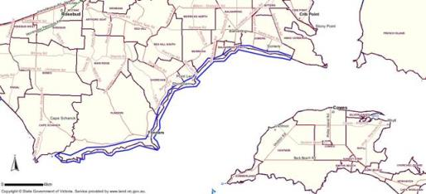

Figure 5: The identified biolink (marked in blue).

* 1. Camping

The Reserve contains three camping grounds which are generally open from 1 September to the Queen’s birthday long weekend. Allowing camping within the Reserve provides the Committee with revenue to continue improving the quality of the land into the future.

The three campgrounds have a total of 141 campsites with 65 powered sites. Each camp ground contains an amenities block with laundromat. The condition of the amenities blocks varies throughout the campgrounds, discussed in detail in Section 5.

The camp grounds contain scattered remnant vegetation which provides valuable shade and shelter during the hot summer months. There are also areas of high quality remnant vegetation which provide valuable habitat and food sources to native fauna. The camp grounds will be managed and maintained primarily as natural features reserves with camping provided in strategic locations. The trees within the campgrounds are regularly assessed by a qualified arborist for safety, and regular maintenance work is undertaken to ensure the safety of the public and campers. As well as general maintenance work, the campgrounds will be progressively revegetated with indigenous species in appropriate locations.

The campgrounds also contain access roads and pathways which provide vehicular access to the individual campsites. These tracks are maintained for public safety and functionality.

The key issue for the campgrounds is the condition of the amenities blocks which are estimated to have been constructed in the 1960s. The amenities blocks are considered structurally sound and can be used by the public; however, they are showing signs of wear and tear. The amenities block showing the most wear is in Camping Reserve A and this will be prioritised for replacement over the next 2 years. The remaining amenities blocks are scheduled to be replaced over the next 10 years, depending on funding from external sources.

The drought experienced over the last 10 years has impacted the condition of the grounds in Camping Reserve C. To ensure the campground was not irreversibly damaged, the Committee has previously closed the campground for longer periods of time to allow the grounds to recover between camping seasons. Although the drought has now broken, all the campgrounds will be closely monitored to ensure that camping does not have detrimental impacts on the natural environment. To ensure the environment can recover from long periods of camping, all campgrounds will be closed for at least two consecutive months of the year and all caravans will be removed from site during this time. This will allow the ground to rest and regenerate.

The committee will investigate options to improve facilities and services within the campgrounds during the life of this plan. Facilities may include additional powered sites, camp kitchen, camper’s lounge and onsite accommodation. Considerations shall include the appropriateness, demand for, number and locations of facilities and their contribution to the sustainable management of the Reserve.

* 1. Recreation

The Reserve provides for a range of recreational activities that are listed in Section 2.7. To support these activities, there are a number of walking tracks, street furniture and areas of sandy beach. In general, the Reserve is available for the public to use for passive recreational pursuits such as walking, on-lead dog walking (summer time restrictions apply to dogs on the beach) and bird watching. These activities are authorised under the Reserve regulations.

To facilitate the use of the Reserve for passive recreational pursuits, the Committee will maintain and improve the paths and surrounding vegetation for public safety and functionality. (This includes employing a qualified professional to assess the health and safety of the trees within the Reserve and undertaking any work within the recommended timeframe.) The Committee will also maintain the surface of pedestrian and vehicular tracks and the functionality of street furniture.

Where an activity will have a larger impact on the Reserve than passive recreation, or where a large group of people will occupy an area of the foreshore, the Committee can issue permits for these uses. All permits issued by the Committee have conditions on how and when the land can be used for that purpose and these are monitored closely by the Ranger and staff. Occasionally there are issues with permit holders not adhering to the conditions of the permit, such as horse-riders riding above the high tide mark which can have adverse impacts on the surrounding natural environment. To ensure the environment is not adversely impacted by permit holders, regular patrols of the Reserve are undertaken and permit conditions closely monitored.

* 1. Access

The Reserve contains two formal car parks that provide parking and pedestrian access to the foreshore. These are located at the Westernport Yacht Club and near the rotunda at the end of Balnarring Beach Road. These car parks are informal gravel car parks which are heavily used and are impacted by severe weather.

There is high demand for the car park at the Westernport Yacht Club during the summer months as it is also used as overflow car parking by campers who bring a second car or boat trailer that cannot be accommodated within the campgrounds. To reduce the demand in this area, campers will be advised of the limited car parking when booking campsites and that two cars per campsite is not recommended.

Due to the high demand car parking and limited spaces available, the Committee will investigate increasing the number of car parking spaces within the Reserve over the next 2 years.

The car park at the end of Balnarring Beach Road is used by the general public and horse floats to access the beach throughout the year. It is common that the car park contains a number of potholes during winter after heavy rains. This car park also has drainage issues, and becomes boggy after heavy rain.

The car parks require regular grading and the addition of gravel to even out the surface. This is done regularly by the Committee with the assistance of Mornington Peninsula Shire Council. The main issue with the regrading of the car parks is that it cannot be done during wet weather when the surface is at its worst. Repairing the surface during wet weather does not allow new gravel to properly settle and compress and it quickly becomes dislodged creating potholes. To ensure that any repair is lasting, it must be done during periods of dry weather. This allows the gravel to be securely compacted into place and less likely to become dislodged creating potholes.

Access to the beach and walking tracks are regularly cleared and maintained by Committee staff by cutting back vegetation to enable clear passage and removing fallen trees.

The Reserve contains a number of different types of paths, these existing pathways have developed over time with little thought or planning. Appendix 7 provides a map of existing pathways.

The main issues with existing pathways are the lack of linkage, lack of opportunity for access for people with limited mobility, informal pathways which may exacerbate erosion, condition and alignment of the formal tracks, poorly located and maintained seating, and difficulty of access for maintenance of the Reserve.

The Committee has prepared a *Balnarring Foreshore Pathways Strategy,* Appendix 7, to address these issues. They propose to install new pathways, and upgrade existing pathways in the reserve to allow access for people with limited mobility, and to integrate and link existing pathways to improve recreational opportunities and natural area management.

* 1. Vegetation management

The Australian coastline is a dynamic, ever-changing environment which is subject to continuous sand movement causing both erosion and accretion of the coastline in different locations and at different times of the year. During periods of erosion, the primary and secondary dune systems are gradually washed away taking with them any coastal vegetation. Initially, the primary dune vegetation disappears, followed by the coast tea tree and coast wattle (*Acacia sophorae*) scrubs, exposing the taller coastal banksia forest to the strong salt-laden winds. The shrubs and tall trees, if not uprooted and washed away, inevitably die from the sudden exposure, and thus previously sheltered inner vegetation communities become more vulnerable. Forest species, such as the coastal manna gum, which once would have formed a narrow swathe throughout the coastal banksia woodland, also struggle to survive.

The main area of erosion within the Reserve is located near Hansens Lane. This area has been eroding at a steady pace over the last 10 years and now contains a small strip of coastal land between the adjoining private property and Western Port. The area contains a rock wall to act as a barrier to the erosive nature of the sea which protects the pedestrian access path and the strip of coastal Crown land between Western Port and the adjoining private property. The rock wall was repaired in September 2012 and will continue to provide a protective barrier to the Reserve.

The Reserve is also accreting in some areas with the main area being near Seawind Road where the Reserve adjoins Merricks Foreshore Reserve. The Reserve in this section has accreted between 20 and 50m over the last 10 years and now contains an area of sandy beach between 60m and 90m in width. This area will be allowed to naturally regenerate into the future and is discussed further in Section 5.2.

The vegetation within the Reserve is generally in good condition. There are representative species from all the historical EVCs and the remnant vegetation is used to determine the most appropriate species to be used in revegetation. The Committee regularly harvests seed from the Reserve to propagate within the nursery. The aim of this is to revegetate the Reserve with species from the immediate area.

The biggest threat to the indigenous vegetation in the Reserve is the presence of weed species. These are regularly treated by various methods. The methods used and the time of year the weeds are treated is dependent on the species of weed and weather conditions.

The introduction of weeds to the Reserve has been occurring since settlement in the area first began. One of the original causes of weed introduction to the Reserve was from species planted in the adjoining private residences. This continues to this day where garden escapees are found throughout the Reserve, generally in close proximity to the boundary with private property. Although the Committee has no responsibility for the management of the adjoining private land, the Foreshore Manager continuously works with local residents to educate them on the benefits of indigenous vegetation, and even supplies them with indigenous plants from the Committee’s nursery.

The Committee aims to gradually remove the majority of invasive weed species within the Reserve over the next 3 years. Due to the amount of weeds species within the Reserve, the cost associated with weed treatment cannot be met by the Committee alone and the weed treatment is dependent on the Committee being successful in grant applications. The Committee will continue to apply for grants throughout the year, specifically to manage weeds within the area known as the spit. The Ranger, staff and volunteers will also continue to treat the smaller infestations of weed species throughout the Reserve as resources and weather permits.

Another threat to the coastal vegetation in this area is vegetation vandalism. This can be seen along the foreshore as branches trimmed to a height which aligns with the window height of the adjoining houses or as vegetation which has been removed and dumped on the Reserve. The removal of this vegetation may increase erosion in some areas, reduce the amenity value of the foreshore and increase wind speed causing damage to infrastructure and vegetation further inland. The Foreshore Manager regularly patrols the Reserve and takes note of vegetation along the coast to ensure that any change in vegetation density or height is noticed and action taken. Wherever relevant, the Committee will enlist the assistance of DELWP Compliance Officers to investigate prosecution of offenders.

The Reserve also contains a number of informal tracks which have been created over the years by Reserve users. These tracks can be located through sensitive coastal environments and can also be unsafe. Some of these tracks may require closure over the coming years to protect the safety of the public and the surrounding coastal vegetation.

* 1. Local fauna management

The biggest threats to the indigenous fauna of the area are the removal of indigenous vegetation, predation by foxes, dogs off lead and the fragmentation of habitat areas caused by adjoining residential developments and fencing which restricts access between habitat areas.

The removal of vegetation from the foreshore removes valuable habitat and feeding grounds for indigenous fauna. Maintaining coastal vegetation and revegetating with indigenous species, specifically large trees with hollows and low growing grasses which provide protection for ground-dwelling fauna should ensure the survival of the highly valued local animals. Ensuring the continuation of the indigenous vegetation into the future will also reduce the incidences of indigenous fauna invading private property in the search for food and shelter.

The Reserve is also home to a number of pest animal species such as rabbits and foxes. The foxes are known predators of indigenous fauna such as antechinus and native rats. Rabbits are also an issue within the Reserve as they compete for the same food sources as indigenous fauna. The high population density of rabbits within small areas is outcompeting indigenous fauna for food causing the gradual decline of the indigenous species.

The Committee has focussed on the control of pest animals within the Reserve over the last 3 years. The results have been encouraging, with a fox-baiting program on the Reserve being highly successful. The issue of control within a distinct area is a difficult one. Foxes and rabbits have a large habitat range, which means they travel large distances for food, generally radiating from a single point containing a den/shelter. When attempting to control foxes and rabbits from a small area, such as the Reserve, it is essential that the surrounding properties be included in any baiting program. This ensures that the surrounding pest animals are also controlled. Although it may not be possible to completely eradicate these species from the Reserve, the Committee will continue to undertake pest animal control in partnership with the surrounding land owners to minimise the impact these species have on indigenous fauna. The recent sightings of agile antechinus, the first in over a decade, have been attributed to the pest animal control works.

Domestic animals are also considered a threat to indigenous fauna, specifically cats and dogs. Cats are known predators of indigenous species, especially birds. Research shows that domestic cats can kill on average 54 small native species per year. By law, cats must be contained within private property limits, and penalties apply for allowing cats to roam outside the property boundary of the registered owner.

Domestic dogs can damage the sensitive coastal environment by trampling smaller plants and digging up root systems. Dogs are also a threat to indigenous fauna as they predate on smaller animals, frighten larger animals by chasing and barking, and leaving their scent which is known to reduce the reproduction rate in indigenous fauna, especially beach nesting birds and ground dwelling mammals. The Committee acknowledges the benefit of providing a dog on-lead area within the Reserve to allow dog owners to ensure their pets are getting sufficient exercise. For this reason, the Committee allows Reserve users to walk their dogs; however, dogs must always be on a lead and are only permitted on the Reserve during certain times of the day. Dogs are not permitted on the beach between 9 am and 7 pm from the 31st October to the 31st March.

Allowing dogs off-lead within the Reserve has been a contentious issue throughout the community in recent times. The public consultation undertaken as part of the preparation of the management plan identified that there was equal support for providing a dog-off lead area as there was for not allowing dogs on the Reserve.

The justification for not allowing dogs off lead within the Reserve is due to the environmental damage they can cause. The Reserve is home to a number of indigenous fauna species that are extremely sensitive to the scent of potential predators. Research has shown that where dogs are allowed off-lead, the birth rate of many indigenous fauna reduces significantly. Dogs off-lead are also more likely to trample through sensitive sand dunes and areas of coastal vegetation.

The Committee considered allocating an area of the Reserve as an off-lead dog walking area following the response from the community. Among the issues considered by the Committee was the safety of the public, the health of foreshore vegetation and the impact to indigenous fauna. The results of the investigation by the Committee was that the negative impact of allowing dogs off-lead on the safety of the public and the natural environment outweighed any benefits provided to individual dog owners. For this reason, off-lead dog walking will not be provided on the Reserve.

The Committee will, however, integrate dog friendly zones onto walk trail maps to identify areas suitable for on-leash and nearby off leash areas for exercising of dogs. And also take an accommodating approach to responsible dog owners exercising their dogs on leash in the summer months.

To ensure the community understands the reasoning behind this decision, the Committee and staff will continue to patrol the beaches and provide information to local residents about the impact of domestic animals on the Reserve. Trailheads will have clear regulatory signs, easy access to the beach along major pathways, and dog bag in dispensers at key access points will be provided to dog owners to educate and improve their experience of the Reserve.

The Committee will also continue to revegetate the Reserve with indigenous species and undertake regular weed control to improve the overall health of the Reserve and increase the habitat and food supply to native fauna.

* 1. Fire Management

The fire risk within the Reserve is considered to be low. The threat of fire in any location is assessed based on a number of factors such as the presence of fuel breaks, the fuel hazard rating and specific site characteristics.

The Reserve contains a number of fuel breaks and fuel reduced zones in the form of tracks, paths and mown areas. The overall fuel hazard level throughout the Reserve is considered low. There are areas within the Reserve that are considered to contain a high fuel hazard level, however, these areas are generally small in size and are surrounded by areas of low fuel hazard rating. The Reserve characteristics also contribute to the low fire risk. These include the narrowness of the Reserve, the south facing aspect, the presence of storm water outlets and the predominant south to south westerly winds.

Factors that may increase the risk of fire during the fire danger period include the build up of fine fuels, vegetation growing over the paths and large populations of weed species.

To ensure a reduced risk of fire within the Reserve the Committee will:

* Ensure all roads and walking tracks are clear and free from debris during the fire danger period.
* Continue to strategically manage and remove weed species from the Reserve and revegetate with suitable indigenous species.
* Ensure all locks and access gates are fully operational and that individuals who need access in an emergency are able to access them.
* Ensure suitable water supply for CFA requirements in each Camping Reserve over the next 5 years.

As part of the registration for a camping reserve, the Committee must prepare a fire management plan and submit it to the CFA for approval every two years. The most recent plan was approved in 2012.

* 1. Education and Interpretation

Signage is currently used on the Reserve for notification of regulations, for wildlife protection, to identify risks, to identify conservation works and for the interpretation of natural and cultural values. Much of the current signage is in a poor state of repair, poor quality (content and construction) and poorly located.

The careful consideration of signage is important. Signs may impact on the visual amenity and detract from natural and scenic values. Overuse of signs may also reduce their effectiveness as the public become ‘blinded by signs’. Well-designed interpretation can improve peoples’ appreciation and understanding of an area’s natural and cultural values. The improved awareness leads to better compliance with regulation and develops a deeper conservation ethos within the community.

The Committee will develop an interpretation plan to develop messaging that will be consistent across the Reserve. Signs will also be included in the regular asset inspection report and damaged, illegible and inappropriate signs will be removed from the Reserve. Further actions can be found in Appendix 7.

3.11 Balnarring Foreshore Pathways Strategy

The Committee has a strategy that incorporates the directions for access and education in the Reserve. This strategy has been developed to provide a planned framework for the development and management of pathways throughout the Reserve. It responds to demand for recreational walking opportunities to meet the needs of residents and visitors alike, over the next five years.

The strategy recognises the significant health and social benefits of regular physical activity, and that well planned recreational trails can protect natural areas from degradation through unmanaged access.

Below is a table that outlines the prioritised actions from this strategy for the next five years, which will be funded in a number of ways including budget allocations, grant funding, and philanthropy. The Committee is unable to predict the level of grant funding and philanthropic donations, thus the actions below are

prioritised based on urgency. See Appendix 7 for the full strategy.

| Priority | Action |
| --- | --- |
| 1 | Seek the advice of recognised experts in native flora and fauna prior to changing access through the Reserve. (2.1.1) |
| 2 | Remove old, duplicated and damaged signs from the Reserve. Replace with new durable regulatory signs with at trailheads.  (2.3.1, 2.3.2, 2.3.3, 2.3.4, 2.3.5, 2.4.1) |
| 3 | Create a pedestrian pathway on the western side of Balnarring Beach Rd from the Rangers Hut to Robertson Park. (2.2.1) |
| 4 | Accommodate responsible dog owners with dogs on leash in summer months. (2.4.2, 2.4.5) |
| 5 | Exclude dogs from the camping grounds and other environmentally significant areas of the Reserve including minor paths within the Bird Sanctuary and Habitat zone. (2.4.3) |
| 6 | Create a map in conjunction with Parks Victoria to promote walking opportunities and dog friendly areas. (2.3.8, 2.4.7) |
| 7 | Develop an interpretation plan that will engender a better appreciation and understanding of the Reserve’s natural and cultural heritage. (2.1.2, 2.1.2) |
| 8 | Create a boardwalk and seating above the rocks on Balnarring Point to arrest erosion. (2.2.2, 2.2.3, 2.2.7) |
| 9 | Extend the boardwalk in stages towards the main car park as funding permits. |
| 10 | Create a linkage to the Coolart walking trails by extending the track from C reserve to the Coolart Bridge along the original Spit track. (2.2.5, 2.2.6, 2.4.4, 2.4.6) |

1. Management Zones

The study area has been divided into many different zones that have been defined by common management aims. This section describes existing conditions and actions for each of the zones in the study area.

As well as the specific tasks within each of the management zones, the Committee employs staff to undertake the day to day activities throughout the year. These include maintenance tasks such as cutting the grass, maintaining vegetation, seed collection and propagation, cleaning the amenities, weed removal and revegetation.

Staff also have a role in community consultation and education and regularly patrol the beach, host working bees, liaise with the local community and visitors and host school groups on the Reserve. These activities aim to educate the public about the Reserve to ensure it is protected and enhanced for future generations.

There are also a number of administrative tasks that are undertaken by Committee staff. These include, manning the office, preparing an emergency management plan, preparing a monthly Ranger report to the committee, preparing a weed management plan annually, hiring contractors, preparing grant applications, administering grant funding and administering and monitoring the horse permits.

* 1. Zone 1: Restoration area

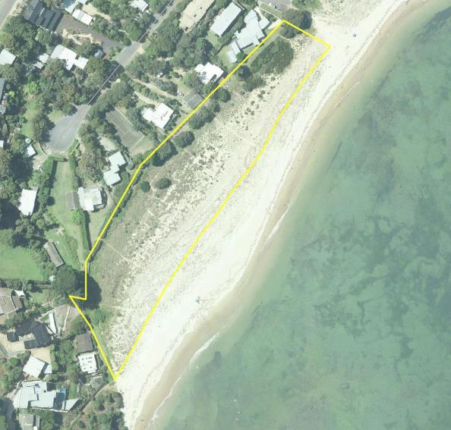

Figure 6: Zone 1 – Restoration Area

The restoration area is located at the western most section of the Reserve. This zone has been gradually accreting over time with natural regeneration of indigenous vegetation beginning to occur. The area is between 70m and 100m in width and approx. 260m in length. This zone provides informal pedestrian access to the adjoining residences and is not heavily used by the public.

There are a number of tea-trees along the boundary to private properties which are likely to expand naturally. This zone also contains a good cover of salt tolerant indigenous grasses. These grasses bind the sand and prevent erosion during high tides and extreme weather events.

This zone contains a number of weed species, including garden escapees. The major weeds in this area are sea spurge (*Euphorbia paraias*) and myrtle-leaf milkwort (*Polygala* *myrtifolia*).

To improve this zone, a healthy habitat area for local fauna will be created by removing invasive plant species and allowing the area to continue regenerating naturally. This zone provides an important habitat link between the adjoining Merricks Foreshore Reserve and Balnarring Beach.

|  |  |  |  |  |  |
| --- | --- | --- | --- | --- | --- |
| **No.** | **Action** | **Responsibility** | **When** | **Cost** | **Funding source** |
| 4.1.1 | Hand weeding on a regular basis | Committee staff | Annually Oct/Nov | N/A[1] | Committee |
| 4.1.2 | Allow the area to regenerate with indigenous vegetation | Committee staff | Ongoing | N/A | Committee |
| 4.1.3 | Plant indigenous vegetation where regeneration does not occur | Committee staff / volunteers | Annually Spring/ Autumn | N/A | Committee |

* 1. Zone 2: Beached areas

This zone contains the sandy beach areas between the high and low water marks throughout the entire Reserve. The zone contains a number of groynes, a non-functional jetty and provides access to Western Port from the yacht club. The area is an important breeding area for beach-nesting birds and provides a resting area for penguins and seals.

This area of the Reserve is utilised by horse permit holders for exercising horses. Horses are authorised to be between the high and low water marks between the hours of 5am and 9am every day. There are also a number of passive recreational pursuits such as walking, on-lead dog walking, bird watching and sunbathing.

To maintain this zone for its current use, it will be managed for recreation and to protect the safety of the public and indigenous fauna. The beach area will be patrolled regularly by Committee staff to inspect for public safety issues, including the non-functioning jetty, and breaches of the Reserve regulations or conditions of permits issued by the Committee. The Ranger will continue to educate the public both formally and informally.

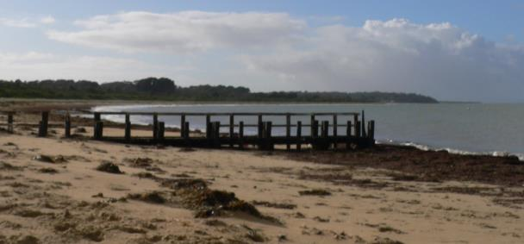

|  |  |  |  |  |  |
| --- | --- | --- | --- | --- | --- |
| **No.** | **Action** | **Responsibility** | **When** | **Cost** | **Funding source** |
| 4.2.1 | Educate the public about dog regulations within the Reserve. | Committee staff/ Committee members | Ongoing | N/A | Committee |
| 4.2.2 | Regularly patrol the Reserve and ensure beach users have dogs on leads at all times. | Committee staff | Ongoing | N/A | Committee |
| 4.2.3 | Regularly patrol and monitor the use of horse permits within the Reserve. | Committee staff/ Committee members | Ongoing | N/A | Committee |

Figure 7: Beach & jetty, looking east

* 1. Zone 3: Bird sanctuary

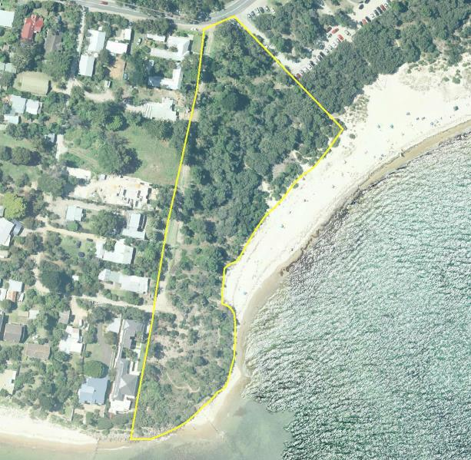

Figure 8: Zone 3 – Bird sanctuary

The bird sanctuary is an area providing habitat for indigenous fauna as it contains good coverage of indigenous vegetation. There are a number of informal tracks throughout this zone providing pedestrian access to Western Port and the remainder of the Reserve. This zone also contains a fire access track which provides access for emergency vehicles.

The south of this zone has been gradually eroding over time and there is now only a thin strip of coastal Crown land between the private residences and the waters of Western Port. To prevent further erosion, a seawall was constructed in this area a number of years ago. Due to further erosion issues, the seawall required minor repairs in 2012.

The dominant indigenous species in this area include coast tea-tree *and* coastal banksia.

There are a number of prominent weeds in this area such as myrtle-leaf milkwort, dolichos pea (*Dipogon lignosus*) and cape ivy (*Delairea odorata*). These weeds will be periodically treated to convert this area to a weed free zone. Weed removal will be undertaken annually in spring using both chemical and mechanical removal. To assist in the funding of contractors to undertake the work, grants will be applied for when possible. The Committee will also host regular working bees in this zone to ensure continued weed removal throughout the year.

It is also planned that the indigenous vegetation cover will be increased in this zone to increase the habitat value for indigenous fauna. The main method of increasing the vegetation cover will be to allow natural regeneration using the existing seed bank. Revegetation will be considered in some areas if required.

The existing fire track must remain available for emergency vehicles at all times throughout the year. The track is kept clear of debris and the grass is regularly mown. To ensure access for emergency vehicles, the use of the fire track for access to private property will not be authorised by the Committee.

|  |  |  |  |  |  |
| --- | --- | --- | --- | --- | --- |
| **No.** | **Action** | **Responsibility** | **When** | **Cost** | **Funding source** |
| 4.3.1 | Annual weed removal using both mechanical and chemical weed control. | Contractors | Annually in spring | $2,000/yr. | Grant |
| 4.3.2 | Revegetate with indigenous species when suitable. | Ranger/ volunteers | Annually Spring/ Autumn | N/A | Committee |
| 4.3.3 | Regularly patrol the fire access track to ensure it remains clear for emergency vehicles at all times. | Ranger | Ongoing | N/A | Committee |
| 4.3.4 | Host regular working bees in this area to continue hand weeding and revegetation with indigenous species. | Ranger/ Committee members/ volunteers | Ongoing | N/A | Committee |

* 1. Zone 4: Car park and rotunda

Aerial imagery of part of the reserve with Zone 4 - Car park and rotunda marked.

Figure 9: Zone 4 – Car park and rotunda

This zone provides an access point to the Reserve with car parking, a rotunda with a BBQ and public toilets. The car park is also the access point utilised by the horse floats when exercising horses on the beach.

The surface of the car park is generally in poor condition, which is exacerbated by heavy rain. The car park contains a number of potholes which pool with water over winter due to poor drainage of the car park surface. Mornington Peninsula Shire Council assists the Committee with the maintenance of the car park surface by grading the surface and providing additional gravel when possible. The Committee is currently investigating an upgrade of the car park surface to improve the drainage, reduce the impact of heavy vehicles and poor weather and potentially increase the number of car parking spaces. The Committee will require additional funding prior to any major works being undertaken.

The rotunda is in good condition and provides a place for families to enjoy and a meeting place for the Committee working bees held on a monthly basis. The public toilets are heavily used by the public, especially during the summer months and they have timed lights for public safety. The public toilets are cleaned regularly by Mornington Peninsula Shire Council.

The area is characterised by more formal plantings of indigenous vegetation which are planted as garden beds rather than natural bushland. This vegetation will be maintained by regular weeding and revegetation where appropriate. The main species in this zone are coast tea-tree and coast beard-heath (*Leucopogan parvifloris)*.

|  |  |  |  |  |  |
| --- | --- | --- | --- | --- | --- |
| **No.** | **Action** | **Responsibility** | **When** | **Cost** | **Funding source** |
| 4.4.1 | Hire contractors to spray weeds | Foreshore Manager | Annually in spring | $500 | Grant |
| 4.4.2 | Undertake regular hand weeding | Committee staff/ volunteers | Ongoing | N/A | Committee |
| 4.4.3 | Maintain the surface of the car park for public safety | Mornington Peninsula Shire | Ongoing | N/A | Council |

* 1. Zone 5: Habitat zone

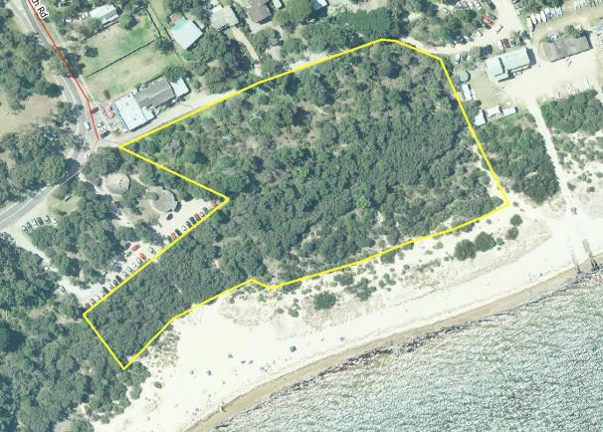

Figure 10: Zone 5 – Habitat zone

This zone contains good coverage of native vegetation and a number of informal walking tracks for passive recreation. The main indigenous species in this area include coast tea-tree and coastal banksia. There are a number of weed species present, such as blue periwinkle, cotoneaster (*Cotoneaster pannosus*) and agapanthus (*Agapanthus praecox* subspecies*. Orientalis*) which will be continually removed to create a healthy habitat area for native fauna. Recent weed control works and planting of indigenous species has seen the habitat values of this area greatly improve, with patches of native grasses self-seeding and spreading.

This zone adjoins Foreshore Road which provides vehicular access to the adjoining residences, the yacht club and the camping ground known as Camping Reserve C. Foreshore Road is maintained by Mornington Peninsula Shire Council as the road management authority.

To maintain the area for passive recreation, the Committee will undertake regular working bees in this area to remove weed species and revegetate with indigenous species.

|  |  |  |  |  |  |
| --- | --- | --- | --- | --- | --- |
| **No.** | **Action** | **Responsibility** | **When** | **Cost** | **Funding source** |
| 4.5.1 | Undertake regular mechanical weed removal. | Committee staff | Ongoing | N/A | Committee |
| 4.5.2 | Host working bees. | Committee staff | Ongoing | N/A | Committee |

* 1. Zone 6: Yacht club and adjoining car park

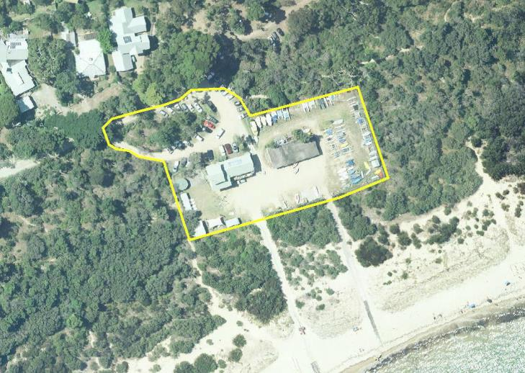

Figure 11: Zone 6 – Yacht club and adjoining car park

The Westernport Yacht Club and adjoining car park are located at the end of Foreshore Road. Westernport Yacht Club has a lease issued by the Committee to occupy the area containing the Yacht Club building and adjoining boat storage area. Westernport Yacht Club is responsible for maintaining the lease area to the satisfaction of the Committee.

To ensure that the yacht club grounds are being maintained in accordance with the requirements of the lease agreement, the Committee and the yacht club are required to meet regularly and discuss any issues or concerns. Currently, this does not occur on a regular basis and the Committee is working towards a better relationship with the yacht club into the future. The Committee will also provide regular updates to the yacht club on works within the Reserve and the date and location of working bees. The yacht club will also be invited to Committee meetings where appropriate.

The Committee is responsible for maintaining the surface of the car park and the surrounding vegetation. The vegetation in this area is minimal with a mixture of indigenous and introduced species. Mornington Peninsula Shire Council undertakes regular maintenance work on the surface of the car park including regrading and the addition of gravel.

The car park is in high demand over the summer months as it is used as overflow car parking for campers in the adjoining campground. The car park is also used for access to the yacht club and for casual users of the Reserve. The Committee will investigate upgrading the car park surface to improve circulation and increase the number of car parking spaces. In conjunction with this, the Committee will discourage campers from bringing additional vehicles over summer.

|  |  |  |  |  |  |
| --- | --- | --- | --- | --- | --- |
| **No.** | **Action** | **Responsibility** | **When** | **Cost** | **Funding source** |
| 4.6.1 | The Committee will host regular meetings with the yacht club | Committee members | Bi-annually | N/A | Committee |
| 4.6.2 | Maintain car park for functionality | Committee staff | Annually as needed | N/A | Committee |
| 4.6.3 | Hire contractors to undertake chemical weed control | Committee staff | 2014-5 in spring | $500/yr. | Grant |

* 1. Zone 7: The Spit

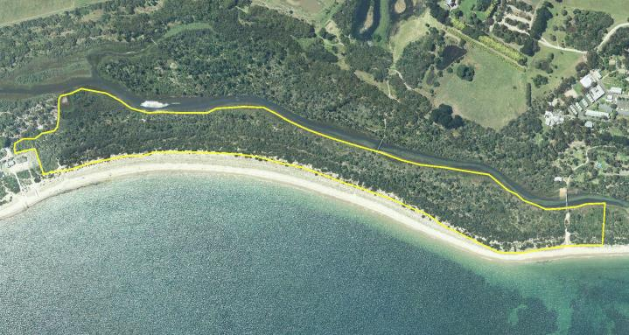

Figure 12: Zone 7 – The Spit

The Spit is water frontage land adjoining Merricks Creek and is not heavily used by the public. There are a number of informal walking tracks providing access to the beach and to Somers Camp via a pedestrian bridge.

The Committee considers this area as a conservation zone and restricts pedestrian use to the existing tracks only and the area is a dog-free zone.

The area known as the Spit contains the largest continuous area of native vegetation within the Reserve. This area is the main habitat area for native fauna and is considered to have the highest environment values within the Reserve. The area contains large populations of coastal banksia*,* Boobialla *(Myoporum insulare)* and coast tea-tree which provides habitat and food sources for native fauna.

Although in reasonable condition, there are a number of weed species present such as dolichos pea, myrtle-leaf pea and smilax (*Smilax sp.*). To maintain and enhance the area as a healthy habitat zone, the weeds will be chemically controlled and the area will be allowed to naturally regenerate and be revegetated when needed. The Committee also intends to undertake a formal survey of the area when funding is available.

There are a number of feral animals that use the area. Over the past three years, the committee has undertaken pest animal control on an annual basis and further follow-up work is required to prevent feral animals from recolonising the area.

|  |  |  |  |  |  |
| --- | --- | --- | --- | --- | --- |
| **No.** | **Action** | **Responsibility** | **When** | **Cost** | **Funding source** |
| 4.7.1 | Undertake chemical weed control | Contractor | 2013-4 | $15,000/yr. | Grant |
| 4.7.2 | Undertake a flora and fauna strategy including a detailed survey | Contractor | 2013/4 | $15,000 | Grant |

* 1. Zone 8: Fethers Road

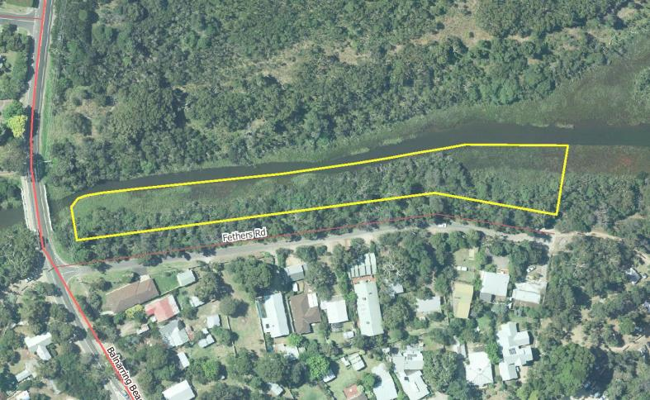

Figure 13: Zone 8 – Fethers Road

The Fethers Road zone is an area of native vegetation between Fethers Road and Merricks Creek. As this area is not accessible by the public, the vegetation is considered to be in good condition. The area is characterised by boobialla and coastal banksia*.*

There are a number of weed species present, such as blue periwinkle, dolichos pea, blackberry and smilax which will require chemical removal over the next three years. Recent weed control works funded by Melbourne Water grants have seen a large reduction of weeds and an increase in the habitat values in this area.

As the weeds are progressively removed, the area will be allowed to naturally regenerate from the existing seed bank. In locations where natural regeneration does not occur, the area will be revegetated with indigenous species.

|  |  |  |  |  |  |
| --- | --- | --- | --- | --- | --- |
| **No.** | **Action** | **Responsibility** | **When** | **Cost** | **Funding source** |
| 4.8.1 | Undertake chemical weed removal | Contractor | 2014 in spring | $2,200 | Grant |

* 1. Zone 9: Camping Reserve A

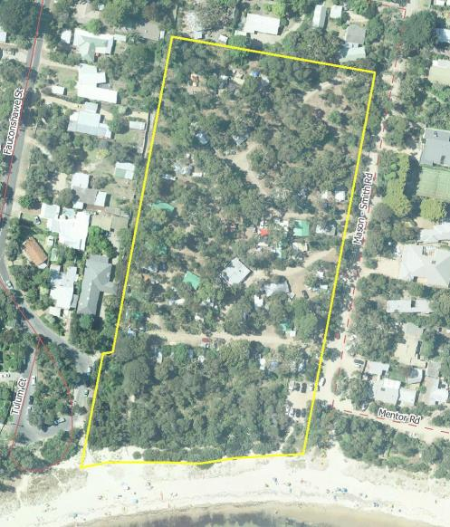

Figure 14: Zone 9 – Camping Reserve A

Camping Reserve A is approximately 2.5 hectares in area and contains 56 camp sites, 45 of which have access to power. (A map of the layout of camping sites within the Reserve is attached as Appendix 6) The camping season within this Reserve is from 1 September to the Queen’s Birthday long weekend in June. Access to the Camping Reserve is via Mason Smith Road. During the closed season, the vegetation is allowed to recover to ensure there are no long term detrimental impacts caused by long periods of camping.

The area contains a number of mature trees including coastal banksia*,* coastal manna gum and coast beard heath. The trees throughout the Camping Reserve provide valuable shade and shelter, especially during the hot summer months when the camp site is heavily used. There is also a large stand of established vegetation between the camp sites and Western Port which provides protection from coastal winds.

The trees within the Reserve are regularly assessed for stability and public safety by a qualified arborist and all work identified within the assessment is undertaken. The trees also provide valuable habitat for native fauna such as possums and koalas. Whenever tree works are undertaken, careful consideration is given to the works and the impact on native fauna to ensure that adequate habitat is provided.

The Committee will continue to undertake weed control within the Camping Reserve and revegetate where necessary with indigenous species.

The Camping Reserve contains an amenities block which contains male and female facilities and a laundromat. The amenities block is considered to be in poor condition and the Committee is in the process of gaining approval for its replacement. It is proposed to replace the existing structure with a new amenities block of similar proportions which will contain an all abilities access toilet and shower. The Committee initiated a building fund to part fund the new structure with the shortfall to be provided by grant opportunities.

To facilitate the use of the Reserve for camping, there is approximately 450m of vehicular access tracks that provide access to individual camp sites. These roads consist mainly of a thin layer of gravel, and in some areas the natural ground. The roads are heavily used and during heavy rain periods, a number of pot holes appear. The roads are also prone to water-logging which can cause access issues during the camping season. The issue of whether to upgrade the surface of the tracks to a more formal surface with adequate drainage has been discussed within the Committee. The main issues that have been considered by the Committee include the amount of funding required, wanting to retain a rustic look and feel of the camp ground and ensuring that any upgrade of the surface does not result in runoff entering campsites and potentially flooding them. At this stage, the Committee does not have the resources required to reconstruct and seal the tracks, however interim measures can be undertaken. These include providing additional rock/gravel to seal existing pot holes and regrading the surface to prevent further pot holes. These works can only be undertaken during periods of dry weather to ensure that the surface of the tracks is adequately compacted.

The Committee is also investigating options to improve camping facilities within the camping grounds. This includes additional powered sites, a camp kitchen, camper’s lounge and onsite accommodation. Whether these options are investigated further is reliant on a number of factors such as the community’s view of the proposals, the requirements of campers, the impact to the environment and financial viability.

|  |  |  |  |  |  |
| --- | --- | --- | --- | --- | --- |
| **No.** | **Action** | **Responsibility** | **When** | **Cost** | **Funding source** |
| 4.9.1 | Maintain grassed areas | Committee staff | Monthly | N/A | Committee |
| 4.9.2 | Trim/remove vegetation as required | Committee staff | Ongoing | N/A | Committee |
| 4.9.3 | Revegetation | Committee staff | Annually in Spring | N/A | Committee |
| 4.9.4 | Seed collection | Committee staff | Ongoing | N/A | Committee |
| 4.9.5 | Chemical weed removal | Committee staff | Ongoing | N/A | Committee |
| 4.9.6 | Mechanical weed removal | Committee staff | Ongoing | N/A | Committee |
| 4.9.7 | Annual maintenance of vehicular access tracks | Committee staff | Annually | $1500 | Committee |

* 1. Zone 10: Camping Reserve B

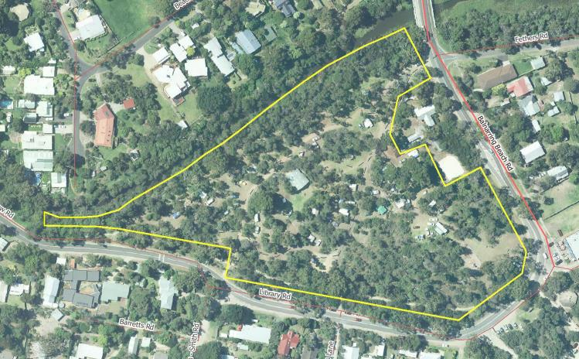

Figure 15: Zone 10 – Camping reserve B

Camping Reserve B is approximately 2.9 hectares in area and contains 52 camp sites, 19 of which have access to power. This Reserve adjoins a section of Merricks Creek to the north. Access to the camping Reserve is via Balnarring Beach Road.

The Camping Reserve contains a number of mature trees including coastal banksia*,* coastal manna gum *and* black wattle (*Acacia mearnsii*). The trees throughout the Camping Reserve provide valuable shade and shelter, especially during the hot summer months when the camp site is heavily used by the public. Individual camp sites are separated by indigenous vegetation including shrubs and grasses which will continue to be maintained by Committee staff. Regular works in this area include regular weeding of invasive species and revegetation with indigenous species.

The annual camping season within this Reserve is from the 1 September to the Queen’s Birthday long weekend in June. The camp ground is closed for camping outside this period to allow the vegetation to recover and ensure there are no long term detrimental impacts caused by long periods of camping. The Committee has been experimenting with the introduction of fire pits in May and June. These fire pits will be allowed within Camping Reserve B only and are restricted to certain camp sites in close proximity to the Ranger’s compound. The Committee first allowed fire pits in 2012 and the viability of this venture long term is dependent on a number of factors, including the damage to the grasses within the camp site, the demand for fire pits and public safety. Fire pits will again be trialled in 2014 to allow proper consideration of the costs, benefits and environmental impacts

To facilitate the use of the Reserve for camping, the Reserve contains an amenities block with a laundromat, a number of electricity and water connections for caravans and vehicular access tracks. The amenities block is a solid brick building which is considered to be in good condition. The Committee has undertaken a lot of work on the amenities block over recent years to ensure it remains safe and functional for campers.

Camping Reserve B also contains an access track for emergency vehicles. This access track must remain clear for emergency vehicles at all times. However the track is currently used as a vehicular access point to 3 camp sites (36, 36a and 37). Over the next 12 months, the access to these three camp sites will be relocated to ensure the area is available for emergency access.

The Committee is also investigating options to improve camping facilities within the camping grounds. This includes additional powered sites, a camp kitchen, camper’s lounge and onsite accommodation. Whether these options are further investigated is reliant on a number of factors such as the community’s view of the proposals, the requirements of campers, the impact to the environment and financial viability.

|  |  |  |  |  |  |
| --- | --- | --- | --- | --- | --- |
| **No.** | **Action** | **Responsibility** | **When** | **Cost** | **Funding source** |
| 4.10.1 | Undertake chemical weed control | Contractor | 2014 in spring | $2,200/yr. | Grant |
| 4.10.2 | Regularly mow the fire track for access | Committee staff | Monthly | N/A | Committee |
| 4.10.3 | Relocate access to sites 36, 36a and 37 | Committee staff | 2014 | N/A | Committee |
| 4.10.4 | Empty septic tank | Contractor | Annually | $1,000/yr. | Committee |
| 4.10.5 | Maintain surface of access tracks | Committee staff | Annually | $2,500/yr. | Grant |
| 4.10.6 | Maintain amenities block | Committee staff/ contractor | Ongoing | $1,000/yr. | Committee / Grant |

* 1. Zone 11: Camping Reserve C

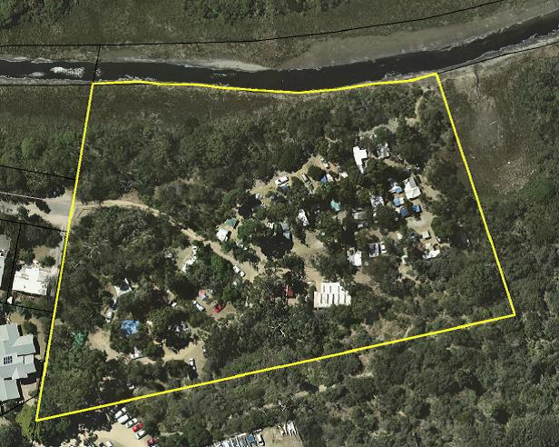

Figure 16: Zone 11 – Camping reserve C

Camping Reserve C is approximately 1.1 hectares in area and contains 33 camp sites, none of which have access to power. This reserve adjoins a section of Merricks Creek to the north. Access to the Camping Reserve is via Fethers Road.

The Reserve contains a number of mature trees including coastal manna gum and coastal banksia. The trees throughout the Camping Reserve provide valuable shade and shelter, especially during the hot summer months when the camp site is heavily used by the public. Individual camp sites are separated by indigenous vegetation including shrubs and grasses which will continue to be maintained by Committee staff. Regular works in this area include weeding of invasive species and revegetation with indigenous species.

The annual camping season within this Reserve is from the 22 December to 31 January and the Easter long weekend. The camp ground is closed for camping outside these periods to allow the grounds and vegetation to recover and ensure there are no long term detrimental impacts caused by long periods of camping. Camping Reserve C is particularly vulnerable to climatic impacts such as drought and flooding events. In previous years, this Reserve has been closed for the entire camping season to protect the indigenous vegetation due to drought conditions. The health of the vegetation in this Reserve will be closely monitored to ensure it is protected from the impacts of camping. When favourable weather conditions allow, Camping Reserve C has been opened for the March Labour Day long weekend and for school groups.

To facilitate the use of the Reserve for camping, the Reserve contains an amenities block with a laundromat and vehicular access tracks. The amenities block is a solid brick building which is considered to be in good condition. The Committee has undertaken a lot of work on the amenities block over recent years to ensure it remains safe and functional for campers. The roof of the amenities block is considered to be in average condition and may require replacement in the near future. The amenities block in this Reserve is not connected to the mains sewer, but to a septic system. The septic system comprises three septic tanks with soaker pits which require regular pumping out.

The Committee is investigating the need to upgrade the amenities block in this Reserve over the next 5-10 years and will continue to undertake regular maintenance.

The vehicular access tracks consist of crushed rock and are considered to be in good condition. The tracks require regular maintenance such as the addition of crushed rock and regular grading to ensure the safety of campers and maintain functionality.

The Committee is also investigating options to improve camping facilities within the camping grounds. This includes additional powered sites, a camp kitchen, camper’s lounge and onsite accommodation. Whether these options are further investigated is reliant on a number of factors such as the community’s view of the proposals, the requirements of campers, the impact to the environment and financial viability.

|  |  |  |  |  |  |
| --- | --- | --- | --- | --- | --- |
| **No.** | **Action** | **Responsibility** | **When** | **Cost** | **Funding source** |
| 4.11.1 | Monitor the condition of the ground before, during and after the camping season | Committee staff | Fortnightly | N/A | Committee |
| 4.11.2 | Undertake chemical weed control | Contractor | 2014-5 – spring | $500 | Committee |
| 4.11.3 | Empty septic tanks | Contractor | Annually | $1,000/yr. | Committee |
| 4.11.4 | Maintain the surface of the access tracks | Committee staff | Annually | $1,500 | Grant |
| 4.11.5 | Replace the roof of the amenities block | Contractor | 2015 | $12,000 | Grant |
| 4.11.6 | OR Fix the roof of amenities block | Contractor | 2015 | $3,000 | Grant |

* 1. Zone 12: Rangers Compound

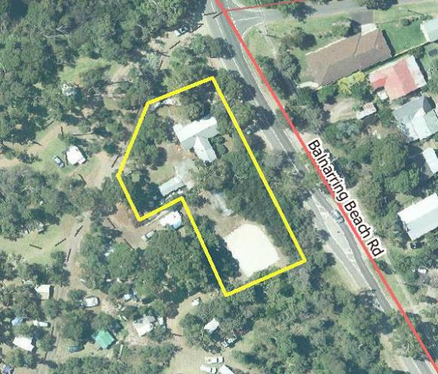

Figure 17: Zone 12 – Ranger’s Compound

The Ranger’s compound contains the Ranger’s accommodation as well as utility sheds and equipment, an animal shelter, plant nursery and volley ball court. This area is used by the Foreshore Manager and staff to store equipment and machinery, such as the Committee owned quad bike and tractor.

The utility sheds are reaching the end of their practical life and will need replacing over the coming years. It is proposed to remove both sheds and replace with a single, larger shed to store equipment and materials.

The Ranger’s cottage also contains the park office which acts as the front of house for the Reserve. This is where campers come to check-in and local residents and visitors can make enquiries regarding the Reserve.

It is proposed over the coming years to make the Ranger’s cottage more environmentally friendly by works such as installing a solar hot water tank and rain water tank. There are also a number of landscaping works proposed to ensure the Ranger’s cottage blends in with the surrounding coastal bushland.

|  |  |  |  |  |  |
| --- | --- | --- | --- | --- | --- |
| **No.** | **Action** | **Responsibility** | **When** | **Cost** | **Funding source** |
| 4.12.1 | Ensure there are adequate supplies to maintain the functionality of the nursery (potting mix, fertiliser and herbicide) | Committee staff | Annually | $1,000 | Committee |
| 4.12.2 | Remove the existing shed | Committee staff | 2014/5 | N/A | Committee |
| 4.12.3 | Install a larger shed in the same location | Contractor | 2014/5 | $10,000 | Grant |
| 4.12.4 | Maintain the area for public safety | Committee staff | Ongoing | N/A | Committee |
| 4.12.5 | Install a water tank for cottage and garden use | Contractor | 2014/5 | $3,000 | Grant |
| 4.12.6 | Install solar hot water to the Ranger’s cottage | Contractor | 2014/5 | $3,000 | Grant |

1. Business Plan
   1. Camping fees

The main income for the Committee is camping fees generated from the three camping grounds. Generally the Committee increases camping fees every two years and the last increase was in 2013. Any increase in camping fees in future years will be guided by a number of factors, including the level of amenities, the number and type of sites provided and maintenance costs.

|  |  |
| --- | --- |
| **Item** | **2013/14** |
| Peak – powered site | $39/night |
| Peak – unpowered site | $31/night |
| Off peak – powered site | $29/night |
| Off peak – unpowered site | $23/night |
| Seasonal sites | $2890/season |

* 1. Income

|  |  |  |  |
| --- | --- | --- | --- |
| **Item** | **2014** | **2015** | **2016** |
| **Income** | **$** | **$** | **$** |
| Camping fees | 269100 | 269100 | 278518 |
| Horse permits | 19872 | 20568 | 21287 |
| WPYC rent | 4320 | 4320 | 4320 |
| Other income | 3436 | 3556 | 3681 |
| **Total income** | **296728** | **297544** | **307806** |

* 1. Expenditure

|  |  |  |  |
| --- | --- | --- | --- |
| **Item** | **2014** | **2015** | **2016** |
| **Expense** | **$** | **$** | **$** |
| **Camping Reserves** |  |  |  |
| Tools | 3105 | 3214 | 7396 |
| Insurance | 5001 | 5176 | 3326 |
| Amenities R&M | 8114 | 8398 | 8692 |
| Caravan park council license | 800 |  |  |
| Service contractors | 16500 | 18150 | 19965 |
| CFA truck water attachments | 1500 |  |  |
| Nursery upkeep | 2070 | 2142 | 2217 |
| Electricity | 12100 | 13310 | 14641 |
| Gas | 3459 | 3805 | 4186 |
| Grounds maintenance | 5175 | 5356 | 5544 |
| Pest control | 621 | 643 | 665 |
| Water | 11259 | 12384 | 13623 |
| **Total Camping Reserves** | **69704** | **72578** | **80255** |
| **Office/Cottage expenses** |  |  |  |
| Auditor fees | 362 | 375 | 388 |
| Booking system | 1735 | 1796 | 1859 |
| Insurance | 1497 | 1549 | 1603 |
| Council rates | 676 | 700 | 724 |
| Stationary | 3416 | 3535 | 3659 |
| Reckon (software) | 517 | 536 | 554 |
| Telephone and internet | 3105 | 3214 | 3326 |
| Website | 21 | 22 | 23 |
| **Total office/cottage expenses** | **11329** | **11727** | **12136** |
|  |  |  |  |
| **Plant and operating equipment** |  |  |  |
| Fuels | 3105 | 3214 | 3326 |
| Kubota tractor | 1059 | 1096 | 1135 |
| Quad bike | 2800 | 811 | 839 |
| Motor vehicle | 1983 | 2053 | 2125 |
| **Total plant and operating equipment** | **8947** | **7174** | **7425** |
|  |  |  |  |
| **Miscellaneous** |  |  |  |
| Protective clothing and equipment | 1537 | 1591 | 1646 |
| Chemical and electrical supplies | 1035 | 1091 | 1109 |
| Bank charges | 1632 | 1690 | 1749 |
| Committee expenses | 518 | 536 | 554 |
| **Total miscellaneous expenses** | **4722** | **4908** | **5058** |
|  |  |  |  |
| **Employees** |  |  |  |
| Training and education | 1035 | 1071 | 1109 |
| Salaries | 113850 | 117835 | 121959 |
| Superannuation | 10247 | 10605 | 10976 |
| Work cover | 724 | 750 | 776 |
| **Total employees** | **125856** | **130261** | **134820** |
|  |  |  |  |
| **Waste management** |  |  |  |
| Waste management contractor | 13455 | 13926 | 14413 |
| Cleaning contractor | 18113 | 18746 | 19403 |
| Cleaning products and chemicals | 3416 | 3535 | 3659 |
| **Total waste management** | **34984** | **36207** | **37475** |
|  |  |  |  |
| **Total expense** | **255542** | **262855** | **277169** |
| ***Net operating income*** | **41186** | **34689** | **30637** |

* 1. Grants

|  |  |  |  |
| --- | --- | --- | --- |
| **Item** | **2014** | **2015** | **2016** |
| **Anticipated grants income** | **$** | **$** | **$** |
| DELWP beach cleaning | 9908 | 10254 | 10614 |
| Melbourne water | 2070 | 2142 | 2217 |
| **Total income** | **11978** | **12396** | **12831** |
| **Anticipated grants expense** |  |  |  |
| DELWP beach cleaning | 9908 | 10254 | 10614 |
| Melbourne water | 2070 | 2142 | 2217 |
|  |  |  |  |
| **Total expense** | **11978** | **12396** | **12831** |
|  |  |  |  |
| **Net grants income** | **0** | **0** | **0** |

Appendix 1: History of Balnarring and Balnarring Beach

Balnarring Beach occupies a long, narrow sand spit that extends from Point Sumner (Palmer’s Bluff) eastward towards what is now called Somers. Merricks Creek parallels the coastline for about 2 ½ kilometres from near the Point to its outlet at Somers.

The first people to know the area were the aboriginal Bunurong people whose traditional lands included the Mornington Peninsula. Indications of their presence are reflected in place names – in particular Tulum (a former name given to the beach area) and to the location of middens (recorded by Europeans in earlier days but since lost to erosion or development). From 1840 it was part of the Colourt (Coolart) run - Crown land, the lease for which was first taken up by the Meyrick cousins. Much of this run was released for selection about 1860 with certain areas being retained by the Crown for specific purposes. Early maps show a planned township on the coast with a proposed road leading to it. The beach area was public reserve and a “Water Reserve” is marked at a point where there is a spring in the creek. It is said that settlers brought barrels to the spring to fill them with fresh water. Land to the north of the creek is shown to have been taken up by Joseph Hann of Coolart and to the west by J. Palmer. Balnarring Beach first appears as a gazetted town in 1886 but few lots were initially taken up. The ones chosen were close to the road or to the beach front. Early land sales had been slow; some lots were bought up in 1914.

A few shacks were put up but tents were commonly used on these blocks.

The sale of lots was again promoted during the early 1920s with the ‘Tulum Township subdivision offering 72 blocks for £3 deposit, £1 per month’. The houses that were erected were simple holiday homes. The use of fibro cement sheet, corrugated iron, packing cases for lining and pressed tin ceilings was common in many of these early buildings. Some were of weatherboard. “The Nook” in Hansen’s Lane was prefabricated by the White family in Moorabbin, transported to Tulum and erected on their beachfront lot. Some of these buildings were leased out as holiday places. Very few were solid constructions of brick or cement block. One exception was Yamba in Foreshore Road which was built in 1924 and was let out. Another was the home built by Dr O. S. Woods in 1926. A veterinarian, he had bought the grazing property that covered the area behind Balnarring Beach back to Balnarring. He built his homestead plus an adjoining cottage on the hill overlooking the bay close to Palmers Bluff. The ‘Tulum Township’ did not extend far beyond the end of Library Road. That area was known as the Sand(y) Paddocks or Fern Paddocks where one could always bag a rabbit or two for the supper pot. This western cove was referred to as ‘the back beach’. It was separated by a low headland from ‘the front beach’ - the eastern cove where development first occurred. Both the names ‘Tulum’ and ‘Balnarring Beach’ appeared on early signs but ‘Tulum’ was dropped from signage after 1923. Many people, however, continued to use it and the name lingered in Tulum Creek, Tulum Bridge.

Since the earliest days when the beach was made accessible to the public, Balnarring’s beach had been a popular recreation spot. Many local families enjoyed a break by the sea and many groups from the growing Balnarring community held an annual beach picnic. Others came greater distances. Towards the end of World War I the Balnarring Progress Association organised, with the Red Cross, a picnic for repatriated soldiers. The foreshore area was also a popular place for camping. The Balnarring Progress Association had been increasingly alarmed at the destruction of trees along the foreshore and the lack of sanitary arrangements for some years and in 1914, formed a committee which would evolve into the Balnarring Beach Foreshore Committee. By 1919 it was reported that over 200 campers had come from ‘all over the metropolis”. A permanent reserve and separate camping grounds were defined over the following years.

The first store was built in 1916 by the Stone family who ran the General Store at Balnarring. This was open only during the summer and provided a range of basic goods, sweets, drinks and newspapers. It stood on the present Library Road. The main road into Balnarring Beach at that time deviated to the west from the present road and brought visitors to the Hansen Lane area. A second store was built a short distance from the bridge by the Strains in 1923. At first it was open only at weekends but then every day. As well as selling provisions Maud Strain ran the Cheero Tearooms from the premises. Here refreshments and light meals could be obtained. Four bungalows offering accommodation were later added behind the store. Another tearoom was established in 1928 by Mr. Bongiorno but did not prosper and later became the shelter shed on the foreshore area.

Water was supplied from pumps tapping into the underground water. One public pump was located near the Reserve opposite the present store. A second pump stood near Stones’ store. Milk was delivered by a horse drawn cart carrying milk cans. A butcher also called as did a fruiterer. Sewerage was collected by the night-man in his cart. Some of the small lanes between properties were originally planned for this purpose.

Fishing and boating were popular and a number of boat sheds were erected on the beach. One resident, Gus Hansen, had a number of rowing boats which he hired out. Motor cycles were a popular means of travel during the 1920s-30s and the Harley Davison Club regularly visited Tulum. The Club used the Cheero Tearooms as its meeting place until a block of land was purchased and a club house erected on the north side of Merricks Creek. On one occasion races were held along the straight stretch of beach that fronts Coolart however future races were quickly banned by the Foreshore Committee. The property remained with the Club until 2002.

In 1931 a separate Reserve Committee was elected and the position of honorary Crown Lands Bailiff was given to Alfred Robertson who ‘lived at Tulum Road during the weekend”. He quickly earned the name “Robbie the Bobby’, such was his vigilance. During the early years of World War II the beach was fortified against possible Japanese attack and invasion as were the other beaches of Western Port. Barbed wire coils and gun emplacements were put in place and a tank trap ditch was dug from the base of the cliffs as far as the creek. A sentry guarded the bridge into Balnarring Beach and troops were camped in the foreshore reserves. The Cheero Tearooms were a popular venue for soldiers camped throughout the district and airmen from the neighbouring Air Force Initial Training School at Somers. The owner of the Tearooms had the small bungalows at the back of the store demolished and a larger dining area built where she could serve meals.

After the war years she bought the Stone’s old store and on its site established a guest house “Tulum Lodge” which had twelve bungalows as well as a communal building. Gwen also introduced postal facilities to Balnarring Beach, opening a post office at the store in 1947 and having a telephone box installed.

Post war years saw the return of holiday makers. Tennis courts were built at the Tulum Recreation Reserve. Caravans were more commonly seen (An area of the camp ground had been set aside for a caravan park towards the end of 1937). Again campers from that era have many recollections of the butcher, the baker, the fruiterer visiting the area and of leaving a billy out (with the money in it) at a certain location to be filled by the milkman as he did his rounds. Mrs Edwards, from a small slab building at her property in Government (Mason Smith) Road, ran a refreshment kiosk where visitors could get drinks and small baked items. Her house has the distinction of probably being the only house on the peninsula to have been shelled during the war – from ‘friendly’ practice fire. Another major land sale and development period took place in the 1950s with subdivided lots on the former ‘sand paddocks’ area being offered. Again most of the houses erected were ‘holiday homes’. Some buildings were translocated from other places and some were quite unusual. The Tram House was two old Melbourne trams placed parallel to each other with an adjoining section. Houses relied on tank water and lamps supplied lighting.

In 1946 severe winter storms washed away a wide stretch of foreshore. Erosion of the spit was a long-time concern and reports of beach loss date from the earliest days of the township. In 1923 it was reported that 11/2 chains (approx. 30 metres) of beachfront had been lost since 1888. During the 1950s a sea wall and wooden groynes were constructed by Melbourne Ports and Harbours along the ‘back beach’ in an attempt to halt erosion. The sand has built up again over the last half century.

In 1958 the name of the recreation Reserve was changed to Robertson’s Reserve in honour of “Robbie the Bobby” who had retired after 30 years of service to the Foreshore Committee.

A Ranger’s cottage was built on a site in the Reserve close to the bridge in 1958 and the camping ground area was extended by reclaiming an area of saltmarsh wetlands by the creek further towards the Coolart end of the township.

Social activities multiplied and amenities improved. A Women’s Life Savings Club was formed and plans were approved to erect a club house at the end of Mason Smith Street but only the foundations were ever constructed.

From about 1950 until 1972 open air picture shows were a very popular form of entertainment. These were held behind the store in early days then on the tennis courts near the Reserve.

A lending library operated from the home of Mr Wally Turner. This was part of the Regional Library service to small communities and books were brought to Mr Turner’s home from the library headquarters. The house, in Library Road, still bears the name “The Old Library”.

The Westernport Yacht Club was formed in 1960 to provide storage and launching facilities at the east end of the township for the boating enthusiasts. WYC was to become a social centre for the community. Its jetty was constructed in 1968 and improvements to the older clubhouse completed in 1971.

Electricity came in the mid 1950s. Mains Water was available during the ‘60s. This meant that septic tanks could be installed. The construction of a new concrete bridge to replace the single-lane wooden one and the surfacing of roads during the latter part of the 1960s made access to and through the area easier.

A system of permits for horses to be exercised on the beach was first issued by the Foreshore Committee in the 1960s. However there is a long tradition of racehorse breeders and trainers using the beach that dates back to the 1890s when Frederick Grimwade owned Coolart. The names of a number of famous horses are associated with the area.

During the 1970s more of the homes became permanent residences. The coming of secondary industry to the Western Port area brought a greater number of people seeking permanent living close to their work-place. Many of the earlier holiday people, too, had reached retirement age and came to live permanently at their Balnarring Beach homes. A number of the old ‘cottages’ were replaced by more substantial buildings with urban-style gardens.

The General Store received a facelift when it was remodelled about 1972 and a new brick facade constructed. The ‘Cheero Tearooms’ were also reintroduced.

Public toilet facilities, changing rooms and a brick picnic rotunda were constructed by the Shire on the site of the old wooden kiosk and dressing sheds.

Prior to the closure of the old Balnarring State School in 1951 and the opening of the new primary school in 1990, children from the area went by bus to the Consolidated School at Red Hill. School buses for various secondary colleges made an appearance from the late 1980s.

Sewerage came to the area in 1999 and natural gas was made available to homes in 2007.

The construction of freeways on the peninsula has made Western Port beaches far more accessible.

The face of Balnarring Beach is again undergoing major change in the first decades of the 21st C. It has become a desirable area and beachside property has skyrocketed in value. Many of the older, simple buildings are being replaced by large-scale homes.

Appendix 2: Management Context

State legislation, policy and plans

Coastal Management Act 1995

The *Coastal Management Act 1995* provides for the coordinated strategic planning of Victoria’s coastal resources. The Act established the Victorian Coastal Council (VCC) and three Regional Coastal Boards to facilitate this process.

The *Coastal Management Act 1995* requires an application for consent to use or develop coastal Crown land. When considering an application, the Minister for Environment must consider the consistency of proposals with the Victorian Coastal Strategy, relevant Land Conservation Council and Environment Conservation Council recommendations and relevant Management Plans and Coastal Action Plans.

Victorian Coastal Strategy (2008)

The Victorian Coastal Strategy (VCS) is the State Government’s policy commitment for coastal, estuarine and marine environments in Victoria. It provides a long-term vision for the planning, management and sustainable use of our coast, and the policies and actions Victorians will need to implement over the next five years to help achieve that vision.

The VCS 2008 is established under the *Coastal* *Management Act* 1995, and is the third VCS to be produced since 1997 – they are reviewed every five years.

Crown Land (Reserves) Act 1978

The *Crown Land (Reserves) Act 1978* provides for the reservation of Crown land for a variety of public purposes, the appointment of committees of management to manage those reserves, and for leasing and licensing of reserves for purposes approved by the Minister for Environment and Climate Change.

Environment Protection Act 1970

This act provides the legal framework by which environmental objectives, regulations and goals are established throughout the State for industry, commerce and the general public. The Act reflects the precautionary principle, the protection of intergenerational equity, the polluter pays principle, and the protection of biodiversity. It puts the responsibility for sound environmental management on Victorian businesses, communities and individuals. The Act aims to achieve greater environmental performance through shifting to collaboration and co-regulation as opposed to the traditional ‘command and control’.

Flora and Fauna Guarantee Act 1988

This Act incorporates a wide range of measures for conserving all Victoria’s native plants and animals. Its broad aim is to prevent the extinction of any more plants and animals, both by saving those that are threatened and by preventing those that are currently secure from being threatened.

Heritage Act 1995

This Act provides protection and conservation of places and objects of cultural significance and the registration of these places. The Act protects all categories of historic cultural significance relating to non-Aboriginal settlement of Victoria.

Planning and Environment Act 1987

The *Planning and Environment Act 1987* establishes State planning and land use processes including provisions for planning schemes for individual council areas. A planning scheme is a statutory document which sets out objectives, policies and provisions relating to the use, development, protection and conservation of land in an area to which it applies. A planning scheme regulates the use and development of land through planning provisions to achieve those objectives and policies. Every planning scheme includes the State Planning Policy Framework. The framework comprises general principles for land use and development in Victoria and specific policies dealing with settlement, environment, housing, economic development, infrastructure, and particular uses and development. The Local Planning Policy Framework sets a local and regional strategic policy context for a municipality including Crown land. It comprises the Municipal Strategic Statement and specific local planning policies.

Regional legislation, policy and plans

Central Coastal Board & Coastal Action Plans

The Central Coastal Board provides strategic planning advice to the Minister for Environment and Climate Change for the area of coast from Breamlea, which is the western boundary of the City of Greater Geelong, to Andersons Inlet at the eastern boundary of the Bass Coast Shire. Under the *Coastal Management Act 1995*, the Board may prepare Coastal Action Plans (CAPs) for its region or a part of its region.

CAPs help to implement the Victorian Coastal Strategy at the regional scale. CAPs enable the broad principles and priorities identified in the Strategy to be further developed and applied at a sub-regional or issue based level. They provide strategic direction for the future management of an area of coast by identifying necessary priorities, actions and outcomes.

Currently only one CAP applies to Balnarring Beach Foreshore Reserve which is the *Recreational Boating Facilities Framework 2014.*

Port Phillip and Western Port Catchment Management Authority & the Regional Catchment Strategy

The Port Phillip and Western Port Catchment Management Authority (PPWCMA) promote and coordinate improved land, water and biodiversity management throughout the Port Phillip and Western Port catchments.

The Port Phillip and Western Port Regional Catchment Strategy, written by the PPWCMA, describes the natural assets of the region, and how they are interrelated, and what needs to be done to manage and use the assets in a sustainable way.

Local policy and plans

Mornington Peninsula Planning Scheme

The Mornington Peninsula Planning Scheme sets out policies and controls for the use, development and protection of land within the municipality. The Planning Scheme is based on model planning provisions for Victoria called the Victoria Planning Provisions (VPPs), which allow for each municipality to insert certain local provisions.

The Mornington Peninsula Shire Planning Scheme contains local controls over the site. Specifically for the study area the following controls are included:

* Environmental Significance Overlay - Schedule 20 (Cliff and Beach)
* Significant Landscape Overlays – Schedule 2 (Coastal Landscape) and 4 (Eastern Peninsula)
* Vegetation Protection Overlays – Schedule 1 (Township Vegetation) and 2 (Significant Treelines)
* Land Subject to Inundation Overlay
* Design and Development Overlay – Schedule 3 (Coast and Landscape Design)

Land within the Balnarring Beach Foreshore Reserve is zoned either Public Conservation and Resource Zone (PCRZ) or Public Park and Recreation Zone (PPRZ).

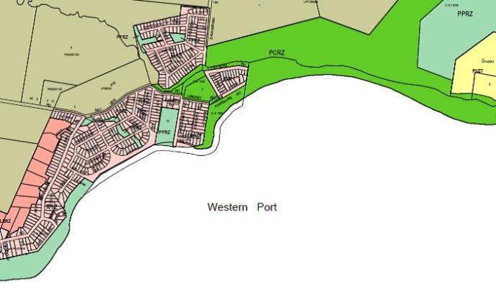

The purpose of a PCRZ zoning is:

* To protect and conserve the natural environment and natural processes for their historic, scientific, landscape, habitat or cultural values.
* To provide facilities which assist in public education and interpretation of the natural environment with minimal degradation of the natural environment or natural processes.
* To provide for appropriate resource based uses.

The purpose of a PPRZ zoning is:

* To recognise areas for public recreation and open space.
* To protect and conserve areas of significance where appropriate.
* To provide for commercial uses where appropriate.

Appendix 3: Reserve Regulations

(As printed in the Victorian Government Gazette 28 June 1989 Page 1561)

**Regulations**

**BALNARRING BEACH FORESHORE AND PARKS RESERVE**

I, Kay Setches, Her Majesty’s Minister for Conservation, Forests and Lands in and for the State of Victoria in pursuance of the powers conferred on me by Section 13 of the *Crown Land (Reserves) Act 1978*, do hereby make the following Regulations for and with respect to the reserved Crown Land in Parishes of Balnarring and Bittern, being the land indicated by red colour on plan marked “B/6.5.65” attached to department of Conservation, Forest and Lands correspondence No. Rs2091 and known as the Balnarring Beach Foreshore and Parks Reserve (hereinafter referred to as the “Reserves”).

The Reserves have been placed under the control of a Committee (hereinafter referred to as the “Committee”) with full power and authority to enforce these regulations.

**PART 1 – GENERAL**

*Title*

1. These Regulations may be cited as the Balnarring Beach Foreshore and Parks Reserve Regulations.

*Application*

1. These Regulations shall apply to the whole of the Reserves.

*Definitions*

1. In these Regulations, unless inconsistent with the context or subject-matter:

“Act” means the *Crown Land (Reserves) Act 1978*.

“Appointed Officer” means any person appointed, in writing, by the Committee as an authorised officer

for the purposes of these Regulations and (except for the purpose of receipt of any fees or the grant, variation or revocation of any permit) also includes any member of the Police Force and any person appointed or deemed to be appointed as an Authorised Officer under Section 13 of the *Conservation, Forests and Lands Act 1987*.

“Camp” without limiting the generality of the term includes:

1. to erect, occupy or use any tent, or any temporary, make-shift or similar form of accommodation; or
2. to park, occupy or use any caravan or other movable form of accommodation.

“Camping Area” means any part of the Reserves set apart by the Committee as a site for camping

purposes.

“Firearm” includes any rifle, gun, pistol, air pistol, or like thing using cartridges, catapult, bow and

arrow or crossbow, and any other implement designed to discharge missiles capable of injuring or destroying animal life.

“Permit” includes any authority, approval, consent, permission, receipt, ticket or the like given, granted

or issued by the Committee or the Regional Manager pursuant to these regulations.

“Regional Manager” refers to the Manager of the Dandenong Region of the Department of

Conservation, Forests and Lands.

“The Committee” refers to the Committee of Management. The Reserves have been placed under the

control of the Committee with power and authority to enforce the following regulations.

“Vehicle” includes any motor car, motor cycle, bus, truck, bicycle, cart, horse-drawn vehicle, trailer or

water craft.

**REGULATIONS**

1. The Reserves shall be open to the public free of charge, except on such days as determined by the Committee, as any portion of the Reserves may be set aside for purposes consistent with the reservation and with the consent of the Committee.

*Behaviour*

1. No person shall:
   1. Enter or remain in the Reserves who may offend against decency as regards dress, language or conduct;
   2. Commit or create or knowingly permit or allow to continue any public or private nuisance or any annoyance to the public or any person lawfully in the Reserve whether such nuisance or annoyance takes place in a public or private building, tent, caravan or other structure or in any enclosed or unenclosed space in the Reserves or do not suffer to be done any act which in the opinion of an appointed officer is or is likely to be to the annoyance or disturbance of any person using the Reserves.
   3. Except in any area set apart for the purpose, play any game in which a hard ball is used to engage in any game or sport likely to cause interference, disturbance or danger to other persons using the Reserves.

*Shooting etc.*

1. No person shall in the Reserves except with a written permit –
   1. Shoot, trap, maim, injure, kill or destroy any bird or animal;
   2. Have in his possession, carry or use any firearm, trap or snare.
   3. Any person carrying or using a firearm, trap or snare in the Reserves without a permit shall surrender the same on demand to any appointed officer who shall issue a receipt therefore.
   4. The person apparently entitled to any such article may collect it from the office of the Committee after completion of investigations and legal proceedings (if any) by the Committee or the Police in relation to any offence alleged against the person who surrendered the same.

*Damage*

1. 1. No person, except with a written permit issued by the Committee, shall in the Reserves, remove, cut, damage, displace, deface or interfere with any rock, timber, tree, shrub, plant, wild flower or other revegetation or any sign, notice board, seat, table, gate, post, fence, bridge, building, structure or any other thing of the like nature to any of the forgoing.
   2. No person shall without a permit from the Committee dig any pit or trench, or remove from or take into the Reserves any gravel, stone, shell grit, sand soil or loam.

*Missiles*

1. No person shall roll or throw any stone or other substance or missile within the Reserves.

*Camping*

1. No person shall camp in any part of the Reserves except in accordance with the provisions of Part II of these Regulations.

*Refuse and Litter*

1. No person shall within the Reserves deposit or cause to be deposited (except in a receptacle provided for the purpose) any bottle, glass object, vessel or other container, broken glass, tins, waste paper, foodstuff, vegetable matter offal or other refuse or litter.

*Glass etc.*

1. No person shall intentionally break any glass, bottle or other container within the Reserves and in the event of breaking any glass, bottle or other container shall immediately gather the pieces up and place them in receptacles provided.

*General*

1. No person shall in any part of the Reserves, except in accordance with and upon the terms of a permit, in writing by the Committee-
   1. Sell or offer for sale any article whatsoever;
   2. Give out, distribute, erect, leave, set up or display any handbills, placards, notices, pamphlets, books, papers, advertising matter or the like thing;
   3. Occupy, use or enter any building, booth, shed or other structure unless the same is set aside for public use;
   4. Erect or place therein, any building, booth, shed, stand or structure subject to the provisions of the Regulations made on 12 March 1980 (vide Government Gazette of 26 March 1980);
   5. Solicit or collect money or orders for goods or services;
   6. Take part in or advertise any entertainment for gain;
   7. Preach, declaim, harangue or deliver any address of any kind or use any amplifier, public address system, loud hailer or similar device;
   8. Let for hire any article, device or thing;
   9. Take photographs for gain or commercial purposes;
   10. Ply any vehicle for hire or carry passengers for fee or reward;
   11. Conduct any school or provide any form of instruction for gain;
   12. Advertise for sale or trade or hire any article, devise, service or thing.

*Dogs*

1. (1) No person shall cause, suffer or permit any dog belonging to him or in his charge-
   1. To be brought into or enter or remain in the Reserves unless such a dog shall be and continue to be under proper control on a chain cord or leash and unless such dog shall be effectively restrained from causing annoyance to any person and from damaging or interfering in any way with the property of the Committee;
   2. To be brought into or enter or remain in any camping area or any portion of the Reserves prohibited to the entry of dogs and indicated by notices.

(2) Nothing in these regulations prohibits a blind person having in the Reserves a dog that is used by that person as a guide dog.

*Horses*

1. No person shall ride, drive or lead any horse upon the Reserves or beaches except in accordance with a written permit from the Committee.

*Animals Generally*

* 1. Save as aforesaid, no person shall cause or suffer or knowingly permit any animal belonging to him or in his charge to be brought into or enter or remain in the Reserves without a permit.
  2. Any animal found in the Reserves contrary to these Regulations may be seized by an appointed officer and impounded or destroyed, and the owner or custodian thereof shall be liable to pay compensation for any damage done by such animal to the property of the Committee.

*Enclosures*

1. No person shall, except where and upon conditions authorised by the Committee, enter any area in the Reserves which is enclosed for plantations of young trees, shrubs or grass plots or for the growth or preservation of native flora or for re-establishment of growth or reclamation or erode areas.

*Fires*

1. No person shall without a permit light a fire within the Reserves, except in a portable barbecue and any person who lights a fire in the Reserves shall take all reasonable and proper precautions to ensure that the fire does not escape from control, nor shall any person wilfully, carelessly or negligently do, or make or permit any act or omission which may result or be likely to result in damage by fire to anything growing or being on the Reserves.

*Roadways, etc.*

1. No person shall unless authorised by the Committee drive, ride, push, place or leave any vehicle in or on the Reserves except in or upon such roadways or areas set aside for the purpose and no person shall allow any vehicle to remain stationary in any position obstructing the lawful passage of others.

*Vehicles*

1. No person shall –
   1. Damage any vegetation or interfere with or disturb any sand, stone, gravel, rock, clay or earth by driving any vehicle;
   2. Drive any vehicle in a manner dangerous to the public;
   3. Drive any vehicle so as to cause noise which is unreasonable in the circumstances;
   4. Drive any vehicle as a speed greater than twenty (20) kilometres per hour.

*Parking*

1. No person shall park any vehicle within the Reserves except –
   1. In an area set apart for the purpose and clearly defined by signs;
   2. As and where directed or appointed by the Committee or an authorised officer;
   3. Upon payment of such fees (if any) as may be prescribed.

*Stranded Vehicles*

1. An appointed officer may remove or cause to be removed or order the removal of any parked, stranded or broken down vehicle from any roadway or area within the Reserves – provided that the removal of any vehicle –
   1. Shall be at the sole risk of the owner of the vehicle who shall be deemed to have accepted such risk as a condition of entry to the Reserves; and
   2. May be effected in such manner as the appointed officer deems fit.

*Abandoned Vehicles*

1. Any vehicle left unattended within the reserves for a continuous period exceeding 48 hours may be removed by the Committee at the risk and expense of the owner.

*Use of facilities*

1. No person shall –
   1. Use any kitchen, laundry, change room, shower, toilet or other convenience or any part thereof in the reserves, except for its proper purpose and upon payment of such fees (if any) as may be prescribed;
   2. Enter or use or permit any child under his care or control to enter or use any place, room, convenience or structure set apart for the use of the opposite sex; provided that this Regulation shall not apply to a child under the age of six years, when accompanied by an adult of the opposite sex.
   3. If above the age of fourteen years, use any swings or play equipment provided for children, or (save whilst in charge of a child under that age) enter any children playground.

*Boatsheds, etc.*

* 1. The Committee may set aside sites on the Reserves for such buildings or structures as it deems necessary.
  2. No person shall occupy any such site or erect or maintain any such structure without a written permit from the Committee.

*Direction by sign*

* 1. The Committee may, by clear notices or signs established in such prominent position or positions as the case requires, prohibit or regulate any act, matter or thing within the Reserves or part thereof.
  2. No person shall erect or remove any such notice or sign except with the authority of the Committee.
  3. No person shall disobey the directions indicated in any such notice or sign.

*Permits*

* 1. The holder of any permit shall observe and comply with all the conditions thereof.
  2. Any person purporting to hold any permit shall produce the same on demand by an appointed officer and unless such permit is thereupon produced that person shall not be entitled to claim the benefit of any such permit.

*Direction to Leave*

* 1. Any appointed officer may direct a person who in his opinion offends any of these Regulations forthwith to leave the Reserves or any place therein.
  2. Every person who fails to comply forthwith with any such direction shall be guilty of an offence and may be removed from the Reserves or such place.

*Giving of name*

1. If, in the opinion of an appointed officer, any person has contravened or failed to comply with any provision of these Regulations, then such officer may demand and receive the name and address of such person and any person who refuses to furnish his name and address or who then furnishes and incorrect name and address shall be deemed to have committed an offence against these Regulations.

*Obstruction to Officers*

1. No person shall obstruct, hinder or interfere with an appointed officer or any employee of the Committee in the execution of his duty in the Reserves.

*General*

1. Every person found to be under the influence of alcohol in the Reserves shall be guilty of an offence against these Regulations.
2. No person shall commit any nuisance or behave in a disorderly manner in the Reserves.
3. Every person bathing from the Reserves shall be decently attired in a bathing costume.
4. No person shall play any game or take part in any activity in or on any portion of the Reserves to the danger, inconvenience or annoyance of the public or any member of the public.
5. The Committee may set part or enclose certain parts of the Reserves for the holding of fetes, sports, carnivals or other amusements subject to such conditions as may be set out on such permit and on such charges as the Committee may decide.
6. Any permits required to be issued by the Committee of the Reserves shall be issued by the Secretary of the Committee or other appointed officer of the Committee.

**PART II – CAMPING AREA**

*General*

1. The committee, with the consent of the Regional Manager may –
   1. Set aside any portions of the Reserves as camping areas;
   2. Set apart individual camp sites within any camping area;
   3. Fix and collect such fees or other charges as it may from time to time determine for the entry, use or occupation of any camping area or of any facilities or sites therein;
   4. Determine conditions under which any authorised camp site may be occupied or used including duration of stay, behaviour and site cleanliness.

*Conditions*

* 1. No person shall camp except on a site set apart as aforesaid.
  2. No person shall occupy or use any site or any facilities or amenities within any camping area except in accordance with a written permit from the Committee.
  3. Any permission issued by the Committee or its appointed officer to a person to use a camping area or camping site may be cancelled or withdrawn by the Committee or its appointed officer, and subject to such cancellation or withdrawal a proportionate refund of any fees or charges paid in advance may be refunded, and the Committee or its appointed officer at its or his discretion may deduct and retain from any such proportionate refund such sums as it or he determines will be necessary to clean up and put in order the site in relation to which the permission has been so cancelled or withdrawn.
  4. No person shall neglect or refuse to remove forthwith any tent, camping structure, caravan or vehicle erected or installed on any portion of the Reserves when directed to do so by the Committee or its appointed officer.

*Cleanliness*

1. Every person using or in any camping area shall –
   1. Maintain any site used or occupied by them and all appurtenances for the time being thereon in a clean, sanitary and tidy condition;
   2. Before vacating such site, clear the same of all refuse and litter whatsoever;
   3. Observe proper standards of hygiene and tidiness in the use of the camping area generally and of facilities and amenities therein;
   4. Abide by all lawful directions given by the Committee or an authorised officer.

**PART III – GENERAL**

*General Powers*

1. The Committee may –
   1. Provide and maintain conveniences, facilities and amenities of any description in any part of the Reserves, or arrange for the provision and maintenance thereof and may from time to time determine or vary the conditions of entry or use thereof;
   2. Make such arrangements as it deems necessary or desirable for or in connection with the proper and efficient management of operation of the Reserves or any portions thereof;
   3. With the approval of the Regional Manager, determine such fees as are appropriate from time to time for the use or occupancy of the Reserve for any activities subject to a permit being obtainable from the Committee.

*Permits*

* 1. Any permit may be granted for such period and subject to such terms, conditions and fees consistent with these Regulations as the Committee may, with the consent of the Regional Manager, from time to time determine either generally or in a particular case.
  2. No permit shall be transferable.
  3. Any permit may be revoked or withdrawn at the discretion of the Committee or at the discretion of the Regional Manager.
  4. The holder of any permit shall observe and comply with all conditions thereof.
  5. Any person purporting to hold any permit shall produce the same on demand by an appointed officer and unless such permit is thereupon produced that person shall not be entitled to claim the benefit of any such permit.

*Compliance*

1. The Committee shall have the power to undertake any reasonable and lawful action to ensure compliance with these Regulations and conditions of any permit issued under these Regulations.
2. No person on the Reserves shall use a beach umbrella or similar device for providing shade or protection unless it shall be securely anchored –
   1. By means of a disc of weatherproof plywood as least 300mm in diameter fitted over the shaft immediately above the tip and the disc buried in the ground to a depth of at least 300mm; or
   2. By means of a bag filled with as least 5 kilograms dry weight of sand securely tied to the shaft as ground level.

These Regulations are made in lieu of all previous Regulations in respect of the said Reserves which are hereby revoked with the exception of the Regulations made on 12 March 1980—(Rs 2091)

Given under my hand at Melbourne on 25 June 1989.

K.P Setches

Minister for Conservation, Forests and Lands

Every person who contravenes or fails to comply with these Regulations shall be liable to the penalties prescribed in section 13 of the *Crown Land (Reserves) Act 1978*.

Appendix 4: List of indigenous plant species found within the Reserve

|  |  |  |
| --- | --- | --- |
| **Plant type** | **Common name** | ***Scientific name*** |
| Large tree | Black Wattle | *Acacia mearnsii* |
|  | Blackwood | *Acacia melanoxylon* |
|  | Coastal banksia | *Banksia integrifolia* |
|  | Coastal manna gum | *Eucalyptus.pryioriana* |
|  | | |
| Medium tree | Boobialla | *Myoporum insulare* |
|  | Cherry ballart | *Exocarpos cupressiformis* |
|  | Coast tea-tree | *Leptospermum laevigatum* |
|  | Coast wattle | *Acacia sophorae* |
|  | Swamp paperbark | *Melaleuca ericifolia* |
|  | Sweet bursaria | *Bursaria spinosa* |
|  | | |
| Small tree | Coast beard-heath | *Leucopogon parviflorus* |
|  | Hedge wattle | *Acacia paradoxa* |
|  | Kangaroo apple | *Solanum laciniatum* |
|  | Prickly moses | *Acacia verticillata* |
|  | Tree everlasting | *Ozothamnus ferrugineus* |
|  | | |
| Shrub layer | Bracken | *Pteridium esculentum* |
|  | Coast pomaderris | *Pomaderris paniculosa* var*.paralia* |
|  | Coast saltbush | *Atriplex cinerea* |
|  | Hop Goodenia | *Goodenia ovata* |
|  | Seaberry Saltbush | *Rhagodia candolleana* |
|  | White Elderberry | *Sambucus gaudichaudiana* |
|  | | |
| Grasses and sedges | Black-anther flax Lily | *Dianella revoluta* |
|  | Blown Grass | *Lachnagrostis billardierei* |
|  | Blue tussock grass | *Poa poiformis* |
|  | Coast sword sedge | *Lepidosperma gladiatum*. |
|  | Common tussock-grass | *Poa labilladieri* |
|  | Knobby club rush | *Ficinia nodosa* |
|  | Plume grass | *Dichelachne crinita* |
|  | Short flowered flax lily | *Dianella brevicaulis* |
|  | Silky spinifex | *Spinifes sericeus* |
|  | Spear Grass | *Austrostipa flavescens* |
|  | Spiny headed mat-rush | *Lomandra longifolia* |
|  | Tall sedge | *Carex appressa* |
|  | Wallaby grass | *Austrodanthonia* spp*.* |
|  | Weeping Grass | *Microlaena stipioides* |
|  | | |
| Climbers/ scramblers | Bower Spinach | *Tetragonia implexicoma* |
|  | Climbing Lignum | *Muehlenbeckia* *adpressa* |
|  | Native Raspberry | *Rubus parvifolius* |
|  | New Zealand Spinach | *Tetragonia tetragoniodes* |
|  | Small-leaved clematis | *Clematis microphylla* |
|  | | |
| Ground cover | Austral crane’s-bill | *Geranium solanderi* |
|  | Austral stork’s-bill | *Pelargonium australe* |
|  | Bidgee-widgee | *Acaena novae-zelandiae* |
|  | Cumbungi | *Typha domingensis* |
|  | Kidney Weed | *Dicondra repens* |
|  | Native forget me not | *Myosatis australia* |
|  | Pennywort | *Hydrocotyle laxiflora* |
|  | Pigface | *Carpobrotus rossii* |
|  | Ross noonflower/ Karkalla | *Caspobrotus rossii* |
|  | | |
| Estuarine | Beaded Glasswort | *Sarcocornia quinqueflora* |
|  | Common Reed | *Phragmites australis* |
|  | Slender knotweed | *Persicaria decipiens* |
|  | White Mangrove | *Avicennia marina* var*.australasica* |

Appendix 5: List of high priority invasive plant species found within the Reserve

|  |  |  |
| --- | --- | --- |
| **Plant type** | **Common Name** | **Scientific Name** |
| Large Tree | Mahogany Gum | *Eucalyptus botryoides* |
|  | | |
| Medium Tree | Cotoneaster | *Cotoneaster pannosus* |
|  | Mirror Bush | *Coprosma repens* |
|  | Sweet Pittosporum | *Pissosporum undulatum* |
|  | | |
| Small Tree | Boneseed | *Chrysanthemoides monilifera* |
|  | Cape Broom | *Genista monspessulana* |
|  | English Broom | *Cytisus scoparius* |
|  | Flax-leaf Broom | *Genista linifolia* |
|  | Myrtle-leaf Milkwort | *Polygala myrtifolia* |
|  | Wild Tobacco Tree | *Solanum mauritianum* |
|  | | |
| Shrub Layer | Agapanthus | *Agapanthus praecox* ssp*. Orientalis* |
|  | Crocrosmia (Montbretia) | *Crocosmia X crocrosmiflora* |
|  | Sea spurge | *Euphorbia paralias* |
|  | Watsonia | *Watsonia merjana* |
|  | | |
| Climber | Asparagus Fern | *Asparagus scandens* |
|  | Bridal Creeper (Smilax) | *Asparagus asparagoides* |
|  | Cape Ivy | *Delairea odorata* |
|  | Dolichos Pea | *Dipogon lignosus* |
|  | English Ivy | *Hedera helix* |
|  | | |
| Scrambler | Blackberry | *Rubus fruticosus* |
|  | | |
| Ground Cover | Blue Periwinkle | *Vinca major* |

Appendix 6: List of fauna likely to be found within the Reserve.

|  |  |
| --- | --- |
| **Common Name** | ***Scientific Name*** |
| **Mammals** | |
| Agile antechinus | *Antechinus agilis* |
| Australian fur seal | *Arctocephalus pusillus* |
| Brush Tailed Possom | *Trichosorus vulpecula* |
| Koala | *Phascolarctos cinereus* |
| Ring-tailed possum | *Pseudocheirus peregrins* |
| Short-beaked echidna | *Tachyglossus aculeatus* |
| Swamp rat | *Rattus lutreolus* |
| Swamp wallaby | *Wallabia bicolor* |
| **Birds** | |
| Australian gannet | *Morus serrator* |
| Black faced cormorant | *Leucocarbo fuscescens* |
| Brown quail | *Coturnix australis* |
| Buff Banded rail | *Rallus philippensis* |
| Bush bronzewing | *Paps elegans* |
| Capsian tern | *Hydropogne caspia* |
| Crescent honeyeater | *Phylidonyris pyrrhoptera* |
| Crested tern | *Sterna bergii* |
| Common diving petrel | *Pelecanoides urinatrix* |
| Fairy prion | *Pachyptila turtur* |
| Kelp gull | *Larus dominicanus* |
| Little penguin | *Eudyptula minor* |
| Pied cormorant | *Phalacrocorax varius* |
| Red-capped plover | *Charadrius ruficapillus* |
| Sacred kingfisher | *Todiramphus sanctus* |
| White-bellied sea eagle | *Haliaeetus leucogaster* |
| Yellow-tailed black cockatoo | *Calyptorhynchus funereus* |
| **Reptiles** | |
| Brown snake | *Pseudonaja textilis* |
| Delicate skink | *Lampropholis delilcata* |
| Skink | *Pseudemoia entreasfeauxii* |
| Tiger snake | *Notechis scutatus* |
| White-lipped snake | *Drysdalia coronides* |

Appendix 7: Balnarring Foreshore Pathways Strategy

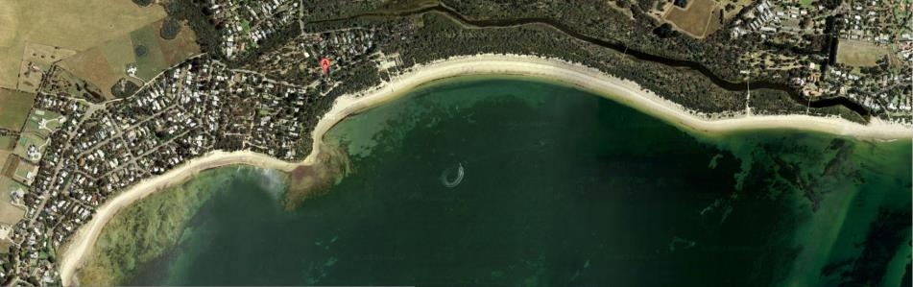

**Balnarring Foreshore Pathways (Draft) Strategy**

**2014-2019**

*Walking experiences designed to develop greater appreciation and understanding of the Reserves natural and cultural heritage.*

*Index*

1. Context 3

2 Issues and Strategies 4

2.1 Conservation 4

2.2 An integrated network 5

2.3 Education and Interpretation 6

2.4 Dog (and wildlife) friendly 7

3 Funding and Prioritisation 8

**Appendix**

1 Types of paths 9

2 Map of existing pathways (2014) 10

3 Map of proposed pathways (2019) 11

4 Reference material 12

Published by the Balnarring Beach Foreshore and Parks Reserve Committee of Management. Copyright 2014.

*Goal*

To develop a diverse network of pathways within the Balnarring Beach Foreshore and Parks Reserve (the Reserve).

The network will provide a range of recreational walking experiences designed to develop greater appreciation and understanding of the Reserves natural and cultural heritage.

*Purpose*

The Balnarring Foreshore Pathways Strategy 2014-2019 has been developed to provide a planned framework for the development and management of pathways throughout the Reserve. It responds to demand for recreational walking opportunities to meet the needs of residents and visitors alike.

The Strategy recognises the significant health and social benefits to be achieved through regular physical activity. It also recognises that well-planned recreational trails can protect natural areas from degradation through unmanaged access.

The Strategy, then, provides a framework for management and development of pathways within the Reserve over the next five years.

*Who will use the Strategy? … And how?*

The (Draft) Strategy shall be used by the Balnarring Foreshore and Parks Reserve Committee of Management (CoM) to seek input from the community, visitors and specialists in native flora and fauna.

These submissions will be considered by the CoM and inform the finalised Strategy. The final Strategy will then guide the budgeting and planning of works on pathways within the Reserve.

*A self-sustaining Reserve in near-natural condition which meets the growing recreational and environmental needs of the community in a cost-effective manner.*

*1. Context*

The Balnarring Beach Foreshore and Parks Reserve Management Plan outlines a vision for a self-sustaining Reserve in near-natural condition which meets the growing recreational and environmental needs of the community in a cost-effective manner. To achieve the vision, the Committee of Management aims to:

* Protect, improve, identify and interpret the flora and fauna values of the reserve.
* Identify, protect and where appropriate, interpret Aboriginal and European cultural heritage sites.
* Improve the quality of recreational experiences and passive enjoyment of the reserve.
* Promote the enjoyment and sustainable use of the reserve.
* Improve the conditions and overall landscape character and amenity of the reserve to promote care and respect for its environmental and cultural values. This includes the protection and improvement of key landscapes and public vistas, including towards Western Port.
* Encourage a sense of shared ownership and custodianship for the Reserve among the local and wider community by pursuing greater community participation in planning and management activities.
* Increase awareness, understanding and appreciation of the reserve’s natural and cultural values among the local and wider community.

The Reserve is located 2 kilometres south of the township of Balnarring on the south-east coast of the Mornington Peninsula, overlooking Western Port towards Phillip Island.

The area was originally occupied by the people of the Bun wurrung (also Bunurong, Boon wurrung and various other spellings) language group. Balnarring and Balnarring Beach are named from an Aboriginal word meaning "camp in open place". Balnarring Beach may contain areas of cultural significance and would have been used for campsites and hunting grounds by Aboriginal people.

European settlers entered the area and from 1840, Balnarring Beach was part of the Colourt (Coolart) run. Much of this run was released for selection about 1860 with certain areas being retained by the Crown for specific purposes. Since the earliest days, Balnarring’s beach had been a popular recreation spot. Many local families enjoyed a break by the sea and many groups from the growing Balnarring community held an annual beach picnic.

The foreshore area was also a popular place for camping. In 1914 a committee was formed which would evolve into the Balnarring Beach Foreshore Committee. By 1919 it was reported that over 200 campers had come from ‘all over the metropolis”. A permanent reserve and separate camping grounds were defined over the following years. Currently there are about 150 campsites on three defined camping reserves. Over summer, Easter and long weekends the campgrounds play host to about 450 campers each night.

There are 353 residents (Census 2011) in Balnarring Beach and over 2527 in the township of Balnarring who regularly use the area for recreation. Balnarring Beach has an ageing demographic with 24% of the population between 65 and 74 years of age. A majority of the population (59%) are characterised as elderly singles, elderly couples and older couples and families over 54 years of age. Within the population there are a large number of people with limited mobility who would benefit from improved access to the Foreshore reserve.

*2. Issues and Strategies*

*2.1 Conservation*

The overarching strategy is to conserve and preserve the natural and cultural values of the Reserve for future generations.

Natural values include those values that are important to the native flora and fauna that reside in or use the reserve for habitat, food or breeding. Cultural values include those values that have developed over time from human use. Examples of these include use of the area for ceremonial or hunting purposes by indigenous Australians and camping, walking and other passive recreation by all Australians.

The coast is a dynamic place subject to a variety of conditions. Climate change is expected to result in higher incidence of storm surge, water run-off and sea level rise over the next century. The Victorian Coastal Strategy requires authorities to take into account a sea level rise of 0.8 m by 2100, taking into account local conditions and other contributing factors, in making decisions for coastal areas.

**Actions:**

|  |
| --- |
| 2.1.1. Seek the advice of recognised experts in native flora and fauna prior to   changing access through the Reserve. |
| 2.1.2 Develop an interpretation plan that will engender a better appreciation and   understanding of the Reserve’s natural and cultural heritage. |
| 2.1.3 Ensure any development of pathways takes into account predicted sea level   change as outlined in the Victorian Coastal Strategy. |

*2.2 An integrated network*

The existing pathways have developed over time with little thought or planning. This Strategy includes rationalising paths, improving heavily used paths and creating new linkages between existing pathways to improve recreational opportunities and natural area management.

**Issues:**

* Pedestrians using the footpaths on Balnarring Beach Rd are forced to cross the road at the bridge where sightlines are limited.
* There is little opportunity for people with limited mobility to access the Foreshore areas to enjoy the natural and recreational values of the Reserve.
* An informal pathway above the rocks on the point may exacerbate erosion. This is caused by people climbing the rocks at various points (depending on tidal conditions) and continuing along to join the formal track.
* The formal track on the point has exposed roots and tripping hazards.
* There are a number of seats along the pathways. Many are poorly located and not well maintained.
* A section of pathway in C reserve is poorly aligned and hazardous. It provides easy access to the Spit for dog owners who fail to take heed of regulatory signs.
* There is an excellent network of pathways within Coolart that are difficult to access from Balnarring Beach.
* There are major weed infestations on the Spit that are difficult to access with weed spraying equipment.

**Actions:**

|  |
| --- |
| 2.2.1 Create a pedestrian pathway in the reserve from the Rangers Hut to Robertson Park. |
| 2.2.2 Create a boardwalk and seating above the rocks on Balnarring Point to arrest erosion. |
| 2.2.3 Close and rehabilitate the existing track on the Balnarring Point. |
| 2.2.4 Continue development of the boardwalk towards the main carpark as funding permits. |
| 2.2.5 Close the track linking the Yacht Club Car Park with the Eastern Spit |
| 2.2.6 Create a linkage between track from C reserve and the Coolart Bridge. The track will be a designated wildlife viewing track (no dogs) and improve access for weed management. |
| 2.2.7 Create seating and rest areas along the pathways that take advantage of views and wildlife viewing opportunities. |

*2.3 Education and Interpretation*

Signage is currently used on the Reserve for notification of regulations, for wildlife protection, to identify risks, to identify conservation works and for the interpretation of natural and cultural values. The careful consideration of signage is important. Signs may impact on the visual amenity and detract from natural and scenic values. Overuse of signs may also reduce their effectiveness as the public become ‘blinded by signs’.

Well-designed interpretation can improve peoples’ appreciation and understanding of an area’s natural and cultural values. The improved awareness leads to better compliance with regulation and develops a deeper conservation ethos within the community.

**Issues:**

* Many of the signs are in a poor state of repair and/or relate to works undertaken years ago
* There are locations with multiple sign posts and/or plinths.
* There are some sign posts with multiple signs.
* Interpretation signs are of poor quality (content and construction) lack consistent messaging and degrade quickly.
* Signs are poorly located and impact on the aesthetic.
* The network of trails is not well known among visitors.

**Actions:**

|  |
| --- |
| 2.3.1 Include signs in the regular asset inspection report. |
| 2.3.2 Remove all damaged, illegible and inappropriate signs from the Reserve. |
| 2.3.3 Remove, relocate or consolidate signs to reduce signage throughout the   Reserve. |
| 2.3.4 Consider placing multiple messages on one well-designed and well-situated   sign. |
| 2.3.5 Consider the height, materials and siting of signs to minimise visual impacts   and ensure longevity. |
| 2.3.6 Replace existing interpretation with messaging consistent with the   Interpretation Plan (see 2.1.2) |
| 2.3.7 Use temporary signage or fencing to identify immediate risk to the public. |
| 2.3.8 Create a map in conjunction with Parks Victoria to promote walking   opportunities in the area. |

*2.4 Dog (and wildlife) friendly*

Dog walking is very popular in sections of the Balnarring Beach Foreshore and Parks Reserve. Walking is good for the pet’s wellbeing and also provides an opportunity for owners to exercise and socialise. It is important to carefully balance the interests of pet owners with the rights of the public and wildlife to enjoy the reserve without the potential risk posed by dogs.

**Issues:**

* Local laws prohibit dogs on the beach between 9 am and 7 pm from 1st November to 31st March.
* Many dog owners regularly use the beach to exercise their dog at all times of the year. Compliance with the dog regulations is low.
* Beach goers expect dog owners to clean up after their dogs
* The beach is very popular with young families in summer.
* The camping ground regulations prohibit pets.
* The Reserve incorporates significant habitat for wildlife including breeding sites for rare and endangered species.
* The presence and/or scent of dogs impinge on natural wildlife including habitation and breeding.
* Baiting (1080) for foxes is conducted seasonally in some areas of the Reserve. The bait will kill domestic pets.

**Actions:**

|  |
| --- |
| 2.4.1 Clearly sign all trailheads with regulatory signs. |
| 2.4.2 Provide dog owners with easy access to the beach along major pathways. |
| 2.4.3 Provide dog bags in dispensers at key access points to the beach. |
| 2.4.4 Exclude dogs from the camping grounds and other environmentally   significant areas of the Reserve including minor paths within the Bird   Sanctuary and Habitat zone. |
| 2.4.5 Exclude dogs from all areas of the Spit (except the beach and the   pedestrian access from Somers School Camp and Lord Somers Camp) by   closing a section of the track from the Westernport Yacht Club. (see 3.2.5) |
| 2.4.6 Take an accommodating approach to responsible dog owners exercising   their dogs on-leash during the summer months. |
| 2.4.7 Impose fines on dog owners found exercising their dogs on the spit,   whether on or off-leash. |
| 2.4.8 Integrate dog friendly zones onto walk trail maps identifying areas suitable   for on-leash and nearby off-leash areas for exercising of dogs. |

*3. Funding and prioritisation*

The actions outlined in the Strategy shall be funded in a number of ways. These include budget allocations, grant funding and philanthropy.

The Committee is unable to predict the level of grant funding and philanthropic donations that will be received at the time of writing. The actions are prioritised on the table based on urgency. Items marked in red will be reliant upon external funding.

| Priority | Action |
| --- | --- |
| 1 | Seek the advice of recognised experts in native flora and fauna prior to changing access through the Reserve. (2.1.1) |
| 2 | Remove old, duplicated and damaged signs from the Reserve. Replace with new durable regulatory signs with at trailheads.  (2.3.1, 2.3.2, 2.3.3, 2.3.4, 2.3.5, 2.4.1) |
| 3 | Create a pedestrian pathway on the western side of Balnarring Beach Rd from the Rangers Hut to Robertson Park. (2.2.1) |
| 4 | Accommodate responsible dog owners with dogs on leash in summer months. (2.4.2, 2.4.5) |
| 5 | Exclude dogs from the camping grounds and other environmentally significant areas of the Reserve including minor paths within the Bird Sanctuary and Habitat zone. (2.4.3) |
| 6 | Create a map in conjunction with Parks Victoria to promote walking opportunities and dog friendly areas. (2.3.8, 2.4.7) |
| 7 | Develop an interpretation plan that will engender a better appreciation and understanding of the Reserve’s natural and cultural heritage. (2.1.2, 2.1.2) |
| 8 | Create a boardwalk and seating above the rocks on Balnarring Point to arrest erosion. (2.2.2, 2.2.3, 2.2.7) |
| 9 | Extend the boardwalk in stages towards the main car park as funding permits. |
| 10 | Create a linkage to the Coolart walking trails by extending the track from C reserve to the Coolart Bridge along the original Spit track. (2.2.5, 2.2.6, 2.4.4, 2.4.6) |

*Appendix*

*1. Types of paths*

The Reserve contains a number of different types of paths. The type of path influences the accessibility and the experience for the walker.

When deciding on the most appropriate surface it is important to consider what sort of traffic will be using the path. Pathways in the Reserve may need to be designed to cater for walkers, elderly people, and people using prams, wheelchairs or riding bikes.

There will be three main types of path on the Reserve. The table below describes each type and explains where it will be applied.

| Type | Description | Application |
| --- | --- | --- |
| Bush track | An unmade track designed for single file use. The walker has a sense of being deep in nature. | Paths with low to moderate use through stable environments. Mowing and/or hedging is the only works undertaken on bush tracks |
| Hardened path | A hardened path using foreign materials to provide a solid base. Designed for two-way traffic that may include prams, bikes and wheelchairs. | Paths with heavy traffic in stable and/or less sensitive environments. Path surfaces are maintained and vegetation hedged to provide clear access. |
| Boardwalk | A raised boardwalk constructed of treated timber and stainless steel fixings. They may be elevated on stumps or floating on the ground surface. | Paths in areas with high conservation value and/or susceptible to erosion. Used in areas where traffic may include prams, bikes and wheelchairs. |

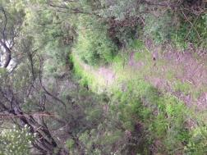

**1. Bush Track**

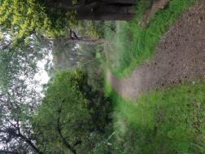

**2. Hardened Path**

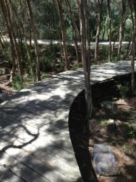

**3. Boardwalk**

*2. Existing Pathway Network*

Map of reserve and surrounding area depicting existing track types: vehicle track, boardwalk, hardenend path, bush track, and informal track.
Also shows roads, green and built up areas, and water at a coarse scale.

*3. Proposed Pathway Network*

Map of reserve and surrounding area depicting proposed track types: vehicle track, boardwalk, hardenend path, bush track, proposed track, proposed boardwalk, and closed/rehabilitated path. Also depicts no dog areas.
Also shows roads, green and built up areas, and water at a coarse scale.

*4. Reference material*

Balnarring Beach Foreshore and Parks Reserve Management Plan 2014, Balnarring Beach Foreshore and Parks Reserve Committee of Management, 2014.

Victorian Coastal Strategy 2014, Department of Environment and Primary Industries, 2014.

Best Practice Management Guidelines for Committees of Management Managing Caravan and Camping Parks on Crown Land, Department of Sustainability and Environment, 2012.

Siting and Design Guidelines for Structures on the Victorian Coast, Victorian Coastal Council, 2008.

Disability Action Plan 2013 – 2017, Mornington Peninsula Shire, 2013

National Disability Strategy 2010 – 2020, Department of Social Services, 2010

Port Phillip and Western Port Regional Catchment Strategy, PPWPCMA, 2004.

The Western Port RAMSAR Strategic Management Plan, Parks Victoria, 2003.

**Relevant Legislation:**

Crown Land (Reserves) Act 1978

Coastal Management Act 1995

Flora and Fauna Guarantee Act 1988

Environment Protection and Biodiversity Conservation Act 1999

Appendix 8:Camping Reserve A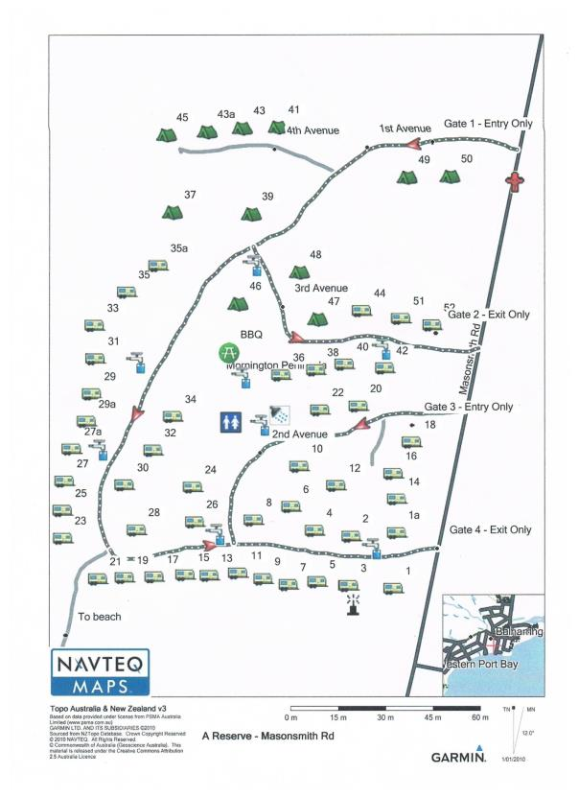

Appendix 9: Camping Reserve B

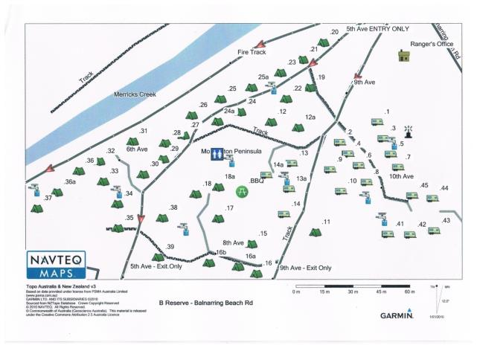

Appendix 10: Camping Reserve C

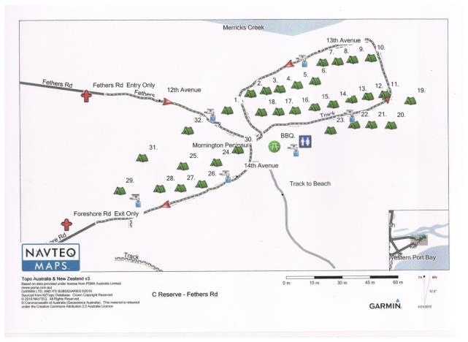

1. Where the cost is listed as N/A, this forms part of the Committee’s general expenditure such as staff wages. Estimates for each individual item are not provided.