delwp.vic.gov.au

|  |
| --- |
| 2021 Coastcare Victoria Community Grants Guidelines    Title  Subtitle |

|  |  |
| --- | --- |
|  |  |

# Warning: Health and safety is paramount

You must put in place relevant Work Health Safety policies and procedures to ensure the safety of those undertaking grant activities. You must comply with all public health measures and directions in relation to coronavirus (COVID-19). Stay up to date at <https://www.dhhs.vic.gov.au/coronavirus> and <https://www.coronavirus.vic.gov.au/>

# Acknowledgements

|  |  |  |  |
| --- | --- | --- | --- |
|  |  |  |  |

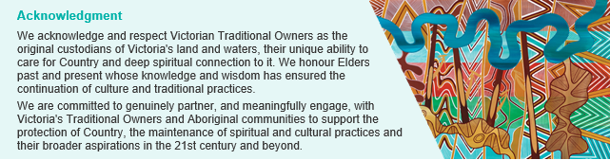

### Our commitment to inclusion and diversity

Coastcare Victoria supports liveable, inclusive and sustainable communities. Coastcare Victoria supports a volunteering culture diverse in ability, gender, sexuality, age, socio-economic status, ethnicities and religious beliefs. Coastcare Victoria believes everyone has the right to feel safe, welcome and have their life experience valued. Fostering diversity and inclusion helps people to learn from each other and develop new ways to work effectively. At Coastcare Victoria we are connected to liveable, inclusive and sustainable communities; we are diverse; we are inclusive and flexible; we are safe and respectful.

© The State of Victoria Department of Environment, Land, Water and Planning 2021.

LogoThis work is licensed under a Creative Commons Attribution 4.0 International licence. You are free to re-use the work under that licence, on the condition that you credit the State of Victoria as author. The licence does not apply to any images, photographs or branding, including the Victorian Coat of Arms, the Victorian Government logo and the Department of Environment, Land, Water and Planning (DELWP) logo. To view a copy of this licence, visit http://creativecommons.org/licenses/by/4.0/

Disclaimer This publication may be of assistance to you but the State of Victoria and its employees do not guarantee that the publication is without flaw of any kind or is wholly appropriate for your particular purposes and therefore disclaims all liability for any error, loss or other consequence which may arise from you relying on any information in this publication.

## Accessibility

If you would like to receive this publication in an alternative format, please telephone the DELWP Customer Service Centre on 136186, email customer.service@delwp.vic.gov.au or via the National Relay Service on 133 677 www.relayservice.com.au. This document is also available on the internet at [www.delwp.vic.gov.au](http://www.delwp.vic.gov.au).

|  |
| --- |
|  |

CONTENTS

Warning: Health and safety is paramount 2

Acknowledgements 2

Accessibility 2

CONTENTS 3

What is the 2021 Coastcare Victoria Community Grants program? 5

How much funding is available? 5

When do applications close? 5

What types of grants are available? 5

1. Stewardship and Education Grants: 6

2. Strengthening Our Volunteer Groups Grants: 6

3. Supporting Traditional Owner Self-Determination Grants: 6

Who can apply? 6

Eligibility 6

Who can sponsor an applicant? 7

Ineligible applicants 7

Assessments 7

Budget 7

Ineligible activities and budget items 8

Does the applicant need to contribute to their project’s budget? 8

How do I calculate the value of our volunteer contribution? 8

How to apply? 9

What supporting documents will need to be provided? 9

Stream 1: Stewardship and Education 10

Objectives 10

Assessment criteria and weighting 10

What sort of projects will be funded? 10

Stream 2: Strengthening Our Volunteer Groups (marine and coastal volunteering) 11

Objectives 11

Assessment criteria and weighting 11

What sort of projects will be funded? 11

Stream 3: Supporting Traditional Owner Self-Determination 13

Objectives 13

Assessment criteria and weighting 13

What sort of projects will be funded? 13

Terms and conditions 15

Additional information and Enquiries 16

What is the notification process? 16

Checklist 16

Contact Details 17

Frequently Asked Questions 18

Key Information 18

Submitting Applications 19

Land Manager Support and Consent 20

Volunteer contributions 21

Budgets and GST 21

Biodiversity Information 21

MapshareVic Instructions 23

## What is the 2021 Coastcare Victoria Community Grants program?

The Coastcare Victoria Community Grants program supports community organisations to protect and enhance the coastal and near-shore marine environment. The 2021 grants program is funded by the Victorian Government’s Sustainability Fund, and the Victorian Great Outdoors Initiative, which seek to build community capacity, support community adaptation and improve ecosystem resilience to climate change. The 2021 Grants Program aims to support the three pillars in the *Coastcare Victoria Strategy 2021-2026*:

**Marine and Coastal Stewardship** - conservation, rehabilitation, restoration and preventative actions for Victoria’s coastal and marine ecosystems.

**Thriving Marine and Coastal Community Groups and Networks** – supporting community organisations to diversify, plan for the future and be responsive to change.

**Victorians Valuing the Coast** - supporting community participation, engagement and education to enhance community knowledge and understanding of coastal and marine management.

## How much funding is available?

The Victorian government is providing funding up to $647,000 for the 2021 Coastcare Victoria Community Grants program.

This year, there are two types of grants available:

* Small grants of up to $5,000
* Large grants from $5,000 up to $30,000 for larger projects

Multiple grant applications may be submitted. However, only one application per group across all streams may be deemed successful.

Each application you submit must be separate (not reliant on another project) and must not be a scaled up or scaled down version of another application.

## When do applications close?

Make sure your application is submitted by **5pm on 23 June 2021.** Late and incomplete applications will not be considered.

Key dates

|  |  |
| --- | --- |
|  | |
| Applications open | Wednesday 12 May 2021 |
| Applications close | Wednesday 23 June 2021, 5pm |
| Successful applicants notified | Late August 2021 |
| Agreements signed (milestone 1) and payments made | September 2021 |
| Job Safety Plan due (milestone 2) | December 2021 |
| Final report due (milestone 3) and project completed | June 2022 (short projects), June 2023 (long projects) |

## What types of grants are available?

Three streams of grants are available in 2021 -

1. Stewardship and Education

2. Strengthening Our Volunteer Groups

3. Supporting Traditional Owner Self-Determination

## 1. Stewardship and Education Grants:

* To build community capacity, support community adaptation and improve ecosystem resilience to climate change through actions which:
  + Conserve, rehabilitate, restore and protect Victoria's coastal and marine ecosystems
  + Support community participation, engagement and education to enhance community knowledge and understanding of coastal and marine management.

## 2. Strengthening Our Volunteer Groups Grants:

* To build community capacity and support community adaptation to climate change through actions which:
  + Expand, diversify and increase inclusivity of volunteer bases (e.g. encourage participation of volunteers from different backgrounds, cultures, nationalities, abilities and youth)
  + "Reimagine volunteering" to attract more/ different volunteers e.g. flexible, casual, event-based or short-term volunteering
  + Improve volunteer recruitment and retention
  + Succession planning for your group.

## 3. Supporting Traditional Owner Self-Determination Grants:

* To support Traditional Owner capacity and support community adaptation to climate change through actions which:
  + Recognise Traditional Owners longstanding and deep knowledge and connection to Country
  + Recognise and support Traditional Owners’ role in leading healing and ongoing care and use of Country
  + Support Traditional Owners in restoring marine and coastal cultural knowledge and practice
  + Support two-way capability and capacity building to improve the effectiveness of working relationships and build a shared understanding between Traditional Owners and other marine and coastal land managers.

## Who can apply?

The following community groups and organisations with a focus on marine and coastal environs are eligible for funding:

* Coastcare Victoria groups
* Aboriginal groups and organisations, land councils, trusts and co-operatives working on-country
* Landcare groups
* ‘Friends of’ groups
* Field naturalist groups
* Coastal Committees of Management
* Non-government community organisations
* Community service organisations and clubs
* Educational institutions including schools and universities (recommended to partner with local coastal volunteer group).

## Eligibility

To be eligible for funding applicants must be:

* an incorporated association registered through Consumer Affairs Victoria or be incorporated through an umbrella group such as Landcare Victoria Inc; or
* registered as a not-for-profit organisation with the Australian Charities and Not-for-profits Commission (ACNC); or
* coastal Committee of Management incorporated under the *Crown Land (Reserves) Act 1978*

Groups and networks that do not meet the above requirements can still apply for funding but must operate under the auspices of a sponsor organisation. You will be required to supply written approval (such as supporting letter) from your auspice (sponsor) as part of your application.

## Who can sponsor an applicant?

A sponsoring group or organisation must:

* be either incorporated, a State Government/ statutory body/authority or registered as a not-for-profit with ACNC;
* agree to take responsibility for the management and safety of the group’s volunteers and participants; and
* sign the funding agreement, receive the grant payment and be accountable for the delivery and reporting of the project.

## Ineligible applicants

* Commonwealth Government agencies
* Private companies or trusts
* Private individuals
* Catchment Management Authorities
* Industry bodies
* State Government statutory bodies/authorities
* Water Authorities
* Local government

Previous recipients of a Coastcare Victoria Community Grant with outstanding project completion reports are ineligible for further funding until reporting requirements are met.

## Assessments

Applications will be assessed by a panel of Coastcare Victoria and other Department of Environment, Land, Water and Planning (DELWP) staff based on the criteria set out in this document (pages 10-14).

## Budget

Your application must fully and clearly define project costs, including any GST on supply items required to deliver your project (for example nursery plants or contractor services).

We encourage applicants, where possible, to provide quotes from contractors etc to support their application.

The program will support the following categories of expenditure (note this list is not exhaustive - please discuss your project and items to be funded with your local Coastcare Victoria Facilitator):

* Advertising
* Environmental assessments*;
* Equipment hire or purchase directly related to project's on-ground components**
* Materials (e.g. chemicals, plants, etc)
* Printing / design
* Rubbish removal (if necessary, prior to site restoration)
* Site preparation
* Training and certification (if directly related to funded activity)
* Contractors*
* Exclusion fencing
* Personal protective equipment (e.g. gloves, goggles and masks)
* Postage
* Project coordination*^
* Signage
* Site security
* Pilot projects
* Costs of permits, Cultural Heritage checks etc directly related to the project.

*MUST demonstrate that contractors, environmental assessment and/or project coordination are essential to facilitate the on-ground works component of the project and are for tasks which your group is unable to carry out.

** Capital items must become a registered asset of the entity.

*^ A maximum of 15% of total grant allocation can be used for incurred costs for project coordination (e.g. management of resources, meetings, information, project plans and schedules, administrative tasks, risk management, reporting, stakeholders).

## Ineligible activities and budget items

Funding is NOT available for the following (note this list is not exhaustive - please discuss your project and items to be funded with your local Coastcare Victoria Facilitator):

* Wages of staff
* Summer by the Sea Program activities
* Works on or for the benefit of private land
* Development of recreation facilities or projects primarily focused on improving amenity
* Any activity involving clearing of native vegetation, unless it is a declared environmental weed in your area and appropriate permits are obtained
* Revegetation works using species which are not local indigenous species
* Removal of exotic trees from coastal foreshore areas where there is little or no remnant vegetation
* Large infrastructure or engineering works
* Activities (or components of projects) that have been funded by other funding bodies
* The purchase or production of promotional goods or merchandise which are considered to be environmentally damaging e.g. plastics (hard or soft), polystyrene, single use items
* Goods or services for competitions, prizes, gifts, vouchers or alcohol
* General operating or travel costs not directly associated with a project/event
* Sand/beach renourishment
* High-risk activities involving the use of fire-arms, tranquilisers, or explosives for vermin control
* Any activity required as an offset (as a condition of a permit to clear native vegetation)
* Projects not relating to Victoria’s marine and coastal environments
* Projects assessed as not meeting the eligibility and assessment criteria.

## Does the applicant need to contribute to their project’s budget?

Applicants do not have to contribute funding to their project, however, a project that can demonstrate in-kind contributions provides greater value for money to Coastcare Victoria. Contributions can be in various forms including time, resources or funds.

## How do I calculate the value of our volunteer contribution?

Volunteer time contributions should be valued at $40 per hour. Multiply the number of volunteers by the hours they will spend on your project, then multiply by $40.

Example: 35 volunteers x 10 hours each x $40 = $14,000 in volunteer time contribution.

## How to apply?

Applications are submitted online using the DELWP Grants Online portal. Use the links below to start your application:

1. Stewardship & Education, go to: <https://delwp1.force.com/publicform?id=a0h4P00001dlQ3q>

2. Strengthening our Volunteer Groups, go to: <https://delwp1.force.com/publicform?id=a0h4P00001dlQ3v>  
3. Supporting Traditional Owner Self-Determination, go to: <https://delwp1.force.com/publicform?id=a0h4P00001dlQ46>

To access existing drafts or submitted applications, go to: <https://delwp1.force.com/>

You’ll need to register for an account prior to commencing your application. You will receive an application number after you apply online. Please quote this number in all communications with DELWP relating to your application.

Make sure your application is submitted by **5pm on 23 June 2021.** Late and incomplete applications will not be considered.

**If you require assistance submitting your application online, contact the Grants Information Line on 1300 366 356 or** [**grantsinfo@delwp.vic.gov.au**](mailto:grantsinfo@delwp.vic.gov.au)**.**

## What supporting documents will need to be provided?

Please submit the following documents with your application:

1. Written support from the relevant public land manager to undertake the activity. At the application stage, we are only asking for support. If successful, formal consents, permits and cultural heritage requirements will be required.
2. Letters of support from partner organisations
3. Map of proposed work area (see Mapshare instructions on page 22 of this document)
4. Current condition photo(s) of the area for pre and post work monitoring purposes.

Supporting documents must be in an acceptable file type, such as Word, Excel, PDF, or JPEG. The maximum file size for each file is 5MB.

Stream 1: Stewardship and Education

## Objectives

To build community capacity, support community adaptation and improve ecosystem resilience to climate change through actions which:

* Conserve, rehabilitate, restore and protect Victoria’s coastal and marine ecosystems
* Support community participation, engagement and education to enhance community knowledge and understanding of coastal and marine management in the face of climate change.

**Note: Project must focus primarily on marine and coastal volunteering in Victoria**

## Assessment criteria and weighting

Applications MUST address ALL the following criteria:

|  |  |  |
| --- | --- | --- |
| Criteria | Value | Description |
| Legacy of project | 10% | The ongoing legacy of this project. Level of effectiveness in how well this legacy is maintained after the funding ends |
| Environmental outcome | 40% | Extent to which the project will help to conserve, rehabilitate, protect or enhance the coastal or near shore marine environment |
| Community involvement | 30% | Extent to which project involves volunteers or the community in on-ground action, engagement or education |
| Risk management | 10% | Application identifies potential risks to the project and adequate actions to remove, manage or reduce the risks |
| Budget | 10% | Project represents good value for money by delivering multiple outcomes, high public benefit, reasonable costings and adequate in-kind contribution |

## What sort of projects will be funded?

Examples of applications Coastcare Victoria is seeking include projects which:

* Protect, rehabilitate and enhance coastal and marine habitats, waterways and wetlands by stabilising dunes, mitigate the effects of coastal erosion, establishing wildlife corridors or enhancing/protecting high quality remnant native coastal habitat
* Establish or contribute to long term community based ‘citizen science’ programs for monitoring of coastal or marine environments as well as marine species
* Protect critical habitat for coastal and marine species, e.g. nesting sites, feeding sites, roosting sites, aggregation sites, from the impacts of threats including pest animals and domestic animal disturbance
* Increase participation of individuals and communities in coastal and marine conservation projects, including enhancing skills and knowledge and raising community awareness
* Reduce or control marine plastic pollution
* Foster new partnerships between community groups and organisations working to protect the coast
* Educate the community about caring for Victorian marine and coastal environments. Focus will be on how communities understand dynamic coastal landscapes, and how they can adapt to climate change.

Stream 2: Strengthening Our Volunteer Groups (marine and coastal volunteering)

## Objectives

To build community capacity and support community adaptation to climate change through actions which:

* Expand, diversify and increase inclusivity of volunteer bases (e.g. encourage participation of volunteers from different backgrounds, cultures, nationalities, abilities and youth)
* “Reimagine volunteering” to attract more/ different volunteers e.g. flexible, casual, event-based or short-term volunteering
* Improve volunteer recruitment and retention
* Succession planning for your group

Further reading – Victorians Volunteering for Nature Environmental Volunteering Plan, State Government of Victoria, 2018, **pages 8-13**: <https://www.environment.vic.gov.au/volunteering>

**Note: Project must focus primarily on marine and coastal volunteering in Victoria**

## Assessment criteria and weighting

Applications MUST address ALL the following criteria:

|  |  |  |
| --- | --- | --- |
| Criteria | Value | Description |
| Legacy of project | 10% | The ongoing legacy of this project. Level of effectiveness in how well this legacy is maintained after the funding ends |
| Volunteer resilience outcome | 40% | Extent to which project helps to strengthen marine and coastal volunteering |
| Innovation | 30% | Application demonstrates willingness to try something new or do something in a different way |
| Risk management | 10% | Application identifies potential risks to the project and adequate actions to remove, manage or reduce the risks |
| Budget | 10% | Project represents good value for money by delivering multiple outcomes, high public benefit, reasonable costings and adequate in-kind contribution |

## What sort of projects will be funded?

This grants category for Coastcare Victoria is designed to support the second strategic pillar of the Coastcare Victoria Strategy 2021-2026:

***Thriving Marine and Coastal Community Groups and Networks*** *– supporting community organisations to diversify, plan for the future and be responsive to change.*

Coastcare Victoria is looking forward to receiving a diverse range of innovative applications. Below are two case studies which provide examples of suitable projects:

**Case Study 1: Renewal, Planning for the Future - South Gippsland Conservation Society**

The South Gippsland Conservation Society (SGCS) has a long-standing history, supporting conservation in the region and feel the need to refresh their vision, management and membership in order to continue to fulfil this role. They have been in operation since 1976 during which time there have been significant internal and external changes. With the assistance of a consultant the SGCS are developing a strategic plan with a focus on increasing volunteer attendance at working bees, strengthening partnerships with both government agencies and other environmental groups and engaging more people to be involved in governance and management of the organisation.

**Case Study 2: Wilderness Coast Project - Sanctuary Youth Group and Friends of Mallacoota**

The Sanctuary Youth Group is partnering with the Friends of Mallacoota to engage the youth of Mallacoota in environmental volunteering in a meaningful way, further supporting recovery after the 2020 bushfires. This project combines on ground works such as weeding, seed propagation and beach litter clean ups and auditing using LitterWatch methodology in conjunction with fun activities such as surf lessons, live music, food vans and much more. Twelve working bees’ over 12 months are supported by an activity once work is completed. This collaboration also demonstrates strong mentoring and sharing between a long-standing group and one just emerging.

Stream 3: Supporting Traditional Owner Self-Determination

## Objectives

* To support Traditional Owner capacity and support community adaptation to climate change through actions which:
  + Recognise Traditional Owners longstanding and deep knowledge and connection to Country
  + Recognise and support Traditional Owners’ role in leading healing and ongoing care and use of Country
  + Support Traditional Owners in restoring marine and coastal cultural knowledge and practice
  + Support two-way capability and capacity building to improve the effectiveness of working relationships and build a shared understanding between Traditional Owners and other marine and coastal land managers

**Note: Project must focus on the marine and coastal environments in Victoria**

## Assessment criteria and weighting

Applications MUST address ALL the following criteria:

|  |  |  |
| --- | --- | --- |
| Criteria | Value | Description |
| Legacy of project | 10% | The ongoing legacy of this project. Level of effectiveness in how well this legacy is maintained after the funding ends |
| Supporting Self-Determination | 30% | Extent to which project helps to strengthen and support Traditional Owner Self-Determination |
| Environmental outcome | 20% | Extent to which the project will help to conserve, rehabilitate, protect or enhance the coastal or near shore marine environment |
| Community involvement | 20% | Extent to which project involves volunteers or the community in on-ground action, engagement or education |
| Risk management | 10% | Application identifies potential risks to the project and adequate actions to remove, manage or reduce the risks |
| Value for money | 10% | Project represents good value for money by delivering multiple outcomes, high public benefit, reasonable costings and adequate in-kind contribution |

## What sort of projects will be funded?

This is a new grants stream for Coastcare Victoria, and is designed to support the Traditional Owner Self-Determination actions of the Coastcare Victoria Strategy 2021-2026:

***Thriving Marine and Coastal Community Groups and Networks*** *– supporting community organisations to diversify, plan for the future and be responsive to change.*

Coastcare Victoria is looking forward to receiving a diverse range of innovative applications. Below are two case studies which provide examples of suitable projects:

**Case Study 1: Gunditj Mirring Convincing Ground Restoration Project**

This project aims to restore a tract of land that was traditionally the clan lands of the Kilcarrer Gunditj where The Convincing Ground massacre took place following conflict with whalers. “The project will get our mob on country to lead the project by educating ourselves in regards to plant identification, weed removal, and planting and restoration in line with how [it] looked prior to colonisation… the area needs to be healed and this can only be done by us.” The Gunditj Mirring Traditional Owners Aboriginal Corporation will also install interpretive signage for storytelling purposes and will undergo track maintenance to improve access, especially for Elders. Following restoration, the area will be used to educate the wider community and provide the opportunity for dual storytelling as the site also contains non-Indigenous heritage associated with early whaling.

**Case Study 2: Moogji Coastal Works Project 2018-2019**

The aims of this project were to control coastal weeds and reduce erosion in close proximity to valued Aboriginal shell midden sites, and to educate the Aboriginal and non-Aboriginal community about the impacts of weeds in the coastal environment. The construction of brush fencing reduced wind erosion which was impacting on the shell midden sites and the native vegetation. The use of ti-tree brush will in time allow

revegetation of the exposed dunes and sand areas.

This project also involves on ground weed control to manage the existing sea spurge and inhibit further infestations in sensitive cultural areas. To ensure minimal disturbance to the shell midden

sites, the sea spurge will be controlled by chemical application. Combining brush fencing and weed control will reinstate the integrity of those site areas.

## Terms and conditions

Prior to receiving funding, successful applicants will be required to enter into a Victorian Common Funding Agreement.

### Funding Agreements

Successful applicants must enter into a Victorian Common Funding Agreement with DELWP. It is recommended that applicants review the terms and conditions before applying. Information about the Victorian Common Funding Agreement is available on <https://www.vic.gov.au/victorian-common-funding-agreement>

Please note, successful applicants may be subject to additional Coastcare Victoria specific funding agreement conditions.

### Legislative and regulatory requirements

In delivering the activity grant recipients are required to comply with all relevant Commonwealth and state/territory legislations and regulations, including but not limited to those listed below. Speak to the relevant land manager for advice on requirements specific to your project.

* *Occupational Health and Safety Act 2004*
* *Marine and Coastal Act 2018*
* *Flora and Fauna Guarantee Act 1988*
* *Native Title Act 1993*
* *Traditional Owner Settlement Act 2010*
* *Aboriginal Cultural Heritage Act 2003*
* *Aboriginal Heritage Amendment Act 2016*
* *Aboriginal Heritage Regulations 2018*
* *Planning and Environment Act 1987*
* *The Privacy Act 1988 (Commonwealth)*
* *The Freedom of Information Act 1982 (Vic)*

### Tax Implications

Applicants should consult the Australian Taxation Office or seek professional advice on any taxation implications that may arise from this grant funding.

Successful applicants without an ABN will need to provide a completed Australian Taxation Office form ‘Statement by a Supplier’ so that no withholding tax is required from the grant payment.

### Acknowledging the Victorian Government’s support

Successful applicants are expected to acknowledge the Victorian Government’s support and promotional guidelines (<https://www2.delwp.vic.gov.au/grants>) will form part of the funding agreement. Successful applicants must liaise with Coastcare Victoria to coordinate any public events or announcements related to the project.

### Payments

Payments will be made if:

* the funding agreement has been signed by both parties,
* grant recipients provide reports as required, or otherwise demonstrate that the activity is progressing as expected,
* other terms and conditions of funding continue to be met.

### Monitoring

Grant recipients are required to comply with project monitoring and reporting requirements as outlined in the funding agreement. This may include progress reports, photos, site inspections, completion reports and acquittal documentation.

### Privacy

Any personal information about you or a third party in your application will be collected by DELWP for the purposes of administering your grant application and informing Members of Parliament of successful applications. Personal information may also be disclosed to external experts, such as members of assessment panels, or other Government Departments for assessment, reporting, advice, comment or for discussions regarding alternative or collaborative grant funding opportunities. If you intend to include personal information about third parties in your application, please ensure that they are aware of the contents of this privacy statement.

Any personal information about you or a third party in your correspondence will be collected, held, managed, used, disclosed or transferred in accordance with the provisions of the *Privacy and Data Protection Act 2014* and other applicable laws.

DELWP is committed to protecting the privacy of personal information. You can find the DELWP Privacy Policy online at www.delwp.vic.gov.au/privacy.

Requests for access to information about you held by DELWP should be sent to the Manager Privacy, P.O. Box 500 East Melbourne 8002 or contact by phone on 9637 8697.

## Additional information and Enquiries

Additional information is available at the program web page: [Coastcare Victoria (marineandcoasts.vic.gov.au)](https://www.marineandcoasts.vic.gov.au/coastal-programs/Coastcare-Victoria)

After reading these Guidelines if you have any questions, please contact your local Coastcare Victoria Facilitator – see contact details below. Coastcare Victoria requires you to discuss your project with your Facilitator before submitting your application to ensure your project has the best chance of success.

## What is the notification process?

Successful and unsuccessful applicants will be notified in writing after the assessment process is completed. All decisions are final and are not subject to further review. Unsuccessful applicants can ask for feedback on their application.

## Checklist

Before applying, please complete the following checklist.

Have you:

 read these guidelines carefully?

 checked if your organisation is eligible for this grant funding?

 checked if your activity is eligible for this grant funding?

 spoken to your local Coastcare Victoria Facilitator about your project?

 spoken to and obtained written support from relevant land managers for your project?

 spoken to local Traditional Owner group?

 prepared the appropriate supporting documents?

|  |  |
| --- | --- |
| **Far South West**  Ellie Morrow  Coastcare Victoria Facilitator  Phone: 0436 284 073  Email: [ellie.morrow@delwp.vic.gov.au](mailto:bethany.hunting@delwp.vic.gov.au)  **Bellarine and Surf Coast**  Alexandra (Ally) Clark  Coastcare Victoria Facilitator  Phone: 0437 035 120  Email: [alexandra.clark@delwp.vic.gov.au](mailto:elise.snell@delwp.vic.gov.au)  **Port Phillip Bay and Westernport**  Johanna (Joiee) Tachas  Coastcare Victoria Facilitator (acting)  Phone: 0427 268 169  Email: [johanna.tachas@delwp.vic.gov.au](mailto:johanna.tachas@delwp.vic.gov.au) | **South Gippsland**  Tracey Miller-Armstrong  Coastcare Victoria Facilitator  Phone: 0427 441 013  Email: [tracey.miller-armstrong@delwp.vic.gov.au](mailto:bethany.hunting@delwp.vic.gov.au)  **East Gippsland**  Bethany Hunting  Coastcare Victoria Facilitator  Phone: 0436 629 941  Email: [bethany.hunting@delwp.vic.gov.au](mailto:bethany.hunting@delwp.vic.gov.au)  **Coastcare Victoria Coordinator**  Jacqui Pocklington  Coastcare Victoria Statewide Coordinator  Phone: 0417 463 532  Email: [jacqueline.pocklington@delwp.vic.gov.au](mailto:jacqueline.pocklington@delwp.vic.gov.au) |

## Contact Details

## 

Frequently Asked Questions

## Key Information

|  |  |
| --- | --- |
|  | |
| **Applications open** | Wednesday 12 May 2021 |
| **Applications close** | Wednesday 23 June 2021, 5pm |
| **Successful applicants notified** | Late August 2021 |
| **Agreements signed (milestone 1) and payments made** | September 2021 |
| **Job Safety Plan due (milestone 2)** | December 2021 |
| **Final report due (milestone 3) and project completed** | June 2022 (short projects)  June 2023 (long projects) |

*For eligibility, criteria, eligible budget items and activities and funding terms and conditions, please read the Coastcare Victoria Community Grants Guidelines 2021.*

**How much funding is available for each grant?**

This year there will be two types of grants available:

* Small grants of up to $5,000 (perfect for smaller initiatives i.e. training courses only, website development, education, on ground works)
* Large grants from $5,000 up to $30,000 for larger projects

### Can we submit more than one application?

* You can submit multiple grant applications. However, only one application per group across all streams may be deemed successful. This is to ensure equity across groups distributed along the Victorian coastline.
* Each application you submit must be separate (not reliant on another project) and must not be a scaled up or scaled down version of another application.

**Will we be required to match funding?**

Applicants do not have to contribute funding to their project, however, a project that can demonstrate in-kind contributions provides greater value for money to Coastcare Victoria. Contributions can be in various forms including time, resources or funds.

**How long do successful applicants have to complete their project?**

Projects must be completed (including the submission of acquittal documentation to Coastcare Victoria) by the due date on the funding agreement.

**Who should we talk to about the project?**

Coastcare Victoria requires you to discuss your project with your local Coastcare Victoria Facilitator before submitting your application to ensure your project has the best chance of success. Your facilitator can help you with project planning and your application.

Please see Coastcare Victoria Facilitator contact details at the end of this document.

You are also **strongly encouraged** to discuss your project with your relevant Traditional Owners before submitting your application to ensure your project has the best chance of delivery within the timeframes. Your local facilitator, in partnership with the relevant regional DELWP Inclusion Officer, can assist in brokering this relationship if you are unsure how to commence discussions.

**Can we apply for a grant if we have received Coastcare Victoria funding in the past?**

Yes, as long as all your projects progress reports from previously funded projects are up to date or have been submitted, or your final acquittal has been submitted by the due date as required in your previous funding agreement. If your project has not yet been completed, please discuss your new application with your Coastcare Victoria Facilitator as you may need to demonstrate progress on your project before being considered eligible to apply.

Coastcare Victoria will not fund activities (or components of projects) that have been funded by other sources.

## Submitting Applications

**How do we apply for the Coastcare Victoria Community Grants 2021?**

Applications are submitted online using the DELWP Grants Online portal.

* To apply for Stewardship & Education Grants (Stream 1), go to: <https://delwp1.force.com/publicform?id=a0h4P00001dlQ3q>
* To apply for Strengthening our Volunteer Groups grants (Stream 2), go to: <https://delwp1.force.com/publicform?id=a0h4P00001dlQ3v>
* To apply for Supporting Traditional Owner Self Determination grants (Stream 3), go to: <https://delwp1.force.com/publicform?id=a0h4P00001dlQ46>

To access existing drafts or submitted applications, go to: <https://delwp1.force.com/>

You’ll need register for an account prior to commencing your application. You will receive an application number after you apply online. Please quote this number in all communications with the department relating to your application.

Applicants can attach documents to an online application as long as they are in an acceptable file type and don’t exceed the maximum file size. Important tips:

* when submitting an application online, applicants should check carefully to ensure all your attachments have been uploaded
* the system has a file size limit of 5MB
* please only email files that you haven’t been able to attach

*Make sure your application is submitted by* ***5pm on 23 June 2021.*** *Late and incomplete applications will not be considered.*

**Can we view previous applications?**

Yes, so long as they use the same login as last time.

**We are having trouble with the online application - where do we go for help?**

If you require assistance submitting your application online, contact the Grants Information Line on 1300 366 356 or [grantsinfo@delwp.vic.gov.au](mailto:grantsinfo@delwp.vic.gov.au) or contact your local Coastcare Victoria Facilitator.

**Is there a word count for the application?**

Please pay attention to the word count as detailed in the relevant sections.

**Does the application form auto-save or should we save it manually?**

* Auto-saves when going to the next page.
* If you wish to go back and forward between pages, you should use the ‘Previous Page’ and ‘Next Page’ buttons – do not use the back and forward buttons on your browser.

**Can we submit more than 10 attachments?**

If you need to submit more than 10 attachments, additional attachments can be emailed to your local Coastcare Victoria Facilitator. We ask that you do not re-send documents that have already been attached. If you are concerned about documents being missed please contact your local Coastcare Victoria Facilitator directly rather than doubling up.

**DELWP Grants Online Portal Hints**

* Do not use the Internet Explorer browser – choose Firefox, Chrome or another browser as these browsers are more stable with the DELWP Grants Online Portal.
* When you register, note down the email and password you used. You will need it to access your application later.
* After you start your application, you will receive a notification email with a link to return to the application form. It is easiest to continue accessing your application via this link.
* If completing application in Word document first, keep formatting simple to assist with copying work across to the DELWP Grants Online Portal.
* Please note, if converting application to a PDF document, there are known alignment issues. Apologies, there has been no known resolution to this issue.
* Two people logging into the same grant application may cause issues such as data loss. You are encouraged to only have one person working in the application at any one time.
* Refer to the DELWP Grants Online Information Sheet available on the Coastcare Victoria website.

## Land Manager Support and Consent

### Do we need consent from a land manager?

If your project involves changing a site in some way, you will need consent from the land manager. This includes (but is not limited to) revegetation, clearing weeds or rubbish, minor works such as fences or paths.

If your project involves holding events or activities on a site, you should seek land manager consent.

If you have any queries about land manager consent, seek advice from the land manager or from your local Coastcare Victoria Facilitator.

When submitting your application, you are required to attach written support from relevant land managers. Formal consent can be obtained later if your project is funded.

It is advised to check the land manager status of your project site with your local Coastcare Victoria Facilitator as this can sometimes be unclear where borders cross and can even change. If you cannot provide the details of your land manager, please follow up with your facilitator before submitting your application. This must be completed before your application is submitted.

### What is the difference between a letter of support and formal consent?

A letter of support shows that your land manager has given in principle support to your project. It can be a simple letter or email. You will need to provide a letter of support with your application.

Formal consent involves gaining official approval to work on the site. Your land manager will check that your project meets relevant obligations, which could include cultural heritage, planning overlays and risk management. Formal consent is comprehensive, takes time and may cost money. You should include time and relevant costs for consents and permits when planning and budgeting for your project.

### Do we need consent from all land managers?

Yes. You will need consent from all relevant land managers that own or manage a site you intend to work on.

### We are not sure who the land managers will be – do we need consent?

Yes. If you need assistance determining the land manager of your site, please contact your local Coastcare Victoria Facilitator.

### We have never needed consent from my land manager before – do we need it now?

If your project involves working on a site, you will need consent – even if you haven’t needed (or had) it for similar activities before.

## Volunteer contributions

### What is the volunteer contribution rate?

$40 per hour for all volunteers and all activities they undertake for your project. This standard rate allows applications to be considered in a consistent way and is based on an average rate that was calculated by the Australian Bureau of Statistics in 2010, which we have corrected for inflation.

### Can we use a higher rate for volunteers with professional skills worth more than $40?

No. $40 per hour is a standard rate that values the contribution that all volunteers make to your project.

### What kind of volunteer activities can count towards in kind support?

Any activity that your volunteers undertake as part of the project can count. This could include:

* Physical work, such as planting, building or litter collection
* Planning the logistics for the project
* Preparing educational material
* Coordinating an event, such as corporate or school volunteering, or running an information session

Volunteers may be members of your group, corporate volunteers or members of the public – they all count, as long as they are actively doing something to progress your project.

## Budgets and GST

### Do we need to have an ABN?

A group should provide its ABN if it has one. If a group does not have an ABN, then an Australian Tax Office form (Statement by a supplier) will be provided to you to complete if your application is successful.

### Do we need to be registered for GST?

Applicants do not need to be registered for GST.

### Do we include GST in the budget when costing the project?

Yes. Applicants will need to list the costs of the project. This may include taxable supply items which include a GST charge such as nursery plants or contractor services. Include each item you are requesting grant funding for and its total cost, including GST.

**Does the grant payment include GST?**

If you have an ABN and are registered for GST, your grant payment will be taxable and will include GST.

If you are not registered for GST, your grant payment will not be taxable, so will not include GST.

### What is the contract that we will be required to sign if I am successful?

Successful applicants must enter into a Victorian Common Funding Agreement with DELWP. It is recommended that applicants review the terms and conditions before applying. Information about the Victorian Common Funding Agreement is available on <https://www.vic.gov.au/victorian-common-funding-agreement>

Please note, successful applicants may be subject to additional Coastcare Victoria specific funding agreement conditions.

## Biodiversity Information

**How can we find out what species are indigenous to my project area?**

You can visit DELWP’s NatureKit website for more information on native vegetation in your area.

<https://maps2.biodiversity.vic.gov.au/Html5viewer/index.html?viewer=NatureKit>

Zoom to the location of your project (1:25,000 scale), open the Ecological Vegetation Classes (EVC) Map Layer on the right for the EVC for your area to be shown.

To find out what species make up the EVC, see the EVC Benchmarks at <https://www.environment.vic.gov.au/biodiversity/bioregions-and-evc-benchmarks>

Use the map to find the Bioregion your project is in, click on the Bioregion name, then select the relevant EVC/s and view a PDF of the recommended species for your site.

It is also strongly recommended that you consult with your land manager for advice and approval to ensure alignment with any site management plan or preferences in species chosen.

MapshareVic Instructions

Below are the instructions for using Mapshare to identify the location/s of your project. If your activity is occurring in multiple locations please identify all relevant locations.

To begin, please open [MapshareVic via this link](https://mapshare.vic.gov.au/mapsharevic/) (or search https://mapshare.vic.gov.au/mapsharevic/) and complete the following:

1. Agree to the disclaimer

2. Click the 'Drawing' tab on the top green bar

3. Click the drop-down arrow next to 'Point' and select 'Polygon' to draw a custom shape on the map

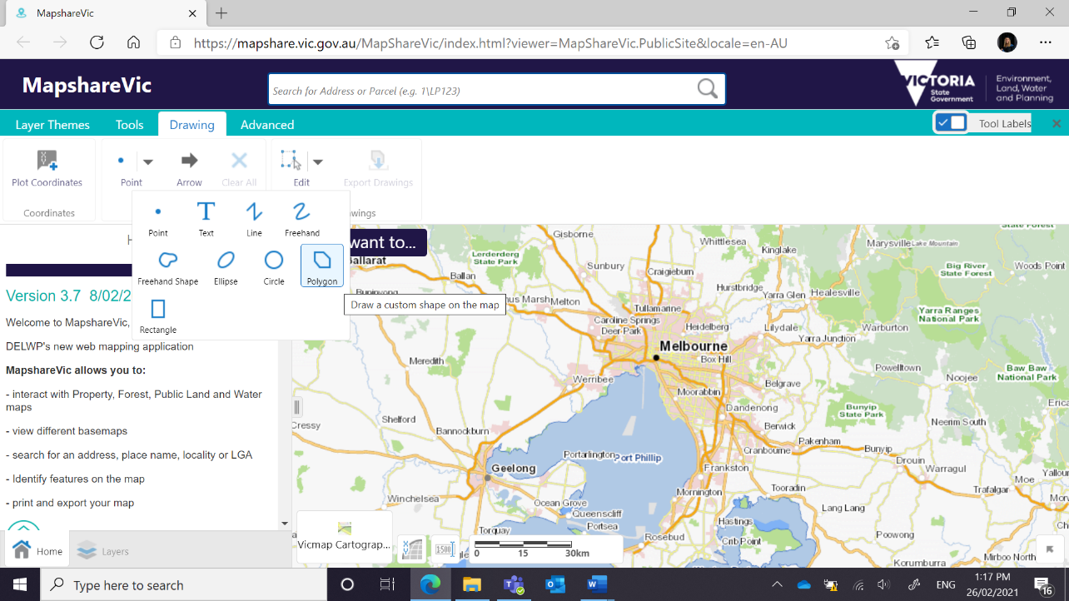

4. Zoom in to your desired location and click the boundaries of your project area to define the polygon shape

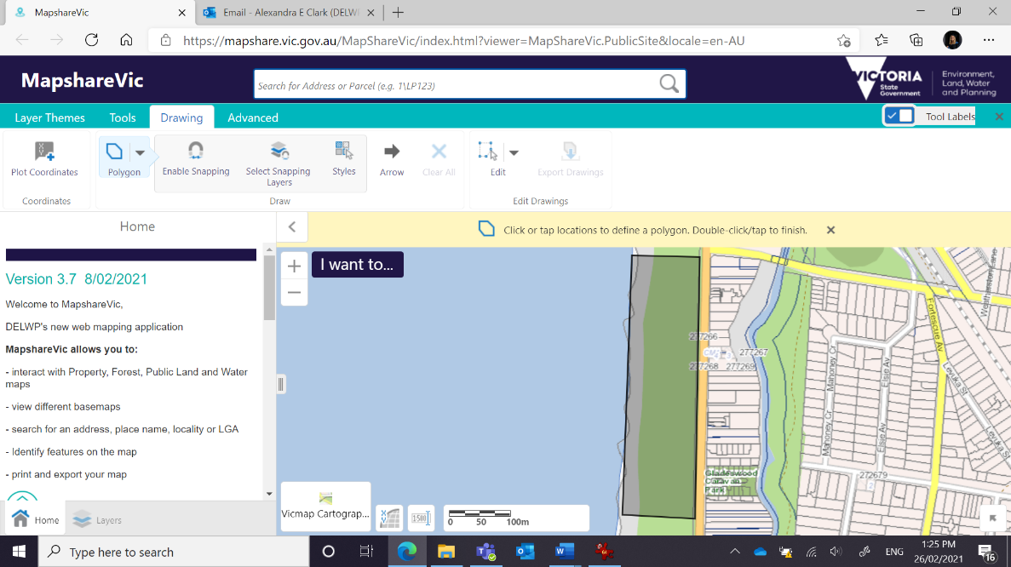

5. Double click to finish the polygon

6. If your project has multiple locations, please add additional polygons by repeating steps 4 and 5 as required

7. Once finished click 'Export Drawings' on the 'Drawing' toolbar. This will download a zipped folder containing the shapefiles you have just created to your device

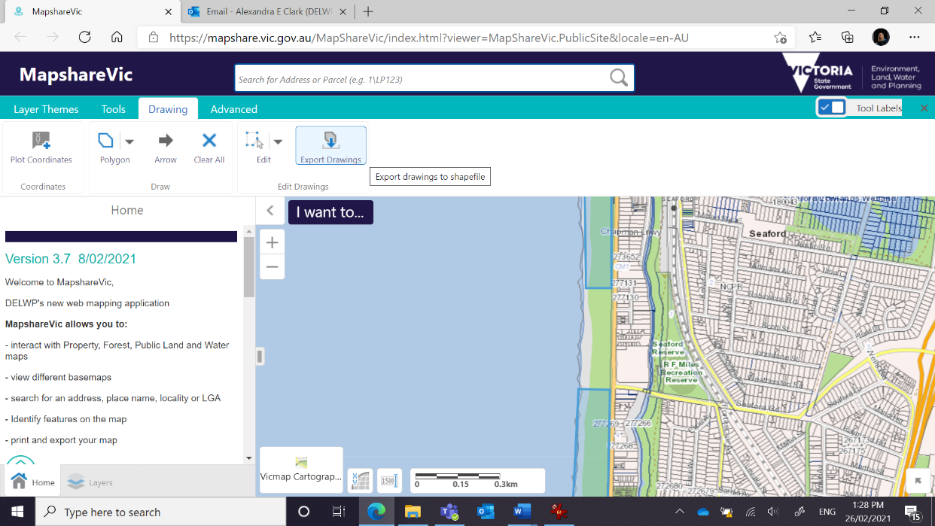

8. Upload the downloaded zipped folder in the “Supporting Documents- Sites” section of your grant application.