Coastal Public Access and Risk grants
2018-19
Funded projects by region
Total funded projects: 20 | Total funding awarded: $853,745
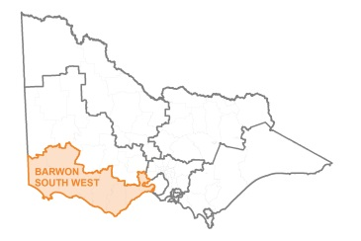
Barwon South West

Recipient | Project | Grant amount
Otway Coast Committee | Skenes Creek Beach Accesses | $18,018
Otway Coast Committee | Wye River Boardwalk | $3,990
Otway Coast Committee | Kennett River Holiday Park Fire Hose Reels | $4,480
Moyne Shire Council | Bourne Avenue Access Ramp, East Beach, Port Fairy | $100,000
Borough of Queenscliffe | Beach Condition and Hazard Identification Assessment | $7,000
Great Ocean Road Coast Committee Inc. | Anglesea Beach Access ramp | $150,000
Great Ocean Road Coast Committee Inc. | Coastal & Terrestrial Process Dynamics in Anglesea Bay | $28,147
Warrnambool City Council | Landscape Master Plan for Levys Point and Spooks | $20,000
Warrnambool City Council | Lady Bay Investigation & Decommission - McGennas & Worm Bay Access | $9,900
Warrnambool City Council | Shipwreck beach Access | $93,400
Warrnambool City Council | Surfside beach Access | $46,700
TOTAL |  | $481,635

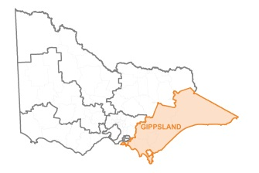
Gippsland

Recipient | Project | Grant amount
Sandy Point Foreshore Committee of Management Inc. | Sandy Point Boardwalk Extension and Roy Henderson Path Upgrade | $25,500
Bass Coast Shire Council | Cowes East Foreshore: Erosion Management Planning | $25,000
Grantville and District Foreshore Committee | Reduction of Public Risk from steel debris and Improve Erosion Prevention | $40,000
Seaspray Reserve Committee of Management Inc. | Seaspray foreshore path and crossover Surf Club to Creek | $20,000
DELWP/East Gippsland Shire Council | Bullock Island pedestrian and vehicle separation and demarcation works | $16,800
TOTAL |  | $127,300

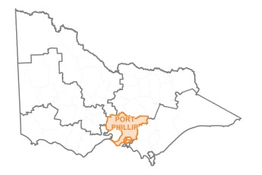
Port Phillip

Recipient | Project | Grant amount
Kingston City Council | Bay Trail Continuation | $150,000
WhiteCliffs to Camerons Bight Foreshore Reserve Committee of Management | Stairway Replacement and Coastal Erosion Mitigation | $52,000
Dromana Foreshore Committee of Management Inc. | Fire Management Plan for LaTrobe Reserve Dromana | $7,810
Mornington Peninsula Shire | Mornington/Mt Marth cliffside fence upgrade – phase two | $35,000
TOTAL |  | $244,810

