Coastcare Victoria VicCoasts Grants – Mapshare and FAQs
  - 2023-24
deeca.vic.gov.au

We acknowledge and respect Victorian Traditional Owners as the original custodians of Victoria’s land and waters, their unique ability to care for Country and deep spiritual connection to it.
We honour Elders past and present whose knowledge and wisdom
has ensured the continuation of culture and traditional practices.
DEECA is committed to genuinely partnering with Victorian Traditional Owners and Victoria’s Aboriginal community to progress their aspirations.
© The State of Victoria Department of Energy, Environment and Climate Action October 2023.
Creative Commons
This work is licensed under a Creative Commons Attribution 4.0 International licence, visit the Creative Commons website (http://creativecommons.org/licenses/by/4.0/).
You are free to re-use the work under that licence, on the condition that you credit the State of Victoria as author. The licence does not apply to any images, photographs or branding, including the Victorian Coat of Arms, and the Victorian Government and Department logos.
Disclaimer
This publication may be of assistance to you but the State of Victoria and its employees do not guarantee that the publication is without flaw of any kind or is wholly appropriate for your particular purposes and therefore disclaims all liability for any error, loss or other consequence which may arise from you relying on any information in this publication.
Accessibility
To receive this document in an alternative format, phone the Customer Service Centre on 136 186, email customer.service@delwp.vic.gov.au, or contact National Relay Service on 133 677. Available at DEECA website (www.deeca.vic.gov.au).

Contents
1. Mapshare Instructions 2
2. DEECA Grants Online 4
Registration & login 4
Starting a new application 5
Accessing existing draft & submitted applications 5
Site navigation 5
Communicate with Program representatives 6
3. Frequently Asked Questions 6
Key Information 6
Submitting Applications 7
Land Manager Support and Consent 9
Volunteer contributions 10
Budgets and GST 10
Biodiversity Information 11

Mapshare Instructions

If your project involves on-ground work, changing a site in some way and/or holding events or activities on a site then you must include a Mapshare file type map to meet eligibility criteria.
If you would like assistance with MapShare, please contact any Coastcare Victoria Facilitator. Details can be found here: Coastcare Victoria (marineandcoasts.vic.gov.au)
Below are the instructions for using Mapshare to identify the location/s of your project. If your activity is occurring in multiple locations, please identify all relevant locations.
To begin, please open MS Edge and then go to MapshareVic via this link (or search https://mapshare.vic.gov.au/mapsharevic/) and complete the following:

1. Agree to the disclaimer.
2. Click the 'Drawing' tab on the top green bar.
3. Click the drop-down arrow above 'Point' and select 'Polygon' to draw a custom shape on the map.

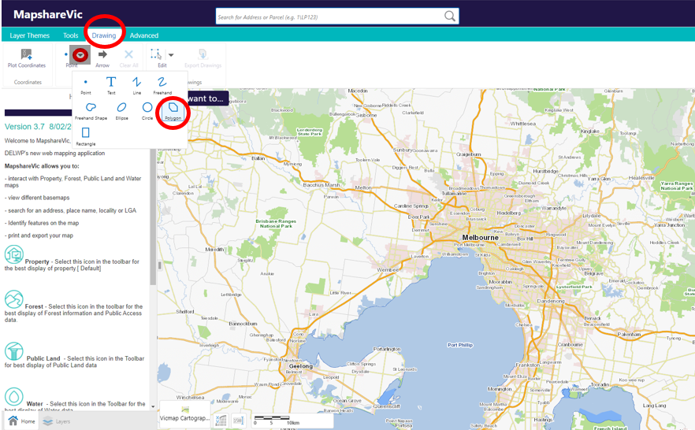
4. Zoom to your desired location using the ‘+’ symbol and use your mouse to navigate and click the boundaries of your project area to define the polygon shape.

5.Double click to finish the polygon.
6.If your project has multiple locations, please add additional polygons by repeating steps 4 and 5 as required
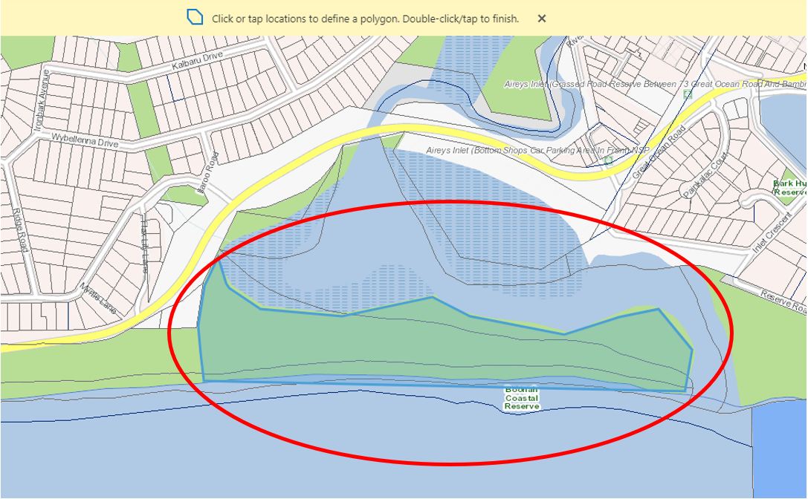
7.Once finished click 'Export Drawings' on the 'Drawing' toolbar. This will download a zipped folder containing the shapefiles you have just created to your device. Click OK. If it prompts you to open or save the file – choose Save. You can locate the Zipped folder in your Downloads in your File Explorer.

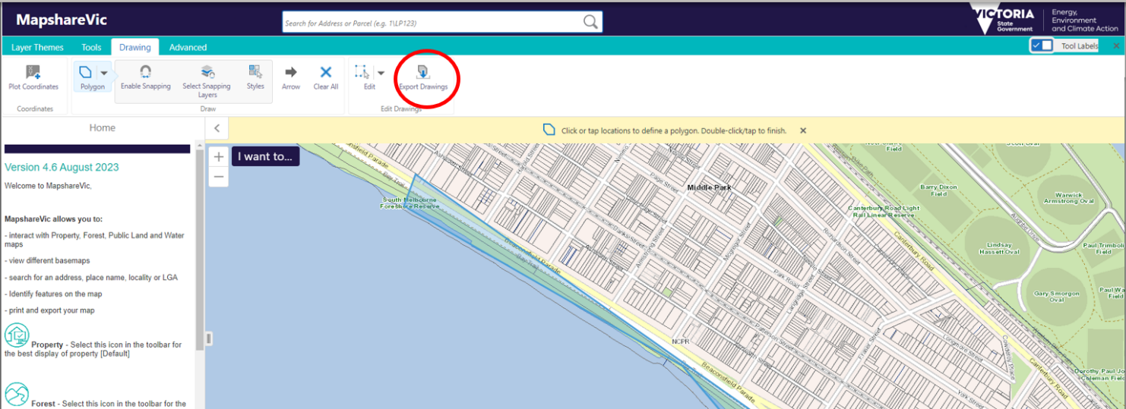
8. Upload the downloaded zipped folder in the “Supporting Documents- Sites” section of your grant application via Grants Online.
If you have difficulty with downloading the Zipped File try the steps again using a different internet browser, such as Firefox.

DEECA Grants Online
DEECA Grants Online - for Community Users. The DEECA Grants Online Portal ‘GEMS’ is used to accept applications for the Coastcare Victoria Community Grants. This Portal is used across all DEECA grants programs.

Registration & login
If you will be creating/submitting grant applications on behalf of your community group, it is highly recommended that you register an account with an organisational generic email address, so that account login details can be shared across the organisation.
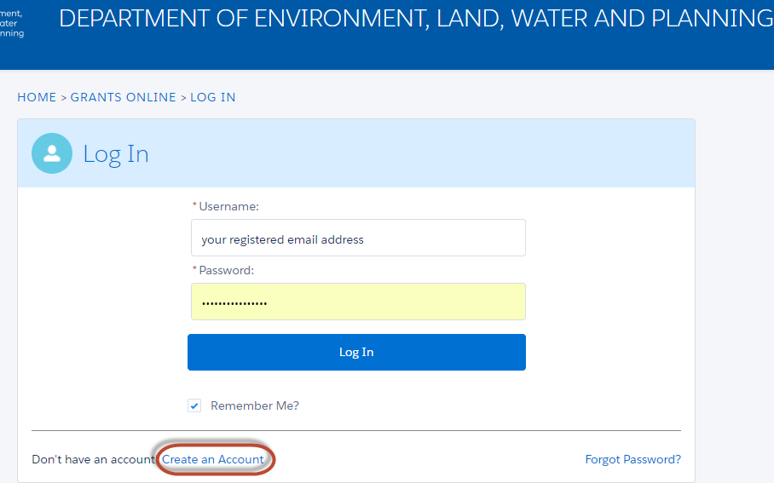

Starting a new application
The ‘Create new application’ link will be available from the relevant DEECA website, as well as the Grants Victoria website, for example:
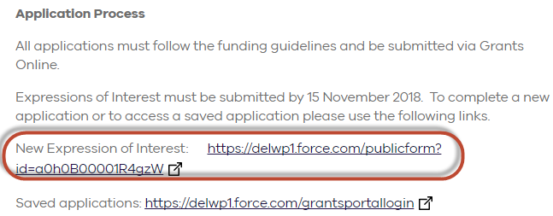

Accessing existing draft & submitted applications
A unique application reference number is generated by the system when your application is saved as a draft. The application number starts with “GA-F” and looks like “GA-F12345-1234”. It is important that you include your application reference number in any communication regarding the grant program.
There are three ways to access existing draft and submitted applications:
- Login to https://deeca.my.site.com/ to access all your draft and submitted applications.
- Using the link provided on the Coastcare Victoria Grants webpage and this document under “How to apply” section
- Using the link provided in notification email you received after creating a new draft.

Site navigation
- The side navigation bar helps you to quickly navigate to the page you have worked on. The navigation bar colour changes from grey to green once the page is completed. And you can only jump to a page that is in green colour.
- When you click on Save as Draft button, your application form is saved.
- When you click on View as PDF button, you can view the entire application form.
- When you click on Next Page button, the previous page content is saved automatically.
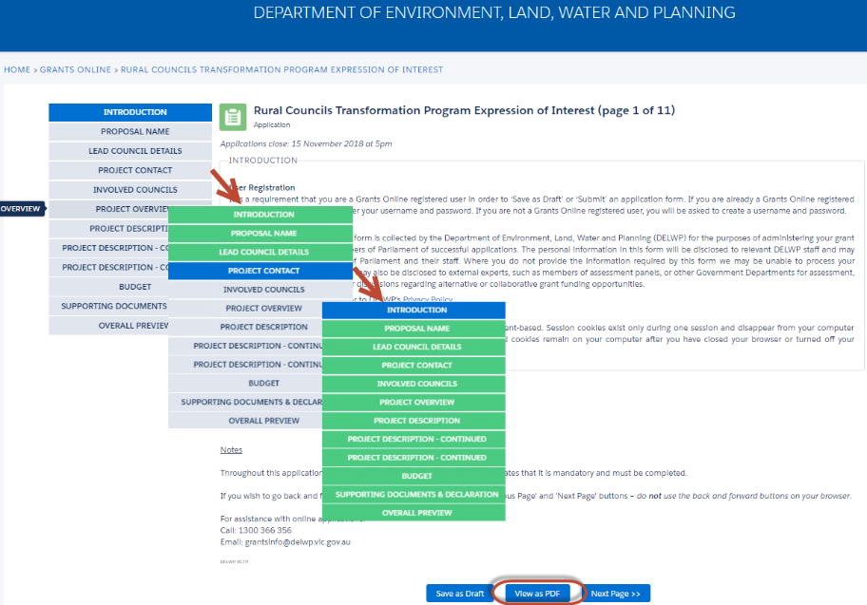

Communicate with Program representatives
When communicating with program representatives (Coastcare facilitators), for example, emailing coastcare.victoria@deeca.vic.gov.au, please include the program name abbreviation, your application reference number, and program staff name if known in the subject line.

Frequently Asked Questions

Key Information
- How much funding is available for each grant?
Up to $10,000 per project is available to successful applicants.

- Can we submit more than one application?
Multiple grant applications may be submitted. However, in the event the grants program is oversubscribed only one application per applicant across all streams may be deemed successful where applicants have submitted multiple grant applications.

- Will we be required to match funding?
Applicants do not have to contribute funding to their project, however, a project that can demonstrate in-kind contributions provides greater value for money to Coastcare Victoria and therefore will receive a higher score against the ‘Value for Money / Budget’ assessment criterion. Contributions can be in various forms including time, resources or funds.

- How long do successful applicants have to complete their project?
Projects can commence once agreements are signed (anticipated June 2024) and must be completed (including the submission of acquittal documentation to Coastcare Victoria) by the end date stated in the funding agreement, which will be 1 June 2025. Time extensions for project completion past 1 June 2025 will not be permitted.

- Who should we talk to about the project?
Coastcare Victoria requires you discuss your project with any Coastcare Victoria Facilitator before submitting your application to ensure your organisation and project activities are eligible.
Please see Coastcare Victoria Facilitator contact details as per the Coastcare Victoria website: https://www.marineandcoasts.vic.gov.au/coastal-programs/coastcare-victoria.
You are also strongly encouraged to discuss your project with your relevant Traditional Owners before submitting your application to ensure your project has the best chance of delivery within the timeframes. Any Coastcare Victoria Facilitator, in partnership with the relevant regional DEECA Inclusion Officer, can assist in brokering this relationship if you are unsure how to commence discussions. You can identify the Registered Aboriginal Party (RAP) for your area here: https://achris.vic.gov.au/#/onlinemap.

- Can we apply for a grant if we have received Coastcare Victoria funding in the past?
Yes, provided that all your funding agreement milestones due at the time of the grant application closing date were completed for previously funded projects. Examples of funding agreement milestones include progress reports, completion reports and acquittals, job safety plans and any special condition milestones.

Coastcare Victoria will not fund activities (or components of projects) that have already been funded on the same site by other sources.

Submitting Applications
- How do we apply?
Applications are submitted online using the DEECA Grants Online portal.
Applications consist of:
Step 1 – Completion of an online application form via the DEECA Grants Online portal. See our website for a MS Word document template of this form for drafting your application prior to copying it into the online form.
Step 2 – Completion of a multi-tab MS Excel spreadsheet, also available on our website. This must be uploaded to the DEECA Grants Online portal as part of the online application form.
Step 3 – Supporting documentation uploaded to the DEECA Grants Online portal.
Determine which Stream best fits your project activities using the descriptions.
Use the links below to start your application and click on the ‘Start New Application’ button:
Stream 1. Stewardship and Education, go to: https://deeca.my.site.com/publicform?id=a0hRF000000Femj
Stream 2. Strengthening our Volunteer Groups, go to: https://deeca.my.site.com/publicform?id=a0hRF000000FfNp
Stream 3. Supporting Traditional Owner Self-Determination, go to: https://deeca.my.site.com/publicform?id=a0hRF000000FfPR

To access existing drafts or submitted applications, go to: https://deeca.my.site.com/ and click on the ‘Access Saved Application’ button.
You will need to register for an account prior to commencing your application. You will receive an application number after you apply online. Please quote this number in all communications with DEECA relating to your application.
You will receive an application number when you submit an application online. Please quote this number in all communications with the department relating to your application.
Make sure your application is submitted by 5.00pm Australian Eastern Daylight Time (AEDT) on Friday, 16 February 2024.

- Can we view previous applications?
Yes, so long as you use the same Grants Online portal login as last time.

- We are having trouble with the online application - where do we go for help?
If you require assistance submitting your application online, contact grantsinfo@deeca.vic.gov.au or contact any Coastcare Victoria Facilitator. Contact details can be found here: https://www.marineandcoasts.vic.gov.au/coastal-programs/coastcare-victoria.

- Is there a word count for the application?
Please pay attention to the word count as detailed in the relevant sections. These are also stated in the MS Word version template of the application. We encourage you to use the word document to draft your application prior to copying into the Grants Online portal form.

- Does the application form auto-save or should we save it manually?
The application auto-saves when going to the next page.
If you wish to go back and forward between pages, you should use the ‘Previous Page’ and ‘Next Page’ buttons – do not use the back and forward buttons on your browser.
If you press the save button you will need to log back into the application.
See the Grants Online guide for further information about navigating the Grants Online Portal.

- What kind of supporting documentation should we submit?
Check the Guidelines (section 8 - What supporting documents will need to be provided?) for supporting documentation that must be submitted with your application. Other documentation such as strategies, plans, detailed methodology, and quotes are not required for this year’s grants application.

- How many attachments can we submit?
Applicants can submit up to 10 attachments via the online GEMS Grants system, with the system file size limit of 10MB each.
DEECA Grants Online Portal Hints
- Do not use the Internet Explorer browser – choose Firefox, Chrome or another browser as these browsers are more stable with the DEECA Grants Online Portal.
- When you register, note down the email and password you used. You will need it to access your application later. If your application is successful, it will form part of your funding agreement.
- After you start your application, you will receive a notification email with a link to return to the application form. It is easiest to continue accessing your application via this link.
- If completing your application in the supplied MS Word template first, keep formatting simple to assist with copying work across to the DEECA Grants Online portal.
- If converting your application to a PDF document, there are known alignment issues. Apologies, there has been no known resolution to this issue.
- Two people logging into the same grant application may cause issues such as data loss. You are encouraged to only have one person working in the application at any one time.
- Refer to the DEECA Grants Online Information available on the Coastcare Victoria website.

- How long does it take to apply?
Based on feedback from previous applicants you should allow around 2-3 full working days across the application open period to plan your grant application and around 1-1.5 working days to complete your application ready for submission.

Land Manager Support and Consent
- Do we need consent from a land manager?
If your project involves changing a site in some way and/or holding events or activities on a site, you will need consent from the land manager for your application to be eligible. This includes (but is not limited to) revegetation, weed management, minor works such as fences or paths and the installation of signage.
If you have any queries about land manager consent, seek advice from the land manager or from any Coastcare Victoria Facilitator.
When submitting your application, you are required to attach written support from relevant land managers (see template available on the Coastcare Victoria website). Formal consent can be obtained later if your application is successful.
It is advised to check the land manager status of your project site with any Coastcare Victoria Facilitator as this can sometimes be unclear where borders cross and can even change. Keep in mind that your site may be managed by more than one land manager.

- What is the difference between a letter of support and formal consent?
A letter of support shows that your land manager has given in principle support to your project. It can be a simple letter or email from a land manager representative with appropriate authority. If your project involves changing a site in some way and/or holding events or activities on a site then you will need to provide a letter of support with your application.
Formal consent involves gaining official approval to work on the site. Your land manager will check that your project meets relevant obligations, which could include cultural heritage, planning overlays and risk management. Formal consent is comprehensive, takes time and may cost money. You should include time and relevant costs for consents and permits when planning and budgeting for your project.

- Do we need consent from all land managers?
Yes. You will need consent from all relevant land managers that own or manage a site you intend to work on.

- We are not sure who the land manager/s is/are – do we need consent?
Yes. If you need assistance determining the land manager of your site, please contact any Coastcare Victoria Facilitator. Contact details can be found here: https://www.marineandcoasts.vic.gov.au/coastal-programs/coastcare-victoria.

- We have never needed consent from a land manager before – do we need it now?
If your project involves changing a site in some way and/or then you will need consent – even if you haven’t needed (or had) it for similar activities before.

- Does my onground project require Marine and Coastal Act consent?
If any of your project activities will be carried out on Marine and Coastal Crown land you may require approval under the Marine and Coastal Act 2018: https://www.marineandcoasts.vic.gov.au/marine-and-coastal-act Before commencing any works, you must obtain approval to use or develop marine and coastal Crown land. You must comply with the conditions of any consent provided.
For more information contact your local Coastcare Victoria Facilitator.

- What is the definition of ‘coastal area’?
The coastal area is defined in the Marine and Coastal Act 2018, the marine and coastal environment includes all waters between the outer limit of Victorian coastal water and five (5) kilometres inland of the high-water mark of the sea.
Noting that the Coastcare Victoria Community grants project sites must be on public (coastal and near-shore marine Crown) land.

Volunteer contributions
- What is the volunteer contribution rate?
$40 per hour for all volunteers and all activities they undertake for your project. This standard rate allows applications to be considered in a consistent way and is based on an average rate that was calculated by the Australian Bureau of Statistics in 2010, which we have corrected for inflation.

- Can we use a higher rate for volunteers with professional skills worth more than $40?
No. $40 per hour is a standard rate that values the contribution that all volunteers make to your project.

- What kind of volunteer activities can count towards in kind support?
Any activity that your volunteers undertake as part of the project can count. This could include:
- Physical work, such as planting, building or litter collection
- Planning the logistics for the project
- Preparing educational material
- Coordinating an event, such as corporate or school volunteering, or running an information session
Volunteers may be members of your group, corporate volunteers or members of the public – they all count, as long as they are actively doing something to assist in delivering your project.

Budgets and GST
- What do we do if we think one of our activities or budget items is ineligible?
Discuss your project with any Coastcare Victoria Facilitator before submitting your application to ensure your organisation and project activities are eligible and your application has the best chance of success.
If you think one of your activities or budget items may fall under one of the types listed under ‘what will not be funded’ section of the guidelines, but you’re not sure, contact any Coastcare Victoria Facilitator with your scenario so they can confirm whether the activity or budget item is ineligible.
Contact details can be found here: https://www.marineandcoasts.vic.gov.au/coastal-programs/coastcare-victoria

- Do we need to have an ABN?
Applicants do not need to have an ABN. A group should provide its ABN if it has one.

- Do we need to be registered for GST?
Applicants do not need to be registered for GST.

- Do we include GST in the budget when costing the project?
Yes. Applicants will need to list the actual costs of the activities or materials you are seeking to be funded. This may include taxable supply items which include a GST charge such as nursery plants or contractor services. Include each item you are requesting grant funding for and its total cost, including GST.

- Does the grant payment include GST?
If you have an ABN and are registered for GST, your grant payment will be taxable and GST will be added to the total amount of funding you have requested/has been approved (e.g total amount requested is $10,000, your GST registered organisation will receive a total amount of $11,000).
If you are not registered for GST, your grant payment will not be taxable, so will not include GST (e.g total amount requested is $10,000, you’re not GST registered, organisation will receive a total amount of $10,000).

Biodiversity Information
- How can we find out what species are indigenous to my project area?
You can visit DEECA’s NatureKit website for more information on native vegetation in your area. Coastkit can be used for looking up marine habitats and species.
Zoom to the location of your project (1:25,000 scale), open the Ecological Vegetation Classes (EVC) Map Layer on the right for the EVC for your area to be shown.
To find out what species make up the EVC, see the EVC Benchmarks at https://www.environment.vic.gov.au/biodiversity/bioregions-and-evc-benchmarks
Use the map to find the Bioregion your project is in, click on the Bioregion name, then select the relevant EVC/s and view a PDF of the recommended species for your site.
It is also strongly recommended that you consult with your land manager for advice and approval to ensure alignment with any site management plan or preferences in species chosen.

